CLOUD AND MOBILE TECHNOLOGIES
Cloud computing. Types of cloud. Services.
Cloud computing is a way of delivering technology resources to users from remote hubs. It provides computing services such as storage, servers, services and applications via the internet.
Cloud computing has become a business necessity without managing the infrastructure. There a lot of companies that use cloud computing in reality like Microsoft, Amazon, Google, Yahoo, VMWare and etc. It helps for new startups and companies to enter the market easier. The cost of infrastructure is greatly reduces, and cloud companies can rent computing power (virtual machines) or storage space (virtual space) according the needs of their business.
There are four different cloud models that you can subscribe according to business needs:
- Private cloud allows systems and services to be accessible within an organization.
- Public cloud allows systems and services to be accessible to the general public.
- Hybrid cloud is mixture of public and private cloud.
- Community cloud allows systems and services to be accessible by group of organizations.

In cloud computing architecture the computing resources are centralized and scalable and on demand can be offered as services, like Internet Services Provider (ISP), Cloud Service Provider (CSP). These services offer cloud platforms to create web services on the internet. Cloud computing enables convenient use and access to a shared pool computing resources, like servers, storage, applications that can be rapidly provisioned and released with minimal effort. Cloud server providers offer three types of services: Software as a Service (SaaS), Platform as a Service (PaaS), Infrastructure as a Service (IaaS).

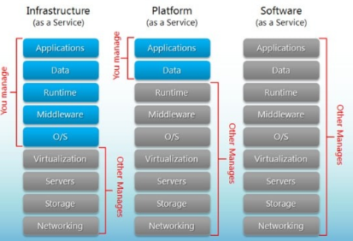

Software as a Service (SaaS) is a model for the distribution of software where customers access software over the internet. In SaaS, a service provider hosts the application at its data center and a customer accesses it via a standard web browser.
SaaS examples: BigCommerce, Google Apps, Salesforce, Dropbox, MailChimp, ZenDesk, DocuSign, Slack, Hubspo.

Platform as a Service (PaaS) is a concept that describes a computing platform that is rented or delivered as an integrated solution, solution stack or service through an Internet connection.
PaaS examples: AWS Elastic Beanstalk, Heroku, Windows Azure (mostly used as PaaS), Force.com, OpenShift, Apache Stratos, Magento Commerce Cloud

Infrastructure as a Service (IaaS) is a service model that delivers computer infrastructure on an outsourced basis to support enterprise operations. Typically, IaaS provides hardware, storage, servers and data center space or network components; it may also include software.
IaaS examples: AWS EC2, Rackspace, Google Compute Engine (GCE), Digital Ocean, Magento 1 Enterprise Edition*

Principles of cloud computing
Principles of cloud computing:
- Scalability and on-demand services. Cloud computing provides resources and services for users on demand. The resources are scalable over several data centers.
- User-centric interface. Cloud interfaces are location independent and can be accesses by well established interfaces such as web services and internet browsers.
- Guaranteed quality of service. Cloud computed can guarantee QoS for users in terms of hardware/CPU performance, bandwidth, and memory capacity.
- Autonomous system. The cloud computing systems are autonomous systems managed transparently to users. However, software and data inside clouds can be automatically reconfigured and consolidated to a simple platform depending on user’s needs.
- Pricing. Cloud computing does not require up-from investment. No capital expenditure is required. Users pay for services and capacity as they need them.

What is cloud computing architecture?
Data centers.
Data centers the backbone of the Internet and host diverse applications ranging from social networking to web search and web hosting to advertisements.
Data centers play a vital role in the success of any organization’s IT infrastructure, as they are used to store computer systems and related components such as telecommunications and storage system. The data center hardware consists of thousands of individual computing nodes with their corresponding networking and storage subsystems, power distribution and conditioning equipment, and extensive cooling systems. Such data centers currently power the services offered by companies such as Google, Amazon, Yahoo, and Microsoft.
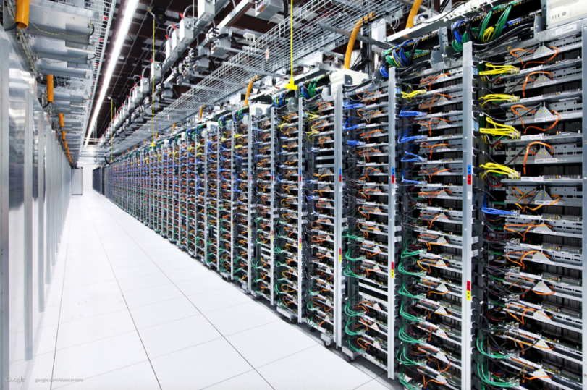
Essentially, a cloud data service is a remote version of data center – located somewhere away from company’s physical premises – that lets you access data through the internet. It is all-inclusive solution in which all computing resources (hardware, software, networking, storage) are provided rapidly to users as demand dictates. It promises to revolutionize information technology and commerce by making computing available, in a fashion very similar to other utilities such as gas and electricity, over the internet.

Virtualization and cloud computing
Virtualization is the idea of partitioning or dividing the resources of a single server into multiple segregated virtual machines (VMs). The earliest use of VMs was by IBM in 1960, intended to leverage investments in expensive mainframe computers. The idea was to enable multitasking – running multiple applications and processes for different users simultaneously. Virtualization can provide dramatic benefits for a computing system, including increased utilization, energy saving, rapid deployment, improved maintenance capability, isolation, and encapsulation. Moreover, virtualization enables applications to migrate from one server to another while they are still running, without downtime, providing flexible workload management, and high availability during planned maintenance or unplanned events.
There are numerous reasons that virtualization is effective in practical scenarios, for example:
- Server and application consolidation: under virtualization, we can run multiple applications at the same time on the same server, resulting in more efficient utilization of resources.
- Configurability: virtualization allows dynamic configuration and bundling of resources for a wider variety of applications than could be achieved at the hardware level – different applications require different resources (some requiring more storage, others requiring more computing).
- Increased application availability: VM checkpointing and migration allow quick failure recovery from unplanned outages with no interruption in service.
- Improved responsiveness: resource provisioning, monitoring, and maintenance can be automated, and common resources can be cached and reused.
Depending on the resources virtualized, the process of virtualization can be classified into the following types:
- OS virtualization.
- Server virtualization
- Memory virtualization
- Storage virtualization
- Network virtualization
- Application virtualization

Mobile technology. Types and services of mobile technology.
Mobile technology is the technology used for cellular communication. Today, the mobile technology has improved from a simple device used for phone call and messaging into a multitasking device used for GPS navigation, internet browsing, gaming, instant messaging tool etc. Professionals argue with the trend that the future of computer technology is rest on wireless networking and mobile computing.
Mobile communication has become more popular in last few years due to fast reform from 1G to 5G in mobile technology. The mobile wireless generation generally refers to a change in the nature of the system, speed, technology, frequency, data capacity, latency etc. Each generation have some standards, different capacities, new techniques and new features which differentiate it from the previous one.
The first generation (1G) mobile wireless communication network was analog used for voice calls only.
The second generation (2G) is a digital technology and supports text messaging. The 2.5G includes phone calls, voicemails, send/receive large emails, GPRS/EDGE, MMS, Wi-Fi, maps navigation and etc.
The third generation (3G) mobile technology provided higher data transmission rate, increased capacity and provide multimedia support.
The fourth (4G) integrates 3G with fixed internet to support wireless mobile internet, which is an evolution to mobile technology and it overcome the limitations of 3G.

