Multimedia technologies

Representation text, audio, video and graphical information in a digital format. Basic technologies for compression of information. 3-D representations of the virtual world and animation. Instruments of development of multimedia applications. Use of multimedia technologies for planning, descriptions of business processes and their visualization.

- Предстовление текстовой, аудио,видео и графической информаций в цифровом формате.
- Инструменты разработки мультимедийных технологий.
- Использование мультимедийных технологии в бизнесе.

Derived from the word “Multi” and “Media”. Multi- Many, Multiple, Media -Distribution tool & information presentation – text, graphic, voice, images, music and etc.
Multimedia- Refers to any computer-based presentation software or application that integrates at least two or more of these elements: text, graphics, animations, audio and video.

Text
- Text is a characters that used to create words, sentences and paragraphs
- Basically, there are 2 types of text, which are Serif and Sans-Serif text.
- Serif-means text with ‘flags’ (decorations), such as Times Now Roman, Monotype Corsiva and Courier New.
- San-serif text is a text without ‘flag’, such as Arial, Helvetica and Impact. It is a simple font type. Try to use more San-Serif fonts in your documents because it can improve readability (easy to read).

Graphics
- Graphics is a digital representation of non-text information, such as drawing, chart or photograph that contains no movement or animation.
- There are two types of graphics, which are Bitmap and Vector.
- The difference between these two types is what they're made up of. Bitmap graphics are made up of little squares called pixels. Vector graphics are made up of lines and curves.

Audio
Audio is music, speech, or any other sound. To store these sounds, a computer
converts the analog sound waves into a digital format. There are several
characteristics of audio to be seen:
- Sampling is the process of digitizing / recording sounds to your pc.
Sampling rate of 44.1 KHz means 44100 samples are taken every second.
Sound card is used in sampling.
- Most software measures the quality of the sound using bitrate, which describes the amount of digital information being stored per second of audio. The higher the bitrate, the better the sound quality but the larger the file size.
Video
- Comprises of photographic images that display at speeds of 15 to 30 frames per second
- To use video, you must digitize it.
- Video files are so large so one-way to reduce the size of the files is video compression. There are several popular compression formats like avi, QuickTime and mpeg.
- Video compression works by taking advantage of the fact that only a small portion of the image changes from frame to frame. Thus, a video compression program might store the first reference frame and then, assuming that the following frames will be almost identical to it, store only

Animation/Graphics
Animation is a sequential series of still images that create an illusion of motion.
- Note the difference between animation and video.
- Whereas video takes continuous motion and breaks
- It up into discrete frames,
- Animation starts with independent pictures and puts them together to form the illusion of continuous motion.
- 2D animation figures are created and/or edited on the computer using 2D bitmap graphics or created and edited using 2D vector graphics. 3D animation are digitally modeled and manipulated by an animator.
- Unlike an animation that we can create from drawings or images a video is created by a photographic process and converted or ported to a computer in sets of Frames where each frame has data stored in every pixel.
- We measure the rate at which frames are displayed in Frames Per Second (FPS).
- Digital video can be copied with no degradation in quality.

Multimedia may be divided into Linear and Non-linear categories.
Linear active content progresses without any navigational control for the viewer such as a cinema presentation.
Non-linear content offers user interactivity to control progress as used with a computer game or used in self-paced computer based training.
A Multimedia Project is identified as Linear when: It is not interactive, user have no control over the content that is being showed to them. Example: a movie, a non-interactive lecture / demo show
A Multimedia Project is identified as Non-Linear when:
It is interactive, users have control over the content that is being showed to them, users are given navigational control. Example: Games, Courseware
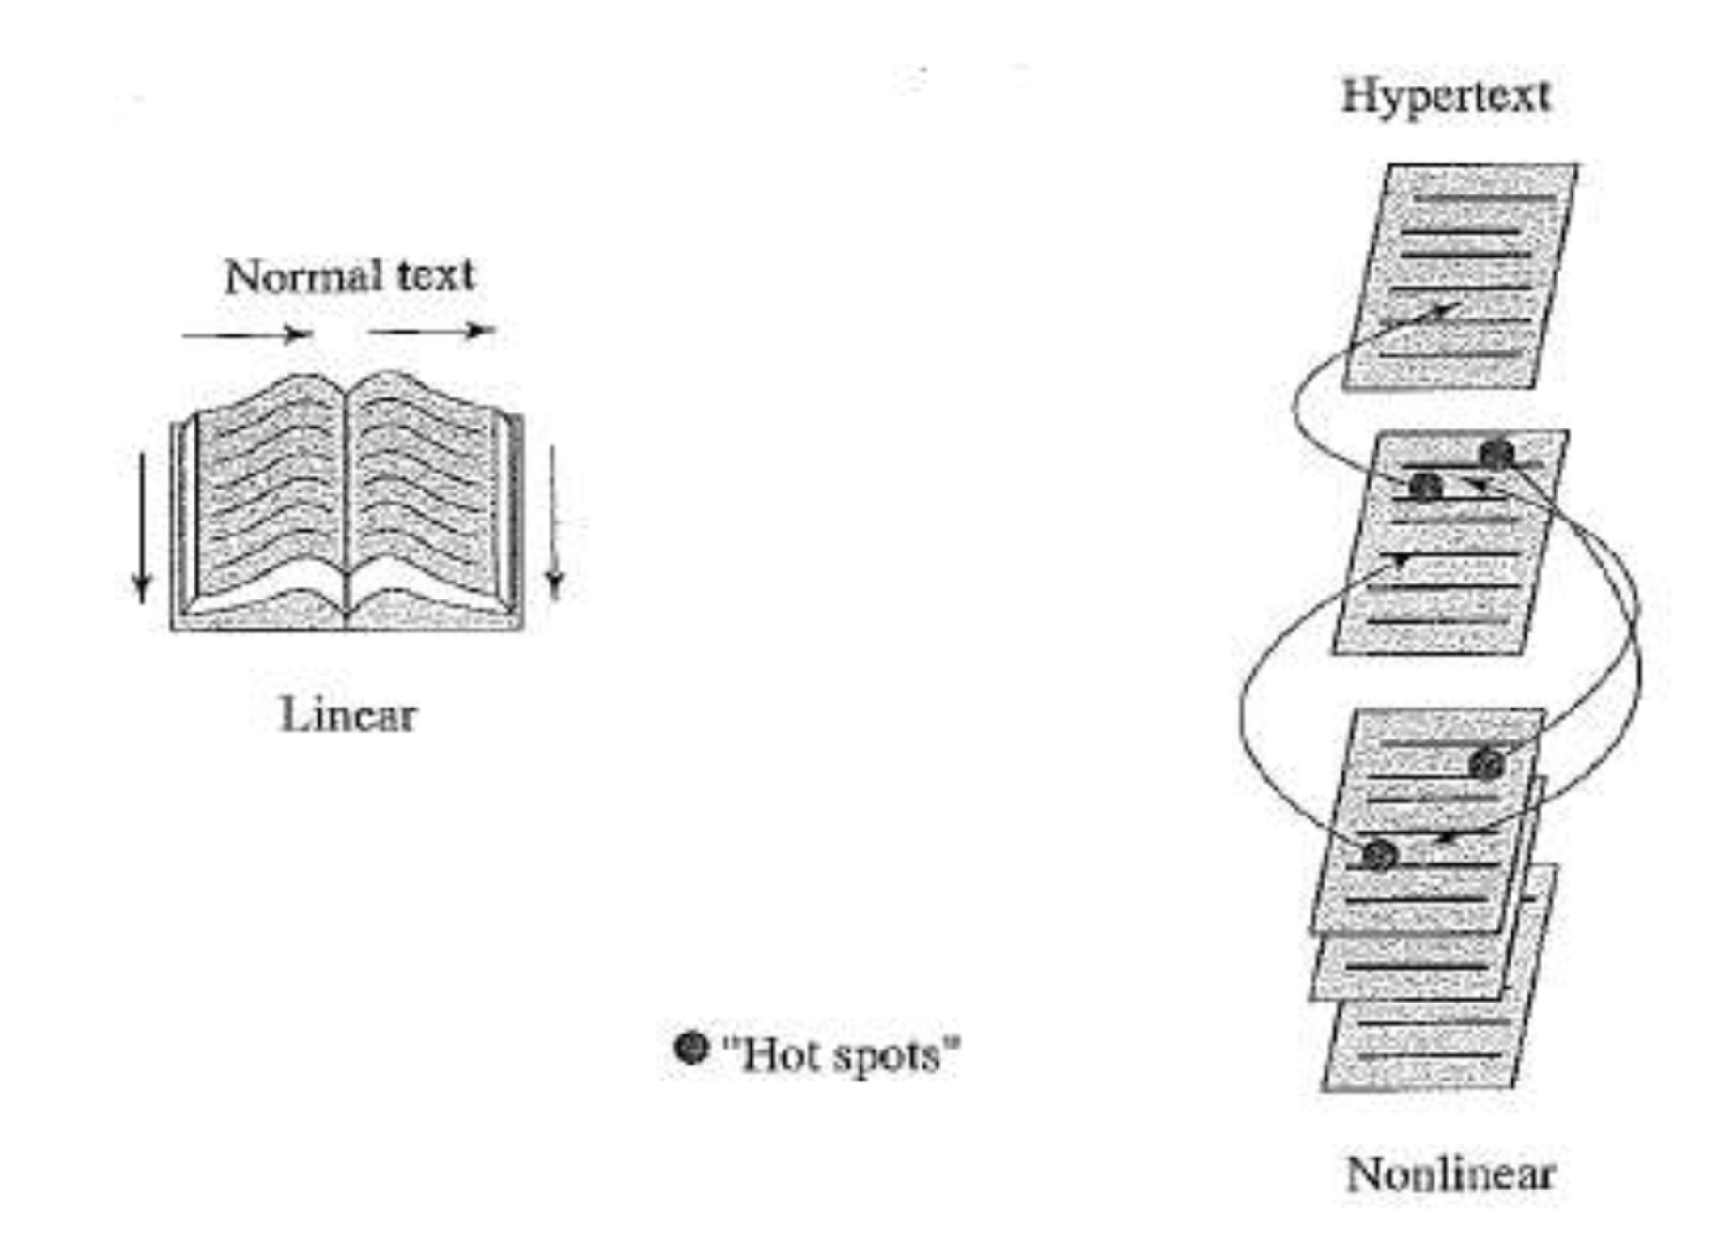

APPLICATIONS OF MULTIMEDIA
- World Wide Web
- Video conferencing Video-on-demand
- Interactive TV
- Digital Transmission
- Webcasting -
- Home shopping Games
- Virtual reality -
- Digital video editing and production systems
World Wide Web. Multimedia incorporates different media: sound, images, video. The world wide web is a global hypermedia system. Animation and video can show information that is difficult to convey statically. Applications of hypermedia include online help, education and e-commerce. Dynamic web content can be used for simple online demonstration or for complete web-based business applications.
Video conferencing Video-on-demand It is the integration of video, audio and peripherals to enable two or more people to communicate simultaneously over some type of telecommunications lines.In other words, you are transmitting synchronized images and verbal communications between two or more locations as if them being in the same room.
Interactive TV, Digital Transmission
Can also be referred as Streaming Media =Streaming media is multimedia that is constantly received by and presented to an end-user while being delivered by a streaming provider

Multimedia finds its application in various areas including, but not limited to
- Advertisements,
- Art,
- Education,
- Entertainment,
- Engineering,
- Medicine
- Mathematics
- Business
- Scientific research
Business.
• Sales / Marketing Presentation
• Trade show production
• Staff Training Application
Education
• Courseware / Simulations
• E-Learning / Distance Learning
• Information Searching
Entertainment
• Games (Leisure / Educational)
• Movies
• Video on Demand– Online
Home
• IPTV
• Satellite TV • Games
Public places
• Information Kiosk (desk)
• Smart Cards, Security
MULTIMEDIA SOFTWARE TOOLS
Categories of software tools
- Music sequencing and Notation Digital Audio
- Graphics and Image Editing
- Video Editing
- Animation
- Multimedia Authoring
A music sequencer (or just sequencer) is a computer program or electronic device for recording, editing and playing back music, in the form of digital audio and/or MIDI data.
- Adobe Audition - Adobe Systems
- DirectMusic Producer – Microsoft
- Deluxe Music Construction Set - Electronic Arts GarageBand - Apple
- Sonar – Cakewalk
- MIDI Converter Studio - ManiacTools

A digital audio editor is a computer application for audio editing, i.e. manipulating digital audio. Digital audio editors are the main software component of a digital audio workstation.
- Acoustica - Acon Digital Media
- Audition - Adobe System
- Creative Wavestudio - Creative Technology
- Logic Pro - Apple
- Sound Forge - Sony
In computer graphics, graphics software or image editing software is a program or collection of programs that enable a person to manipulate visual images on a computer.
- Adobe Photoshop – Adobe
- Adobe Fireworks – Adobe
- Adobe Flash – Adobe
- Adobe Free hand - Adobe
Video editing software, also known as Non Linear Editing (NLE), is application software which handles the editing of video sequences on a computer. NLE systems replace traditional flatbed celluloid film editing tools and analogue video tape-to-tape machines.
These software applications allow non-linear editing of videos:
- Adobe Premiere 9 (Windows)
- AviSynth (Windows)
- Final Cut Express (Mac OS X) - Apple
- Blender 3D animation suite (cross-platform)
- AVS Video Editor (Windows)
- CineFX Formerly known as: Jashaka (introduced as "Jahshaka Reinvented") (Cross platform)
- Cinelerra (Linux)
VideoStudio (Windows) - Ulead Studio
- VLMC VideoLan Movie Creator (Pre-alpha)

Multimedia is the combination of text, graphics, sound, animation and video, to effectively communicate ideas to users delivered by computer. Multimedia projects can be linear or nonlinear. Multimedia projects are often stored on CD-ROM or DVDs. They can also be hosted on the Web. Multimedia is widely used in business, schools, public places, and at home.

