E-TECHNOLOGIES. ELECTRONIC BUSINESS. ELECTRONIC TRAINING. ELECTRONIC GOVERNMENT
Electronic business: Main models of electronic business. Information infrastructure of electronic business. Legal regulation in electronic business. Electronic training: architecture, structure and platforms. Electronic textbooks. Electronic government: concept, architecture, services. Formats of implementation of the electronic government in developed countries.
The world is undergoing radical change. Technology has become an every-day part of our lives. Everything is becoming digital: business, education, government and etc.
Electronic business: Main models of electronic business. Information infrastructure of electronic business. Legal regulation in electronic business.
E-business has provided firms with new ways of approaching, acquiring, and retaining customers. On top of various web-based marketing sources, firms have recently shown significant interest to online social networking as a new marketing source. Online social networking services such as Facebook, Twitter, Telegram provide firms with significant business building communities based on interests and relationships. According to eMarketers, firms are expected to spend about $1.6 billion in social networking in 2008. That is an increase of 69% from 2007 expense (BuzReport, 2008b). In 2007, 37% of the US adult Internet users and 70% of teens participated in online social networking at least once a month. eMarketer predicted that the number of participants will continue to grow by more than 45% by the year 2011.
E-business models can generally be categorized into the following types:
- Business-to-business (B2B)– supports commercial transactions between two or more businesses. It is the sale of products or services, or information exchange, among two or more businesses through electronic technology, usually involving the Internet, through a public or private exchange.
Examples of B2B: Skype, Kickstarter, LinkedIn, Chocolife.me.
Skype allows a cheap way to make conference call for B2B business people from all over.
Kickstarterallows entrepreneurs, filmmakers, designers, and other creators find the resources and support they need to make their ideas/business plans a reality.
LinkedInallows businesses a great way to be “in the known” and get to know others in their field.
Chocolife.meallows businesses a several services that help to gather clients.
- Business-to-consumer (B2C) – supports commerce between a business and an individual consumer. It refers to the exchange of products or services from businesses to end-consumers.
Examples of B2C: online shopping (eBay, Amazon.com, olx.kz)
- Consumer-to-consumer (C2C) – supports direct business transactions and information exchange between and among consumers.
Examples of C2C: eBay, Amazon.com, olx.kz
eBay – online auction site, it is acts as both B2C and C2C marketplace. Amazon.com, olx.kz also being B2C and C2C marketplace.

Information infrastructure of electronic business
E-business infrastructure refers to the combination of hardware such as servers and a client PCs, the network used to link this hardware and the software applications used to deliver services to workers within the e-business and also to its partners and customers.
E-business infrastructure consists of five-layer model:
- Application layer includes CRM, supply chain management, data mining, content management systems
- Systems software layer includes web browser and server software and standards, networking software and database management systems
- Transport or network layer includes physical network and transport standards (TCP/IP)
- Storage/physical layer includes permanent magnetic storage on web servers or optical backup or temporary storage in memory (RAM)
- Content and data layer includes web content for intranet, extranet and internet sites, customer’s data, transaction data, clickstream data

The Internet refers to the physical network that links computers across the globe. It consists of the infrastructure of network servers and communication links between them that are used to hold and transport information between the client computers and web servers.

Client/server : The client/server architecture consists of client computers, such as PCs, sharing resources such as a database stored on a more powerful server computer.

Protection by government policy and legal regulations includes financial and privacy protection.

Electronic training: architecture, structure and platforms. Electronic textbooks.
Electronic training or electronic learning (e-learning) is the use of computer and internet technologies to deliver a broad array of solutions to enable learning and improve performance. Many organizations and institutions are using e-learning because it can be as effective as traditional training at a lower cost. Of course, developing e-learning is more expensive than preparing classroom materials and training the trainers, especially if will be used multimedia and interactive methods. But costs of web servers and technical support for e-learning are significant lower than those for classroom facilities, instructor time, participant’s travel and job time lost to attend classroom sessions.
E-learning can offer effective instructional methods, such as practicing with associated feedback, combining collaboration activities with self-paced study, personalizing learning paths based on learners’ needs and using simulation and games. Further, all learners receive the same quality of instruction because there is no dependence on a specific instructor.

Nowadays there are many e-learning products existing in the market which are implemented using different platforms, such as:
- MOOCs (Massive Online Open Courses), for example www.coursera.org, www.edx.org
- Virtual learning environment (VLE), for example Moodle, Blackboard
- Video streaming services, for example YouTube, Netflix
- Virtual instructor-led training (VILT), for example WebEx, webinars
- Discussion boards
- Forums
- Podcasts
Electronic textbooks
https://www.sciencedirect.com/science/article/pii/S1877042812026390
https://link.springer.com/article/10.1007/s40692-014-0023-9
The rapid adoption of iPads, tablets, and e-book readers as personal digital devices in the education systems around the world has been observed recently.
Electronic textbooks or e-Textbooks have the potential to provide teachers with a teaching tool that can help them to effectively deliver their lessons to their students. e-Textbooks become a main learning resource. It looks like a platform for learning that combines e-learning and e-publishing technologies, and serves as a dynamic and interactive reading material, and as an interface for learning activities among learners and the learning communities.
They have the following advantages:
- Offering various presentations of information and activities.Electronic books can present any material using different types of representations such as pictures with sounds, text, music, animations, videos with subtitles and etc. Students can controls the rate of speech, can choose the language in text or videos, decide to repeat the presentation.
- Facilitating the evaluations of student’s work.Electronic books can to check a student’s work automatically and then immediately report to teacher the errors made by students. It helps instructors to make analysis of student’s performance.
- Automating some feedbacks for students. Electronic books can evaluate each reponse and provide appropriate feedback.
- Providing the framework for learning process. Electronic books provide to highlight text sections, and take notes, have the ability to create drawings within the book.
- Ensuring sustainable resources of knowledge.Electronic books can contribute to effort reducing the number of trees cut down to produce printed books.

Electronic government: concept, architecture, services. Formats of implementation of the electronic government in developed countries.
E-government is a mechanism for cooperation of state and citizens with the help of information technologies. It uses internet and communication technologies to automate governance in innovative ways, so that it becomes more efficient, more cost-effective, and empowers the human race even more.
E-government became possible only after the appearance of the World Wide Web and the widespread use browsers like Internet Explorer, Mozila and Chrome.
In e-government there are three main principals: government, citizens and business entities. So e-government is interaction between these participants in which the government plays the pivotal role. And it can be divided into:
- G2C – is referring to the interaction between government and citizens. For example, it could be national voter’s services, apply online for passport, apply online to schools, kindergartens, and etc.
- G2B – is referring to the interaction between government and business enterprises. For example, electronic incorporation forms, tax forms, social insurance forms, electronic payments and so on.
- G2G – is referring to the interaction between two government departments. For example, it is communication between two government departments for data access and data sharing.

E-government in Kazakhstan
Today, Kazakhstan ranks 46thplace in the world rating of the United Nations(2018) on the index of e-government development. It consists of indicators of the human capital development, telecommunications infrastructure and online services.
In Kazakhstan, the portal e-government egov.kz is introduced in 2006. The concept of electronic government has been developed for comfort, clear without obstacles communication between the state and the people. Government provides opportunities for the best way of fulfillment of each citizen that guarantees integrity and compliance with law.
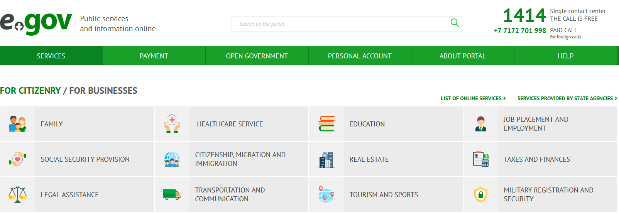
The availability of public services in the online format was made possible by providing citizens with electronic digital signatures (EDS) on a free basis. EDS allows you to receive the necessary public services and certificates without leaving home.
Users of the eGov portal today are more than 6 million people. Through its infrastructure, it is possible to implement 760 electronic services and services.
“Electronic government” was created for more effective, transparent and accessible work of government agencies.
Formerly each state agency had been acting separately and had weak contacts with the rest and at the same time citizens had to rush different instances to obtain necessary certificates and references, verifications and other loads of documents. All this made the process of obtainment of only one service unbearable with endless visits to numerous agencies. Today it is all over owing to the projects of the “electronic government”.
Electronic government is the integrated mechanism of interaction between the state and citizens, state agencies with each other, ensuring consistency with the help of informational technologies. This mechanism reduced queues to state agencies and simplified acceptance of certificates, references, permits and many other documents and services.
In other words “electronic government” it is when for obtainment of license you need only Individual identification number (IIN) (other necessary data is taken by automatic requests), it is when you can pay for utility services and fines online, it is when for getting a certificate at «State-owned corporation «Government for citizens» NJSC you may only need your ID card, it is when you may independently register your business and get the certificate at the “electronic government” web-portal within 10-15 minutes, it is whet you may get info about the turn of your kid the waiting list to the kindergarten at any time of the day and night, or get statement of residence on cell phone and hundreds more of such “when”.

List of online services for citizen includes family healthcare services, education, job placement and employment, social security provision, citizenship, migration and immigration, real estate, taxes and finances, legal assistance, transportation and communication, tourism and sports, military registration and security.

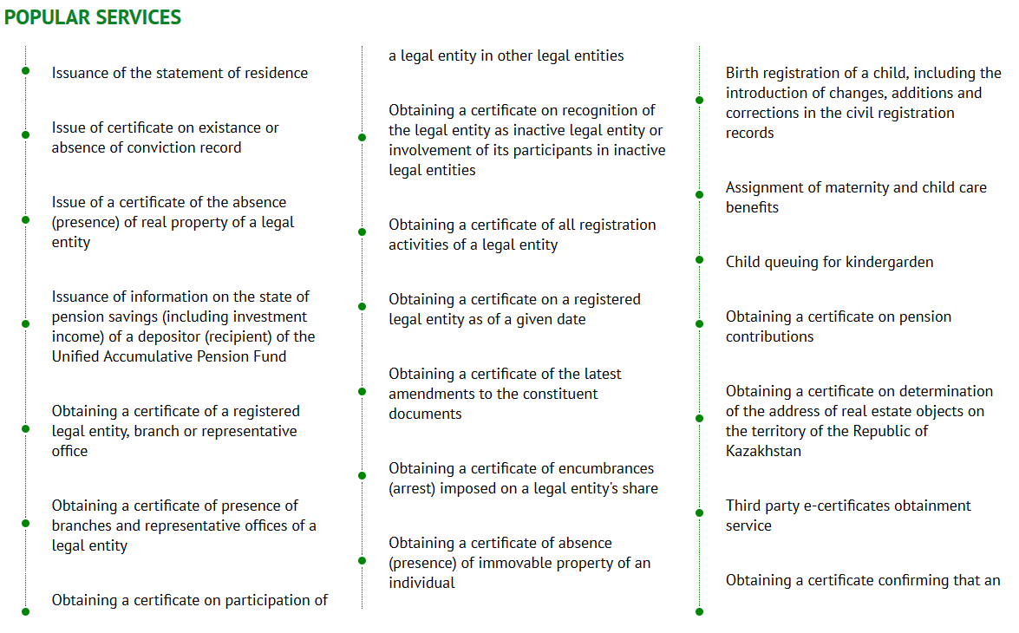

https://publicadministration.un.org/egovkb/en-us/Reports/UN-E-Government-Survey-2018

