Introduction to computer systems. Architecture of computer systems

Plan of Lecture
Review of computer systems. Evolution of computer systems. Architecture and components of computer systems. Use of computer systems. Data representation in computer systems.

- Definition of computer
- Earliest computer
- Computer History
- Computer Generations

Definition of computer
Computer is device or a flexible machine which aids humans in performing arithmetic and logical operation. Computer is a device to analyze, process data and converts it into information.
Evolution of computer systems

Principles characteristic of computer systems
Computer can store and retrieve large amounts of data.
Computer responds to a specific set of instructions
Computer can execute a pre-recorded list of instructions.
Earliest computer
THE ABACUS
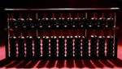
Abacus
Abacus is known to be the first mechanical calculating device. Which was used to be performed addition and subtraction easily and speedily? This device was a first developed by the Egyptians in the 10th centaury B.C, but it was given it final shape in the 12th centaury A.D. by the Chinese educationists. Abacus is made up of wooden frame in which rod where fitted across with rounds beads sliding on the rod. It id dividing into two parts called ‘Heaven’ and ‘Earth’. Heaven was the upper part and Earth was the lower one. Thus any no. can be represented by placing the beads at proper place.
NAPIER’S BONES
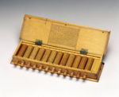
Napier
As the necessity demanded, scientist started inventing better calculating device. In thus process John Napier’s of Scotland invented a calculating device, in the year 1617 called the Napier Bones. In the device, Napier’s used the bone rods of the counting purpose where some no. is printed on these rods. These rods that one can do addition, subtraction, multiplication and division easily.
PASCAL’S CALCULATOR
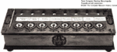
Pascal's calculator
In the year 1642, Blaise Pascal a French scientist invented an adding machine called Pascal’s calculator, which represents the position of digit with the help of gears in it.
LEIBNZ CALCULATOR
Leibnz Calculator
In the year 1671, a German mathematics, Gottfried Leibniz modified the Pascal calculator and he developed a machine which could perform various calculation based on multiplication and division as well.
ANALYTICAL ENGINE
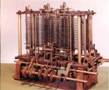
Analytical Engine
In the year 1833, a scientist form England knows to be Charles Babbage invented such a machine. Which could keep our data safely? This device was called Analytical engine and it deemed the first mechanical computer. It included such feature which is used in today’s computer language. For this great invention of the computer, Sir Charles Babbage is also known as the father of the computer.

Mechanical computation machines- Earlier 19th century
Babbage- The Analytical Machine
The anlaytical machine was designed but not built. The main parts of his machine were called the “store” and “mill”. Punched card store data, which is equivalent to the memory unit in computers. Mill weaves or processes the data to give a result, which is equivalent to the central processing unit in computers. He used conditional processing of data. Example: If block in Scratch.
ADA ovelace- The first programmer
ADA lovelace, a friend of Babbage wrote the first sequence of instructions for various tasks for the analytical engine. Used programming concept of looping for repetitive actions. Example: repeat block in Scratch. She used subroutines in her programs.
Hollerith desk
It consisted of a card reader which sensed the holes in the cards, a gear driven mechanism which could count and a large wall of dial indicators to display the results of the count. For example: a car speedometer is a dial indicator. This was used for U.S census 1890.
Analog computers- First general purpose computers- first half of 1900-1940
1936- Alan Turing regarded to be the father of modern Computer Science provided a formalisation for the concept of algorithm and computations.
1941- Konrad Zuse inventor of the program-controlled computer, built the first working computer. This computer was based on magnetic storage.
1942- Atanasoff-Berry computer which used vacuum tube, binary numbers, was non programmable.
1943- Colossus a secret British computer with limited programmability built using vaccum tubes, was built to break the German wartime codes. It was the first computer to read and decipher the codes using cryptography.
1944- Harvard Mark I an electromechanical computer built out of switches, relays, rotating shafts, and clutches had limited programmability. It used punched paper tape instead of the punched cards. It worked for almost 15 years. Grace Hopper was theprimary programmer. She invented the first high level language called Flow-Matic which later developed into COBOL. She also constructed the first compiler. She found the first computer “bug”: a dead moth that got into the Mark I and whose wings were blocking the reading of the holes in the paper tape. The word “bug” had been used to describe a defect since at least 1889 but Hopper is credited with coining the word “debugging” to describe the work to eliminate program faults.
Digital computers- 1940 to 1970
Computation machines- Second half of 19th century
First generation computers
These computers were named Eniac, Edvac, and Univac. These computers were made ofvaccum tubes way back in 1945-55. They were huge in size and very costly to maintain.
Second generation computers
These computers developed after 1955, had transistors in the place of vaccum tubes.Trasistors were more reliable, much cheaper and smaller. This generation had more computing power, were smaller in size, easier to maintain and were more affordable than the previous generation.
Third generation computers
These computers developed in the 1960’s, used integrated circuits. The trasistors were miniaturised and kept on silicon chips called the semiconductors which drastically increasedthe speed and efficiency of computers.
Computation machines- After 1970’s
Fourth generation computers
These were developed in the 1970’s and used microprocessors or chips. The microprocessors were smaller than a postage stamp and had tremendous computing capabilities.
Fifth generation computers
These were developed in 1980’s and used the concept of Artificial intelligence. The different types of fifth generation computers are Desktop, notebook or laptop, palmtop, server, Mainframe and Super Computer.
- Desktop computers are based on IC’s.
- Notebook or laptop computer is same as desktop but can be carried around.
- Palmtop is a miniature version of notebook with limited capabilities.
- Server is a powerful version of desktop capable of catering to various applications in
a network environment.
- Mainframe is a powerful version of server and is capable of handling huge applications
and data processing.
- Super computer has multiprocessors to perform typical scientific applications that need trillions of information per second while processing.
Late 20th century - Networking, Smart phones and FOSS
Networking
On the evening of October 29, 1969 the first data travelled between two nodes of the ARPANET, a key ancestor of the Internet. The men who symbolically turned the key on the connected world we know today were two young programmers, Charley Kline at UCLA and Bill Duvall at SRI in Northern California, using special equipment made by BBN in Cambridge, Massachusetts.
Internet
In 1977 Cerf and Kahn successfully linked three networks in a dramatic round-the-world transmission from a cruising van. The Internet was born.
Inventing the Web2 major milestones
1.At the world’s biggest physics laboratory, CERN in Switzerland, English programmer and physicist Tim Berners-Lee created “WorldWideWeb” on an advanced NeXT computer in 1990. It featured a server, HTML, URLs, and the first browser. This browser also functioned as an editor, like a word processor connected to the Internet – which reflected his original vision that the Web also incorporate authoring and personal organization tools.
2.The world’s first popular browser one of the first graphical web browsers Andreesen’s Mosaic (later Netscape)– led to an explosion in web use in 1993, made the World Wide Web system easy to use and more accessible to the average person and sparked the internet boom of the 1990s.
Web browsers 1994 – Netscape navigator
1995 Microsoft released it’s Internet Explorer
1996 Opera focused on mobile phone web browsers and was preinstalled on over 40 million phones. It is also available on embedded systems and Nintendo’s In WII games console.
1998 Netscape launched Mozilla foundation to provide a competitive open source web browser which has led to the current firefox.
2003 Apple’s safari was released
2009 Google’s Chrome
Search engines Early search engines: 1990 Archie, 1991 Veronica and Jughead 1992 Vlib (Berners and Lee), 1993 Excite (Stanford undergrads), Aliweb (Martijn Korster).
Some of the popular search engines: 1994 Altavista, Yahoo, webcrawler; 1996 Google, Hotbot, Ask jeeves; 1998 MSN.
Many more came in later. Some of the latest additions are as follows: 2009-2010 Cuil (Managed by previous google employees), Bing (Msn’s live search).
Video conferencing
1990 Ericsson company initiated video conferencing services which was adopted initially by business firms all over the world.
CHAT
1988 Internet Relay Chat was introduced and it did not take long to become popular. Soon, other varieties of chat like voice and video chat evolved.
Smart phones
1992: The first smartphone IBM Simon was designed in 1992 and released in 1993. It also contained a calendar, address book, world clock, calculator, note pad, e-mail client, the ability to send and receive faxes and games. It had no physical buttons, instead customer sused a touchscreen to select telephone numbers with a finger or create facsimiles and memos with an optional stylus. Text was entered with a unique on-screen “predictive” (as one types the words are predicted and select the word) keyboard.

Architecture and components of computer systems

Computer Model
- Input: keyboard, mouse, scanner, punch cards
- Processing: CPU executes the computer program
- Output: monitor, printer, fax machine
- Storage: hard drive, optical media, diskettes, magnetic tape

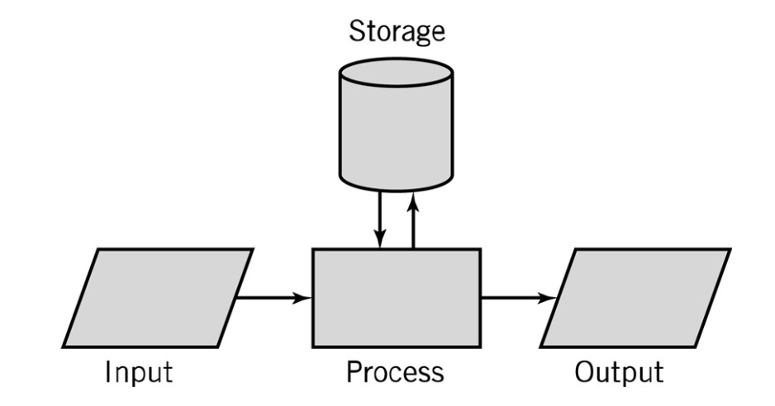

Computer Components
- CPU
- Mother Board
- Memory
- Hard Disk
- Display
- Keyboard
- Mouse
- Power Supply
- Network Interface

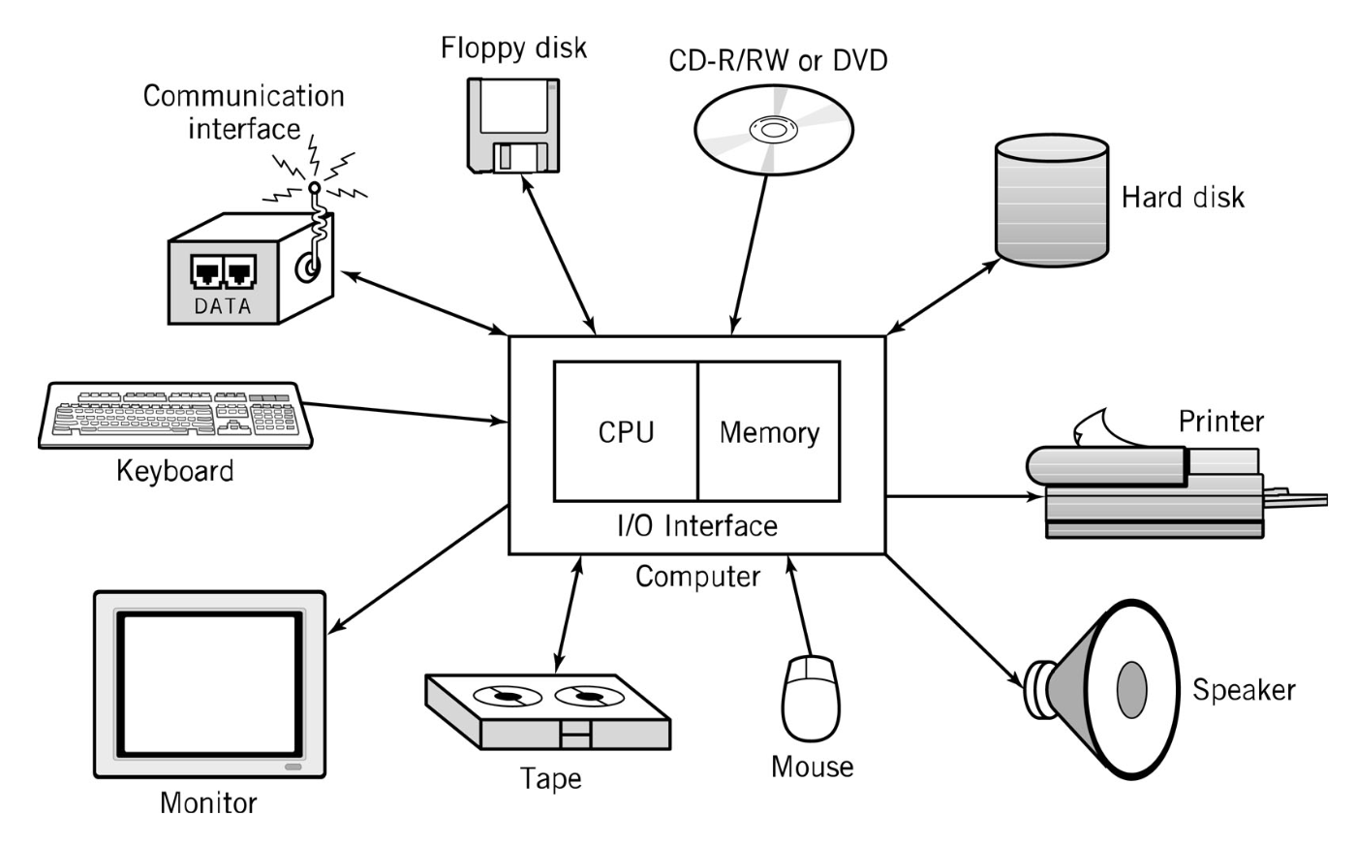

CPU
CPU – Central Processing Unit (Microprocessor)
consists of three parts:

- Control Unit
- Execute programs/instructions: the machine language
- Move data from one memory location to another
- Communicate between other parts of a PC
- Arithmetic Logic Unit
- Arithmetic operations: add, subtract, multiply, divide
- Logic operations: and, or, xor
- Floating point operations: real number manipulation
- Registers

- CPU speed is influenced by several factors:
- Clock speed: Megahertz, Gigahertz
- Word size : 32-bit or 64-bit word sizes
- Cache: Level 1, Level 2 caches
- Instruction set size
- Single Core/Multi Core

Processor Architecture

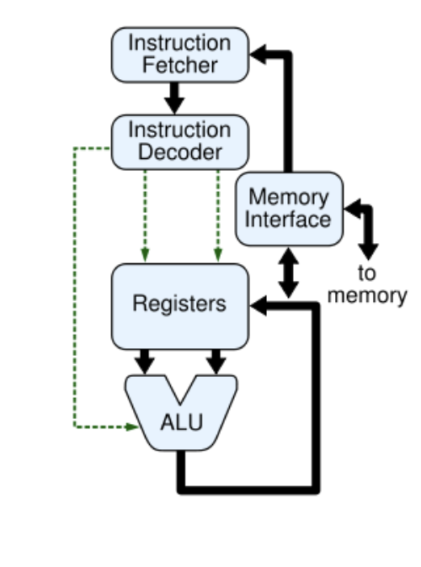

The processor is the central device computer, consisting of two parts:
ALU - arithmetic-logical the device in which the process occurs processing information encoded zeros and ones. CU– device management, which coordinates the work all parts of the computer.

RAM — Random Access Memory. RAM - “fast” memory relatively small in size which stores information for the task, currently being processed. With turning off the computer the RAM is erased.

ROM - read-only memory. RAM contains unchangeable information that is recorded yet in the manufacture of the computer. In particular, contains boot commands computer.

ESD – external storage device. ESD stores information for long use, usually on disks, flash drives. This is the largest in volume. part of computer memory.

