Internet Technologies

Basic concepts Internet. The universal identifier of resources (URI), its assignment and components. Service DNS. Web technologies: HTTP, DHTML, CSS, and JavaScript. E-mail. Message format. SMTP, POP3, IMAP protocols.

- Основные понятия интернет.
- Логические составляющие Интернет технологии.
- Веб технологии. CMS: Content Management System (система управления содержимым)
- Социальные сети.

Internet technologies are all kinds of technologies and services that allow you to carry out all activities on the Internet computer network.
Internet technology is all that the Internet works with. First of all, these are all kinds of sites, forums, blogs ... Also Internet technologies include software and all kinds of mechanisms for working with the World Wide Web.
Internet technologies are based on hypertexts (texts with hyperlinks to other hypertexts) and sites hosted on the global Internet or on local computer networks.
As soon as the first computers appeared, the first Internet technologies appeared. They were designed for computers to communicate with each other. The turning point in the development of these technologies was the creation of the Internet and the first browser in the early 90s
The Internet is a global network of networks connecting millions of users worldwide via many computer networks using a simple standard common addressing system and basic communications protocol called TCP/IP (Transmission Control Protocol/Internet Protocol). This allows messages sent over the Internet to be broken into small pieces, called packets, which travel over many different routes between source and destination computers.

Internet technologies are a complex system of interaction between two components: physical and logical.

The physical component of Internet technologies includes:
1) Internet
- TCP / IP protocols.
- Hierarchy of Internet domain names.
- The backbone of the Internet. Routing
2) Internet software
- Network operating systems.
- Special software for connecting to the Internet.
- Application protocols.
3) Computers (servers and clients) on the Internet
- Email servers
- Web servers.
- FTP servers.
- Teleconferencing servers.
- Instant messaging servers.
4) Digital communication lines
- The choice of provider. Internet connection
5) Internet access
- Connection of a network card with a local network.
- Ethernet cable systems.
6) Remote access to global networks.
- Access "computer - network."
- Network-to-network access.
The logical component of Internet technologies includes:
1) Internet services
- WWW - World Wide Web
- Email. Teleconferencing systems.
- Data transfer.
- On-line chat.
- Fast messaging.
- Audio and video conferencing.
- Voice communication.
2) Work on the Internet
- Browsers.
- Search engines. Internet navigation.
- View pages in a browser.
3) Information resources on the Internet
- Web pages, online stores, online portals. Web space.
- URL and data transfer protocols, addressing.
- Website development. Web programming languages.
- Entries on the Internet. Representation.

World Wide Web (WWW) is a distributed system that provides access to related documents located on different computers connected to the Internet
Web browser is a program that allow you to view a Web page
Hyperlink is a some of the file element of the web page usually allocated by color or by underlining, which is the starting point to navigate to the another web pages.
Web-page. A computer file created using a special hypertext markup language HTML
Web-site. A collection of web pages, which are united by some principle

URI stands for Uniform Resource Identifier. URI is a text which is used to identify any resource or name on Internet. URI has two specializations in the form of URL (Uniform Resource Locator) and URN (Uniform Resource Name) to identify resource and name.
Unique address for a web page.
URL (Uniform Resource Locator) is a unique identifier used to locate a resource on the internet. It is also referred to as a web address. URLs consist of multiple parts -- including a protocol and domain name -- that tell a web browser how and where to retrieve a resource.
It's not necessary that URL always include HTTP as protocol, it can use any protocol e.g. ftp://, https:// or ldap://
For example https://www.google.kz/
URN stands for Uniform Resource Name. URN is also the subset of URI. One of the best examples of URN is ISBN number which is used to uniquely identify a book. URN is completely different than URL as it doesn't include any protocol.
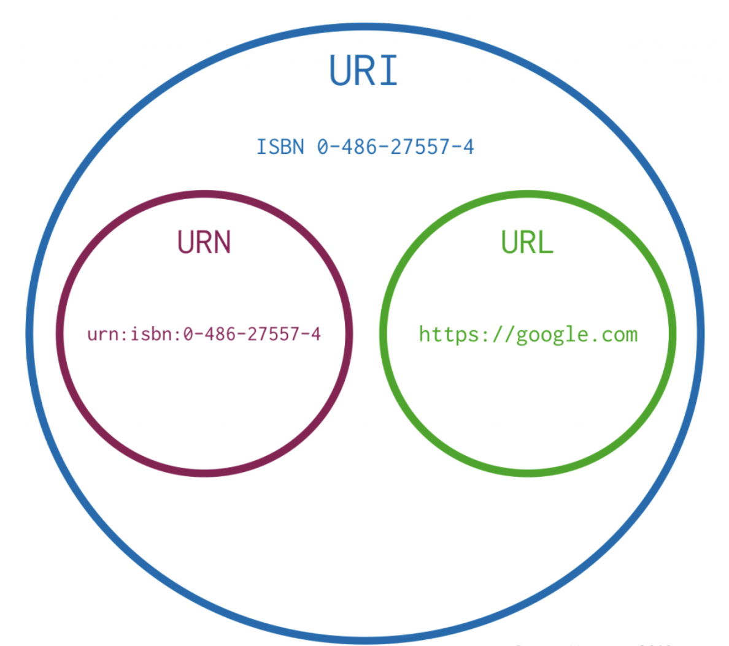

Web- technologies
HTML:
HTML (Hyper Text Mark-up Language) is the glue that holds together every web site. Like building a house, you always build a strong foundation first. For any site, HTML is that foundation. HTML is an open source language (i.e. not owned by anyone), which is easy to learn, and requires no fancy packages to start using it. All you need is something to type with, such as Windows Notepad, and a lot of time and patience.
HTML works on a 'tag' system, where each tag effects the content placed within that tag, e.g.
<TAG>What the tag effects</TAG>.
DHTML
DHTML (Dynamic HTML) is just as the name suggests, it adds dynamic, moving or changing content to your plain old HTML pages. It is as a more advanced version of HTML, although DTHML is in fact not a programming language in itself. DHTML is a broad term used to describe a group of applications, the main ones are described below:
JavaScript: JavaScript is a 'scripting' language. A bit like a script in a feature film, it is used to decide 'what happens next'. This may be a sequence of screen events, where one event is initiated by the end of another, or it could be a programmed response to a user interacting with the page in some way, e.g. moving their mouse over a link. JavaScript is a complex and powerful language, and may be placed directly inside a HTML page, or in a separate JavaScript file.
CSS: CSS (Cascading Style Sheets) is a relatively new language, designed to expand upon the limited style properties of HTML. Easy to learn and implement, CSS is an excellent way to control the style of site, such as text styles like size, colour and font.
DOM (DOCUMENT OBJECT MODEL) a software interface that allows programs and scripts to access the contents of the HTML document and change the content, structure and execution of such documents
Web-server is a program that uses HTTP (Hypertext Transfer Protocol) to serve the files that form Web pages to users, in response to their requests, which are forwarded by their computers' HTTP clients. Dedicated computers and appliances may be referred to as Web servers as well.
The client/server protocol used to exchange hypertext documents is called HTTP (HyperText Transport Protocol). The main thing you need to know is that HTTP is a language spoken between your web browser (client software) and a web server (server software) so that they can communicate with each other and exchange files.
HTTP is a "request-response" type protocol that specifies that a client will open a connection to a server then send a request using a very specific format. The server will then respond and close the connection.

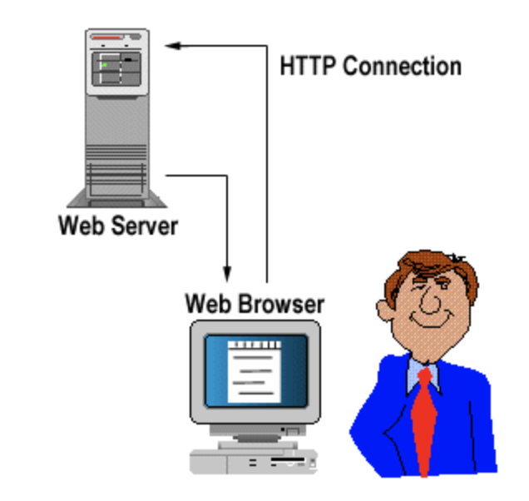
Fiber optic connection.
DNS Server (DOMAIN NAME SYSTEM)
A DNS server is a computer server that contains a database of public IP addresses and their associated hostnames, and in most cases serves to resolve, or translate, those names to IP addresses as requested. DNS servers run special software and communicate with each other using special protocols.
It's easier to remember a domain or hostname like technolgy.kz than it is to remember the site's IP address numbers 123.123.123.123.
When you want to navigate to the “google” website, all you have to type in is the URL https://www.technolgy.kz. Conversely, computers and network devices don't work well with names when trying to locate each other on the internet. It's far more efficient and precise to use an IP address.
The DNS server sits in the space between humans and computers to help facilitate their communication.
Simple Mail Transfer Protocol (SMTP) is used to communicate with a remote server and then send messages from a local client to a remote server, and ultimately to a recipient server. It is worth mentioning that SMTP is used exclusively for sending messages.
POP3 (post office protocol version 3) is often used to communicate with a remote email server and download messages to a local email client and then delete it on the server, for example, Outlook, Thunderbird, Windows Mail, Mac Mail, etc. However, mail clients usually offer the choice of whether to leave copies of messages on the server or not. If you use multiple devices to send messages, it is recommended to leave this feature enabled, otherwise, on another device you will not have access to sent messages that were not stored on a remote server. It is also worth noting that POP3 is a protocol that works only in one direction, which means that the data is taken from a remote server and sent to a local client.
IMAP (application level protocol for access to e-mail), as well as POP3, is used to receive e-mail messages to a local client, however, it has a significant difference - only e-mail headers are downloaded, the message text itself remains on the server. This communication protocol works in two directions, if changes occur on the local client, they are transmitted to the server. Recently, IMAP has become more popular, as e-mail service providers like Gmail have begun to recommend using it instead of POP3.

Content Management System
(Content Management System (content)) - a computer program or information system that is used to organize and support the process of joint creation, management and editing of site content.
The main objective of such a system is the collection and integration into a single whole, based on roles and tasks, various sources of information. These sources may be available both within the organization itself and outside its boundaries. In addition, this system provides the opportunity for interaction between various employees, projects and working groups, with those knowledge and data bases that were previously created

CMS allows you to:

Fill the site with content, modify and administer the resource, while not being an IT specialist and without serious programming skills;
create new pages in a short time without extra costs;
optimize the appearance of the site and improve the quality of its content

There are several popular systems on the market:

Drupal - free, but fully functional and quite difficult CMS, which includes everything you need to create a site;
1C Bitrix is ​​ paid system that is too difficult for simple tasks, but copes well with complex ones;
Joomla is easy-to-use free engine that is used by beginner site builders and companies that do not require a big computing resources;
MODx - convenient for developers free CMS, with a high degree of security and sufficient flexibility to solve most problems;
WordPress is a world-famous engine that was originally intended to create blogs, but at the moment it has much wider functionality;

