Discipline: Information and communication technologies
Module assignment 4
Tasks
- Develop your own model for organizing classes in a computer-based learning environment.
- ﻿Develop a lesson structure using computer communications.
- To propose a system of measures to solve ethical problems of communication using computer means of communication.
- Develop a project topic to be carried out by a distributed group (groups of 3 people).
- Conduct research on the issue “The influence of computer games on personality development” in the Internet forum mode.

Perform tasks on converting y from one number system to another
Task 1 . Convert the number 125 from the decimal number system to the binary number system. How many units does the resulting number contain? In your answer, indicate one number - the number of units.
Task 2. Convert the number 121 from the decimal number system to the binary number system. How many units does the resulting number contain? In your answer, indicate one number - the number of units.
Task 3 . Convert the number 134 from the decimal number system to the binary number system. How many units does the resulting number contain? In your answer, indicate one number - the number of units.
Task 4 . Convert the number 143 from the decimal number system to the binary number system. How many units does the resulting number contain? In your answer, indicate one number - the number of units.
Task 5 . Convert the number 141 from the decimal number system to the binary number system. How many units does the resulting number contain? In your answer, indicate one number - the number of units.
Task 6 . Convert the number 126 from the decimal number system to the binary number system. How many units does the resulting number contain? In your answer, indicate one number - the number of units.
Practical work
Goal: Editing the “Accruals” form
Tasks: Editing the “Accruals” form
Guidelines:

Open the Accruals form in design mode.
1) Removing fields from a form
- In the form, click on the DataP element in the place with the inscription attached to it and press the Delete key .
2) Changing the title
- Remove the name of the Accruals form
- Click on the Caption button on the toolbar.
- Move the mouse pointer to the title area and drag the rectangle to the desired size while holding down the left mouse button.
- Type the title text on your keyboard: Salary
- When you finish typing, click outside the frame.
3) Adding fields to the form
- In the form, move all the elements below. To do this, select all the elements (the elements represent a table, so selection is applicable for tables) and drag them below using the mouse.
- Let's add two new fields to the space vacated at the top.
- Field button on the ribbon.
- Move the mouse pointer to an empty space in the data area and drag the rectangle while holding down the left mouse button. You will have two rectangles, one for the inscription, the other for displaying the current date. If these rectangles overlap each other, you need to move them apart for ease of work (use the mouse to grab the square in the upper left corner and move the rectangle).
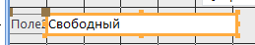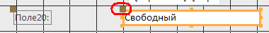
- Click inside the rectangle containing the text 'Free' and type function = Date () (enter empty parentheses after the function name).
- When you finish typing, click outside the frame.
- Select by clicking the element in the form of a rectangle with the field number to display the inscription for the current date (initially with the caption “Field No.” - with a number).
- Right-click to open the context menu and select the Properties command.
- In the resulting properties window, on the “All” tab, find the Signature parameter, replace the existing field signature with Date.
- Close the properties window
- Create the Salary field in the same way.
- signature Field No. – Salary
- replace the text "Free" with the formula: =[TarRate] * [RegHour]
In the properties on the “All” tab, in the “Field format” line, call up the drop-down list of formats and select the Currency format in it ; in the “Number of decimal places” line , call up the list and select the number 2 from it.
- Close the properties window.
- Make the fields equal, align them on the grid.
4) Changing the design style of the created form.
- To do this, click on the Design Tools ribbon, form Designer, click the select all button
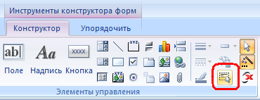.
Go to the Arrange ribbon, expand the AutoFormat list, and select the Median style.
- Save the form .

Open the Employees-Results form and enter data into it, fill out the benefits field yourself.

Code | Surname | Floor | DateP | TabNumber | Discharge | Shop | PlanMonth | FactMonth | OtrChas
1 | Tarasov | m | 10.01.55 | 1418 | 6 | 1 | 123.00 | 124.00 | 140
2 | Toropov | m | 07/14/60 | 1162 | 5 | 2 | 172.80 | 172.80 | 150
3 | Smirnov | m | 11/19/59 | 1942 | 4 | 1 | 145.56 | 144.89 | 147
4 | Avdeev | m | 12/22/61 | 1111 | 4 | 1 | 123.76 | 144.00 | 170
5 | Soboleva | and | 1.05.60 | 1516 | 3 | 2 | 146.89 | 145.98 | 150
6 | Bunina | and | 11/18/48 | 1212 | 7 | 2 | 234.67 | 235.75 | 140
7 | Tereshchenko | m | 02/20/58 | 1411 | 7 | 3 | 234.00 | 231.00 | 142
8 | Golovko | and | 7.07.57 | 1230 | 6 | 3 | 236.90 | 236.90 | 154
9 | Voronov | m | 30.8.63 | 1537 | 5 | 3 | 123.6 | 124.00 | 140

Open the Accruals form.
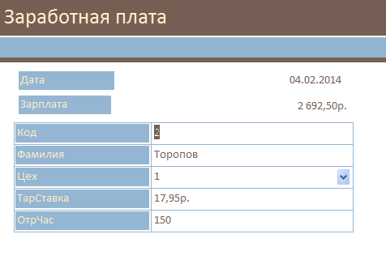
Tasks:
Calculate the salaries of all employees for 2 years
Tasks for independent work:
It is necessary to edit the Accruals form:
- Removing fields from a form
- Changing Headers
- Adding fields to a form
- Changing the design style of the created form

Security questions :
- Why do you need a Substitution Wizard?
- What are the requests for?
- What types of requests do you know?
- How can you create queries?
- What is a query with a parameter used for?
- How can you do calculations in queries?
- Is it possible to create queries based on multiple tables?
- What are the reports for?
- What methods of creating reports do you know?
- How can you calculate totals in reports?

Test tasks:
Question: What is the result of a query?
SELECTClint Code, Order Code
FROM Orders
WHERE City = ”Vladikavkaz”
AND Cost >= 1000
A. A table in which two columns of the original table Orders and those rows in which the City field has the value Vladikavkaz are selected .
B. A table with 2 columnsClint Code and Order Code , which reflects orders worth at least 1000 placed by clients from Moscow.
C. A table in which there are only those rows in which the City field has the value Vladikavkaz .
You need to justify and prove your answer.

