Laboratory work 2. Computer components

Part 1. Laptop Computer Selection
You are a new graduate student. The department requires you to have a computer with the following requirements:
- 8 GB of RAM
- 250 GB hard drive
- DVD-ROM or DVD-RW drive
- Wireless connection
- Ethernet network card
- Windows Professional version
Your university has Wireless connection, and Ethernet jacks. However, some classes are three hours long, and your AC adapter may not be long enough to reach an outlet. You also would be carrying this computer around from class to class.
The most you can spend is 500 000 tenge.
1. Indicate the range of values you desire for each of the following criteria:
a. Weight
b. Screen size
c. Number of USB ports
d. Number of Firewire ports
e. Need CD-RW?
f. Need DVD-ROM?
g. Need DVD-RW?
h. Manufacturer preferences?
2. Search the Internet for two suitable computers/laptops meeting the above requirements and your budget constraint. Submit screenshots of the Web pages detailing the computer configuration and price.
3. Record your search results in a MS Excel spreadsheet. Fill column A with the following category labels:
1. Manufacturer
2. Processor
3. Memory (maximum upgrade capacity)
4. Screen size
5. Weight
6. Graphics card
7. USB
8. Firewire
9. CD-ROM
10. DVD-ROM
11. Communications (e.g. wireless, Ethernet)
12. Battery life
13. Price
14. Available Rebate
Save and submit your Excel file.
4. Make your final purchase decision and justify your decision.
Part 2. Computer Components
Define all Components inside the System Unit, and write the definition (min.2 sentences). 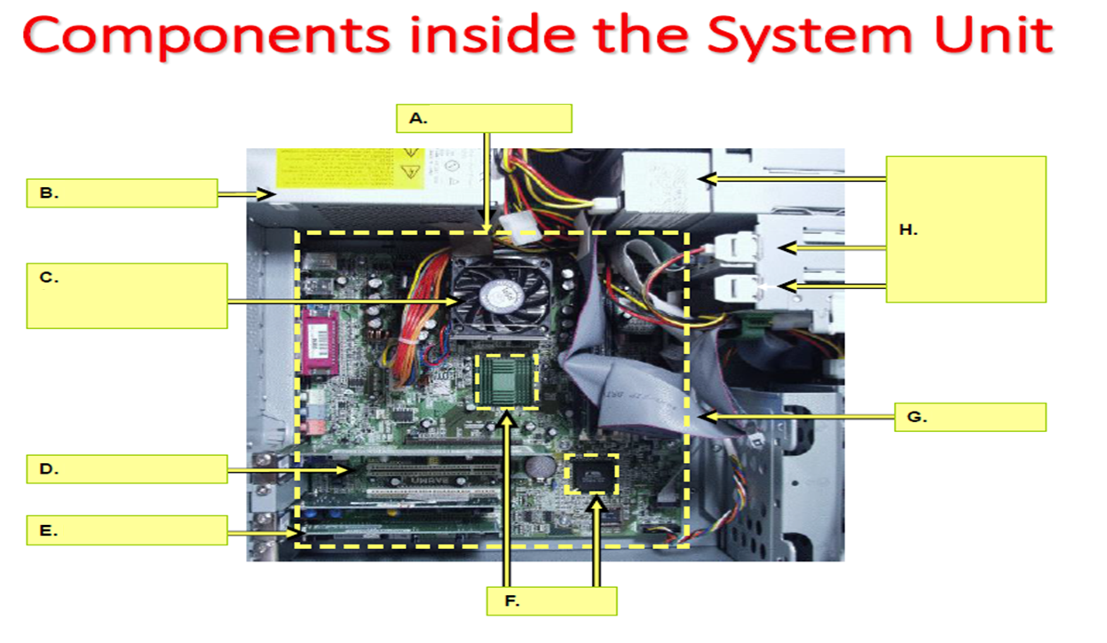
A. -
B. -
C. – Cooling fan. It’s decrease the temperature of components of system unit.
D. -
E. -
F. -
G. -
H. -

Part 3. Define all devices, and give definitions (min.2 sentences)
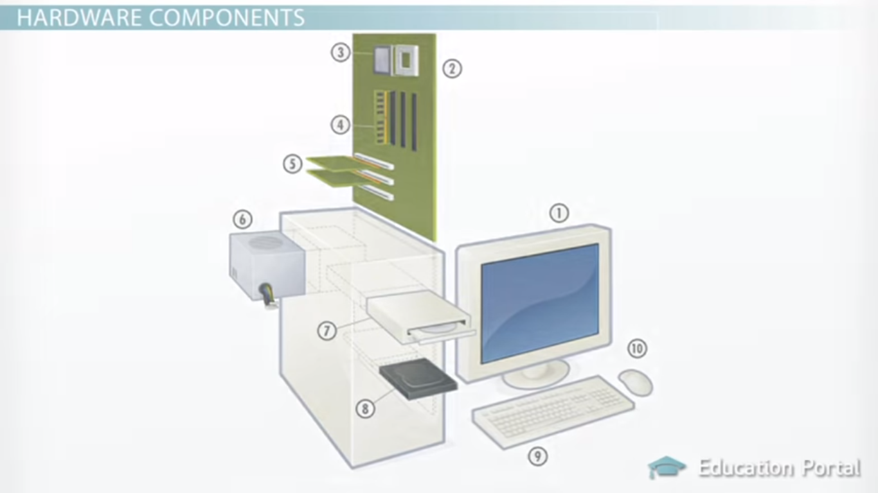

- – Monitor. It is output the information.
- –
- –
- –
- –
- –
- –
- –
- –
- –

Part 4. Give a definition.
Hardware system –
Software system -
Motherboard -
Power supply -
BIOS ROM Chip -
Cooling fan -
Expansion slot -
RAM chip -
Expansion card -
Disk drives -
Chipset -
IDE cable -
Ethernet cable -
PCI bus -

