Laboratory work № 4
Visual and empirical assessment of user interface usability

Purpose: The purpose of this exercise is to familiarize students with the usability term, its meaning and with common usability law: students will work to analyze websites and discuss how websites make them feel and will try to articulate common law for usability.

Activities:
Student should perform each of the following activities:
- Run any browser on PC type the URL depending on your variant. Go to homepage. Make sure you have pen and paper to put notes.
- Write down which element on webpage you focused the first 7-10 seconds, which element you focused the next and the third. For example, 1 – a website title, 2 – login section, 3 – photo etc.
- Try to distinguish adjectives which would perfectly reveal your feelings about this website. For example, interesting phrases, boring colors scheme and etc., and write them down.
- Depending on website purpose write down all your questions about it, like, “How can I get in touch (contact) with them?”
- Go back to homepage – try to answer on your previous questions, timed it. For example, I was able to find contact information in 15 sec.
- What websites or website features make you think too much?
- Split in groups in two. Analyze with your classmate all notes you have made. Create 3 rules for webpage usability.

Variants (recommendation is to focus on charity and education web-portals):
- www.charitynavigator.org,
- www.shelterbox.org,
- animalcharityevaluators.org
- https://www.coursera.org/
- https://yandexdataschool.ru/
- http://www.charityengine.com/
- https://www.kaggle.com/
- https://www.edx.org/
- https://www.udacity.com/

An example of implementation:
- URL: https://www.coursera.org/

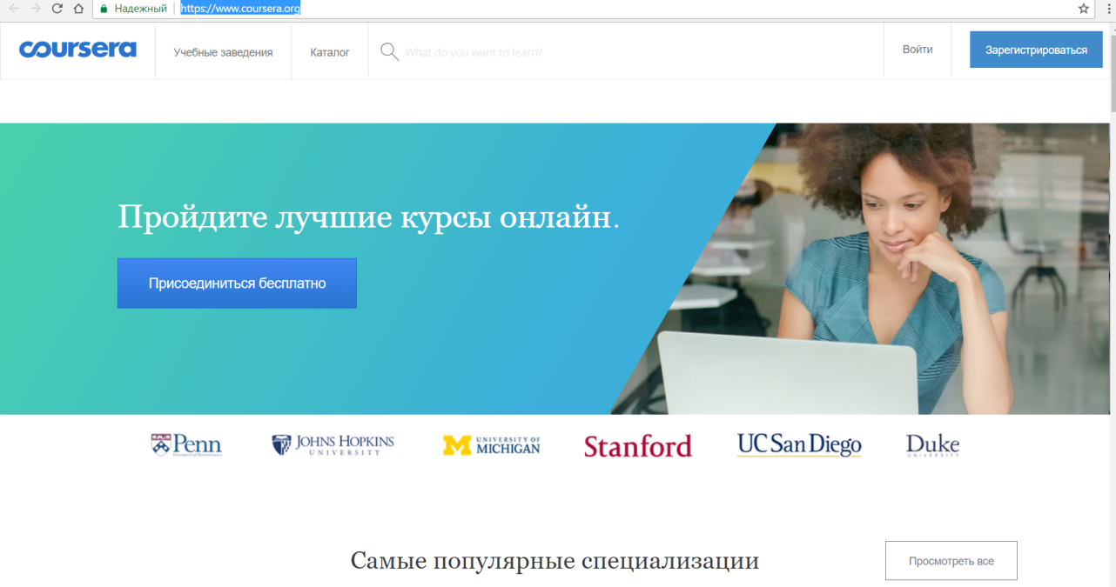

- The first element I was focused for over 5 seconds is the button Присоединиться бесплатно, the second one is the Photo of a girl on the right side, then the button Зарегистрироваться and the last is the Logo – Coursera.
- I like the color pallet, it is calm and modern. All design looks trustworthy especially placing those universities’ logos. I find this web page very interesting and it makes me willing to join some course.
- I was wondering if certificates are free or not for courses. And also I did not understand does online education’s certificate has the same value as traditional diploma.
- I found Catalog of courses in 5 sec, and Universities list in 7 sec. It took me 15 sec to reach the footer and see all the list of all sections.
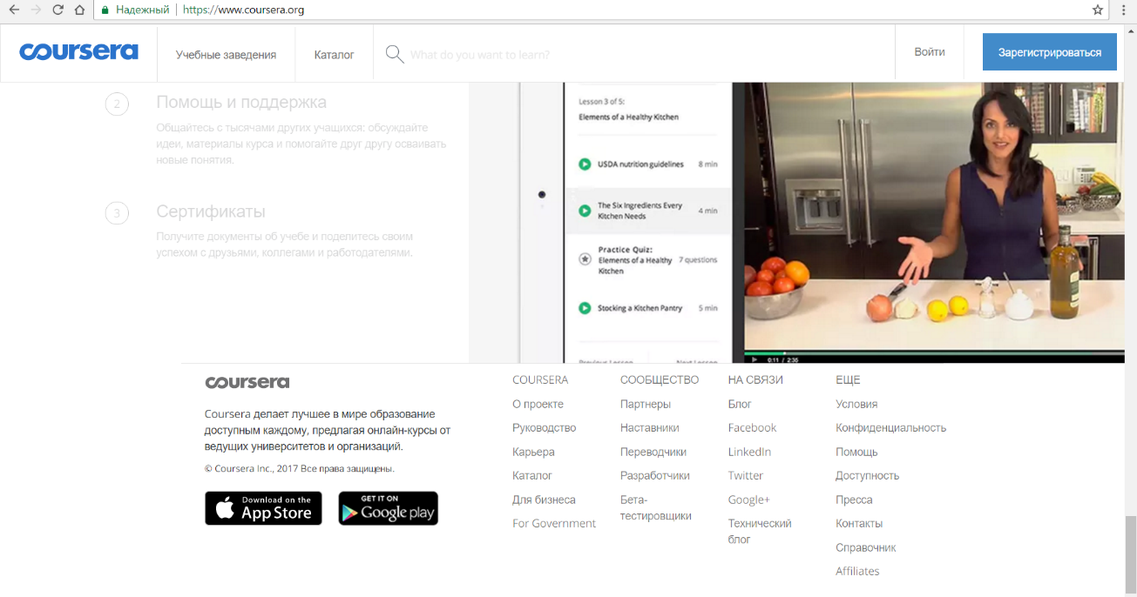
- It was not clear for me why description of education represented as this According to the photo I thought this is about some conversation. Cooking and education resource are not associate for me.
- 1. Display only necessary information on web page.
2. Avoid using to many colors or colors with too high contrast.
3. Make navigation bar as simple as possible, no need to overflow it by showing all existing sections. Use footer menu for additional web page sections.

