Laboratory work № 10

Network Tools

In this laboratory work, you will make use of common network tools. For each part below, capture the appropriate program output and include it with your answers to the questions.

Part 1: Ping
Ping is a computer network administration utility used to test the reachability of a host on an Internet Protocol (IP) network and to measure the round-trip time for messages sent from the originating host to a destination computer.

The ping command is a command used to test the ability of the source computer to reach a specified destination computer. The ping command is usually used as a simple way verify that a computer can communicate over the network with another computer or network device.

If you are having connectivity problems, you can use the ping command to check the destination IP address you want to reach and record the results. The ping command displays whether the destination responded and how long it took to receive a reply. If there is an error in the delivery to the destination, the ping command displays an error message.

You can use the ping command to:
- Ping your computer (by address, not host name) to determine that TCP/IP is functioning.
- Ping the local router to determine whether the router is running.
- Ping beyond your local router.

Ping Command Syntax:

ping [-t] [-a] [-n count] [-l size] [-f] [-i TTL] [-v TOS] [-r count] [-s count] [-w timeout] [-R] [-S srcaddr] [-4] [-6] target [/?]

-t = Using this option will ping the target until you force it to stop using Ctrl-C.

-a = This ping command option will resolve, if possible, the hostname of an IP address target.

-n count = This option sets the number of ICMP Echo Request messages to send. If you execute the ping command without this option, four requests will be sent.

-l size = Use this option to set the size, in bytes, of the echo request packet from 32 to 65,527. The ping command will send a 32 byte echo request if you don't use the -l option.

-f = Use this ping command option to prevent ICMP Echo Requests from being fragmented by routers between you and the target. The -f option is most often used to troubleshoot Path Maximum Transmission Unit (PMTU) issues.

-i TTL = This option sets the Time to Live (TTL) value, the maximum of which is 255.

-v TOS = This option allows you to set a Type of Service (TOS) value. Beginning in Windows 7, this option no longer functions but still exists for compatibility reasons.

-r count = Use this ping command option to specify the number of hops between the your computer and the target computer or device that you'd like to be recorded and displayed. The maximum value for count is 9 so use the tracert command instead if you're interested in viewing all hops between two devices.

-s count = Use this option to report the time, in Internet Timestamp format, that each echo request is received and echo reply is sent. The maximum value for count is 4 meaning that only the first four hops can be time stamped.

Example of Ping

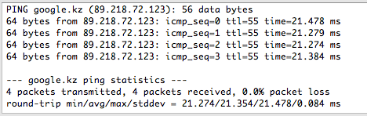

Part 2: ipconfig
IPCONFIG (Internet Protocol CONFIGuration) is a command line utility that is used to display and the IP address assigned to the machine. In Windows, typing ipconfig without any parameters displays the computer's currently assigned IP, subnet mask and default gateway addresses.

This tool is often used for troubleshooting network connectivity issues. With ipconfig, you can identify the types of network adapaters on your computer, the computer's IP address, the IP addresses of the DNS (Domain Name System) servers being used, and much more.

Ipconfig Parameters
Parameter | Description
/all | Display the full TCP/IP configuration information for all network adapters.
/release | Release the IPv4 address for the specified adapter.
/release6 | Release the IPv6 address for the specified adapter.
/renew | Renew the IPv4 address for the specified adapter.
/renew6 | Renew the IPv6 address for the specified adapter.
/flushdns | Purges the DNS Resolver cache.
/registerdns | Refreshes all DHCP leases and re-registers DNS names.
/displaydns | Display the contents of the DNS Resolver Cache.
/showclassid | Displays all the DHCP class IDs allowed for adapter.
/setclassid | Modifies the DHCP class ID.
/showclassid6 | Displays all the IPv6 DHCP class IDs allowed for adapter.
/setclassid6 | Modifies the IPv6 DHCP class ID.
/? | Displays help information.

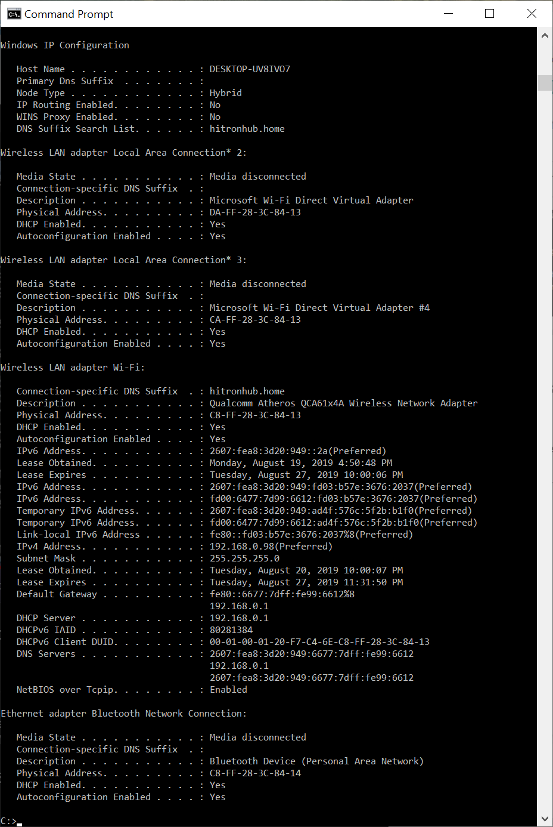

Part 3: netstat

Netstat is a tool which allows administrators to achieve the following:
- Display active TCP connections
- Display TCP and UDP ports on which a computer is listening
- Display Ethernet statistics
- Display IPv4 and IPv6 statistics
- Display IP routing table

This is an useful tool so it is frequently used to inspect connections, opened ports and check statistics.

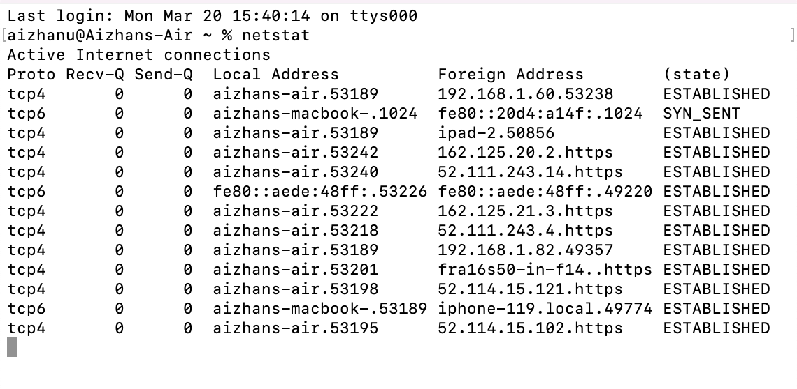

Part 4: tracert

Run the tracert program on Windows to trace the route to some random destination (such as some popular Web site). The tracert program also measures the roundtrip times to each of the routers along the path. Attempt to verify these roundtrip times using the ping utility. Finally, which hop on the path is the longest?
Things to do:
1. With the command traceroute (tracert in the command window Windows) explore the routes up to 3 servers or end devices located in different parts of the world (1 of them in Kazakhstan and 2 other countries).
2. Find out and record the location of the intermediate nodes. To do this you need to use database of IP-addresses, for example:
http://ipgeo-base.ru,
http://www.db.ripe.net/whois,
http://www.hostip.info
http://www.ip2location.com,
http://www.whois-service.ru/lookup/
3. Scroll to the tracing plots, in which the signal is transmitted over a distance of more than 300 km. Specify between which cities / countries is this site and evaluate its approximate length.
4. For each router (intermediary device), enter the name of the main network provider to whom it belongs.
5. Build flowchart of routes using a map.
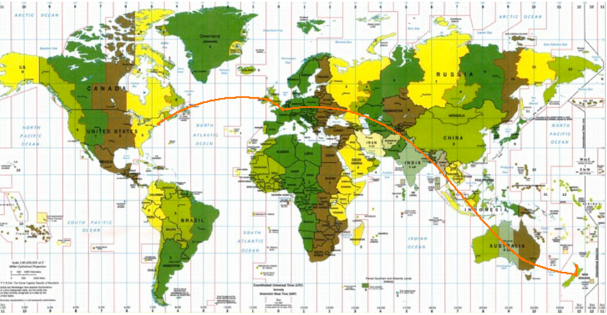
Note: don’t use a Traceroute from the Internet browser. Use only your PC.

