**Practical 4 - Calculation of material flows of the leaching process**

**1 академический час**

Calculation of material flows of the leaching process

Calculation of material flows of the leaching process

**Solute +solvent = solution**

**Leaching:** is the separation of a solute from solid mixture by dissolving it in a liquid phase.

**Leaching occurs in two steps:**

1. Contacting solvent and solid to effect a transfer of a solute (leaching).

2. The separation of the solution from the remaining solid (washing).

**Factors influencing the rate of extraction:**

There are four important factors to be considered:

1. Particle size.

2. Solvent.

3. Temperature.

4. Agitation of the fluid.



**Batch Leaching**

Mass transfer rates within the porous residue are difficult to assess because it is impossible to define the shape of the channels through which transfer must take place. It is possible, however, to obtain an approximate indication of the rate of transfer from the particles to the bulk of the liquid. Using the concept of a thin film as providing the resistance to transfer, the equation for mass transfer may be written as:

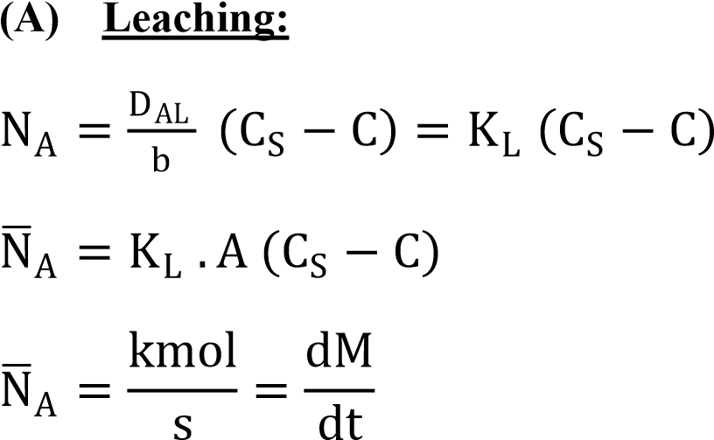

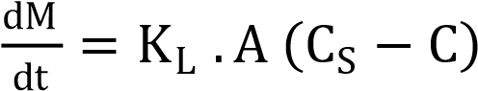



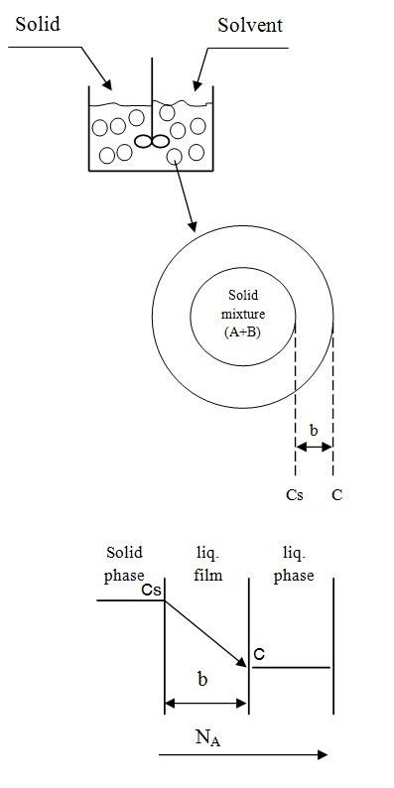d (Constant volume)

ln

C

S

−

C

C

S

=

−

K

L

.

A

V

t

C

S

−

C

C

S

=

e

−

K

L

.

A

V

t

C

=

C

S

1

−

e

−

K

L

.

A

V

t

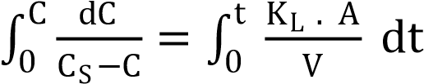

**(B) Number of Washing:**

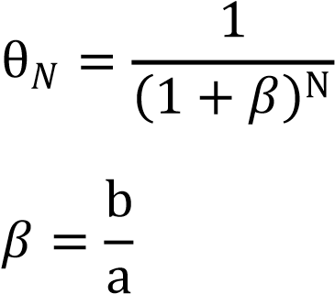

Where:

*:* is the fraction of solute remain with the residue from the original.

: Solvent decanted per solvent remaining in the insoluble solid.

a : is the solvent remaining.

b : is the solvent decanted.

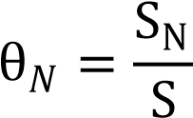 **equals/ divided by/**

SN : is the weight of solute remaining in the solid after washing.

S : is the original weight of the solute which was in the solid before washing.

**Example (1):**

500 kg of the inert solid containing 28 percent by mass of the water-soluble component (A), is agitated with 100 m3 of water for 600 sec.

After each decanting 25% of the solution produced remain in the residue. Water is saturated with the solute at a concentration of 2.5 kg/m3.

**Find the concentration of the solute (A)** in the solution after the leaching and **number of washing** such that the concentration of A in the solid residue is 0.01% by mass.

In a pilot scale test using a vessel 1m3 in volume, a solute was leached from an inert solid and the water was 75 percent saturated in 10 s. **Assuming conditions are equivalent to those in the pilot scale vessel.**

**Solution:**

For the pilot scale vessel:

V = 1 m3, t = 10 sec, Cs = 2.5 kg/m3 and C = 0.75 Cs

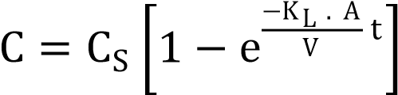 0.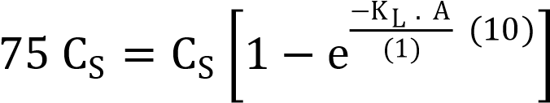



For the full-scale vessel:

V = 100 m3, t = ?,

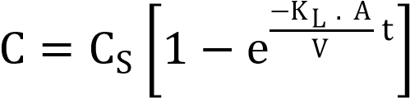 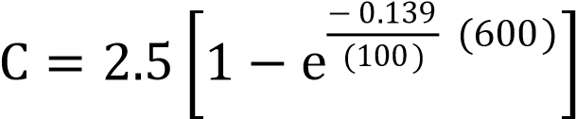

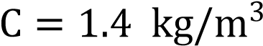

The initial amount of the solute in the solid = (500) (0.28) =140 kg



That’s mean that the leaching process is efficient.

**Number of washing:**

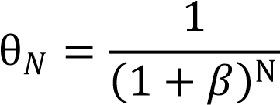

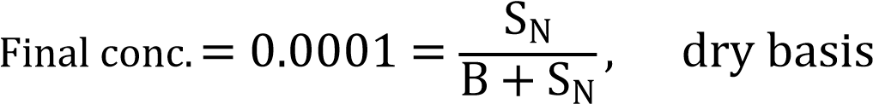

B = (500) (1- 0.28) = 360 kg 0.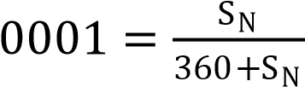

SN = 0.036 kg

S = (0.25) (100) (1.4) = 35 kg

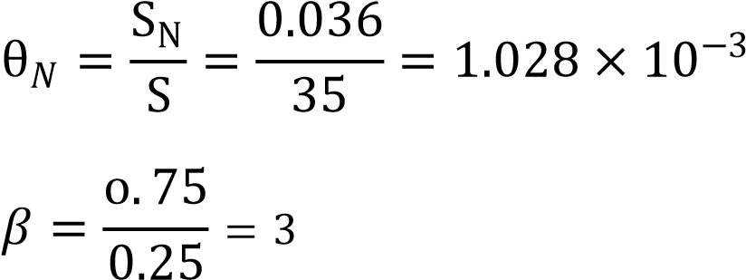

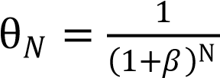

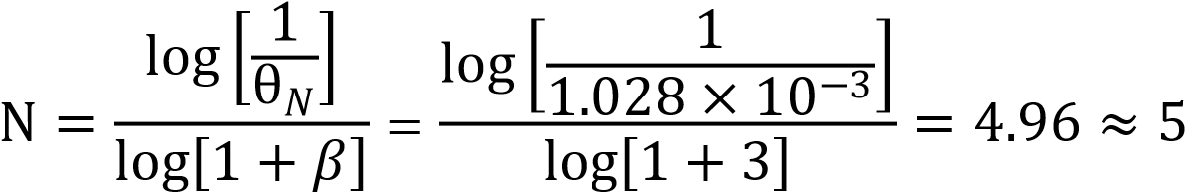

**Example (2):** Repeat the previous example (1) but the time of leaching is 300 sec. Find the concentration of solute in the solid (dry basis)? after five washes where the decanting ratio is the same.

**Solution:**

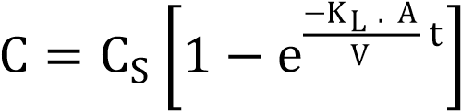 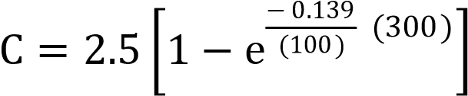

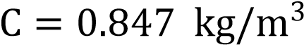

The amount of solute unleached = (500) (0.28) – (0.847) (100) = 140 – 84.7 = 55.3 kg

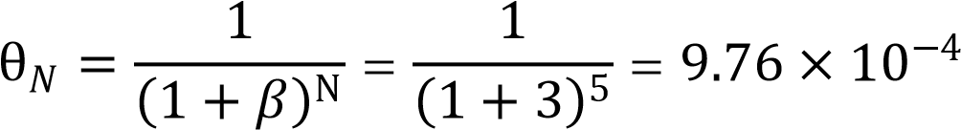

S = (0.847) (100) (0.25) = 21.175 kg

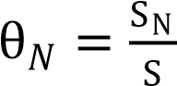 9.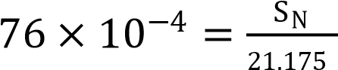

SN = (21.175) ( kg

B = (500) (1- 0.28) = 360 kg

Total solute = unleached + remaining in the solid after washing

= 55.3 + 2.kg

