Lecture 7 - Extraction of REM from catalysts and electronic scrap

Metal Extraction Processes for Electronic Waste and Existing Industrial Routes: A Review and Australian Perspective

Abstract:

The useful life of electrical and electronic equipment (EEE) has been shortened as a consequence of the advancement in technology and change in consumer patterns. This has resulted in the generation of large quantities of electronic waste (e-waste) that needs to be managed. The handling of e-waste including combustion in incinerators, disposing in landfill or exporting overseas is no longer permitted due to environmental pollution and global legislations. Additionally, the presence of precious metals (PMs) makes e-waste recycling attractive economically. In this paper, current metallurgical processes for the extraction of metals from e-waste, including existing industrial routes, are reviewed. In the first part of this paper, the definition, composition and classifications of e-wastes are described. In the second part, separation of metals from e-waste using mechanical processing, hydrometallurgical and pyrometallurgical routes are critically analyzed. Pyrometallurgical routes are comparatively economical and eco-efficient if the hazardous emissions are controlled. Currently, pyrometallurgical routes are used initially for the segregation and upgrading of PMs (gold and silver) into base metals (BMs) (copper, lead and nickel) and followed by hydrometallurgical and electrometallurgical processing for the recovery of pure base and PMs. For the recycling of e-waste in Australia, challenges such as collection, transportation, liberation of metal fractions, and installation of integrated smelting and refining facilities are identified.

Keywords: electronic waste (e-waste); recycling; pyrometallurgy; printed circuit boards (PCBs); precious metals (PMs) extractions; copper

Introduction

The demand of electrical and electronic equipment (EEE) has increased dramatically with the advancement in technology. Drastic innovations on the electrical and electronic technologies further shortened the life, and thus enhanced the generation of waste from electrical and electronic equipment (WEEE) or electronic waste (e-waste). The global production of e-waste/WEEE is increasing rapidly and is expected to accelerate in the near future. Currently, 20 to 25 million tons per year of e-waste are being generated globally with major share of Europe, USA and Australasia. However, China, Eastern Europe and Latin America are expected to become significant e-waste producers in the next decade [1]. In Europe, it is expected that the production of e-waste will increase by 45% between 1995 and 2020. Therefore, a three pillars strategy of waste prevention, recycling and reuse has been suggested to minimize the environmental impact and promote the efficient utilization of wasted resources [2].
E-waste is classified as hazardous material therefore should be managed properly. However, the presence of precious metals (PMs) in e-waste such as gold (Au), silver (Ag), platinum (Pt), Gallium (Ga), palladium (Pd), tantalum (Ta), tellurium (Te), germanium (Ge) and selenium (Se) makes it attractive for recycling. In this article, metal extraction processes from e-waste, particularly the existing industrial practices and routes, will be reviewed. Industrially, different metallurgical routes are used to extract valuable metals from e-waste. Both pyrometallurgical and hydrometallurgical processes are commonly employed to recover PMs. These routes will be described and their advantages and disadvantages will be outlined. In the final part of this paper, insights into e-waste recycling in the Australian context will be presented. The challenges and barriers associated with recovery of the PMs will be highlighted.

  - Definitions, Classification and Composition of E-Waste

There is no standard definition for WEEE or e-waste. E-waste or WEEE embraces various forms of EEE that have no value to their owners. The reported definitions of e-waste in literature are described here:
European WEEE Directive
“Electrical or electronic equipment which is waste … including all components, sub-assemblies and consumables, which are part of the product at the time of discarding.” [2,3].
Basel Action Network
“E-waste encompasses a broad and growing range of electronic devices ranging from large household devices such as refrigerators, air conditioners, cell phones, personal stereos, and consumers electronics to computers which have been discarded by their users.” [4].

WEEE or e-waste is divided into ten categories based on the European WEEE Directives 2002/96/EC and 2012/19/EU [2,3] and is given in Table 1. The scope of each category is detailed elsewhere [2,3]. E-waste is a complex mixture composed of ferrous, nonferrous, plastic and ceramic materials. According to the Association of Plastics Manufacturers in Europe (APME), material consumption in electric and electronic equipment is summarized in Table 2 [5].

Table 1. Waste from electrical and electronic equipment (WEEE)/electronic waste (e-waste) categories according to the European directive on WEEE [2,3]. Reprinted with permission from [2,3], 2002 and 2012.

No. | Category | Label
1 | Large household appliances | Large HH
2 | Small household appliances | Small HH
3 | IT and telecommunications equipment | ICT
4 | Consumer equipment | CE
5 | Lighting equipment | Lighting
6 | Electrical and electronic tools  (with the exceptions of large-scale stationary industrial tools) | E & E tools
7 | Toys, leisure and sport equipment | Toys
8 | Medical devices  (with the exception of all implanted and infected products) | Medical equipment
9 | Monitoring and control instruments | M & C
10 | Automatic dispensers | Dispensers

Table 2. Main materials found in electrical and electronic equipment (EEE) [5]. Reprinted with permission from [5], 2004.

No. | Material | Percentage
1 | Ferrous | 38
2 | Non-ferrous | 28
3 | Plastics | 19
4 | Glass | 4
5 | Wood | 1
6 | Other | 10

Printed circuit boards (PCBs) are found in electrical and electronics appliances (televisions, computers, mobile phones and laptops). Generally, PCBs are composed of 40% metals, 30% plastics and 30% ceramics [6]. PCBs are coated with base metals (BMs) (tin, silver or copper) to make them conductive. There are two types of PCBs (FR-4 and FR-2), which are used in mobile phones and personal computers. FR-4 types PCBs are made of a multilayer of fiberglass coated with copper and FR-2 types are made of a single layer of fiber glass or cellulose paper or phenolic material that is also coated with a copper layer. PCBs of FR-4 types are used for small electronic equipment (mobile phones) and FR-2 is used for larger appliances (computers and television). Polymers and industrial plastics are other major constituents of PCBs that contain polyethylene, polypropylene, epoxies and polyesters.
Sampling is difficult for e-waste composition analysis due to the inhomogeneous and composite nature of the materials. Large numbers and various kinds of small of components are attached to PCBs.

Generally, PCBs are crushed into smaller sizes (less than 1–2 mm) and various techniques including magnetic, electrostatic, electrowinning, and selective dissolution are implemented to separate the components [6–13]. Yamane et al. [14] investigated the composition of spent PCBs from mobile phones and personal computers. Preprocessing included crushing and then separation by magnetic and electrostatic techniques. Chemical analysis was conducted using aqua regia leaching, loss on ignition and inductively coupled plasma-atomic emission spectroscopy (ICP-AES). The results showed that PCBs from mobile phones had higher (34.5%) copper contents compared to personal computers (20%). The typical composition of PCBs from different sources is given in Table 3.

Table 3. Typical compositions of printed circuit boards (PCBs) [6,15]. Reproduced with permission from [16–19].
Materials | Typical Concentrations (in wt% and ppm)
Metals (Max. wt. 40%) | Shuey and Taylor [16] | Kim et al. [17] | Iji and Yokoyama [18] | Ewasteguide.info [19]
Cu | 20 | 15.6 | 22 | 6.9
Al | 2 | - | - | 14.2
Pb | 2 | 1.35 | 1.55 | 6.3
Zn | 1 | 0.16 | - | 2.2
Ni | 2 | 0.28 | 0.32 | 0.85
Fe | 8 | 1.4 | 3.6 | 20.5
Sn | 4 | 3.24 | 2.6 | 1.0
Sb/ppm | 0.4 | - | - | 20
Au/ppm | 1000 | 420 | 350 | 20
Ag/ppm | 2000 | 1240 | - | 200
Pd/ppm | 50 | 10 | - | -
Ge/ppm | - | - | - | 20
As/ppm | - | - | - | 10
Ti/ppm | - | - | - | 200
In/ppm | - | - | - | 20
Ta/ppm | - | - | - | 200
Co/ppm | - | - | - | 200
Se/ppm | - | - | - | 20
Ga/ppm | - | - | - | 10
Ceramics (Max. wt. 30%) | Shuey and  Taylor [16] | Kim et al. [17] | Iji and  Yokoyama [18] | Ewasteguide.info [19]
SiO₂ | 15 | 41.86
Al₂O₃ | 6 | 6.97 | 30 | 24.9
Alkali and alkaline earth oxides | 6 | CaO 9.95
Titanates and mica, etc. | 3 | -
Plastics (Max. wt. 30%) | Shuey and Taylor [16] | Kim et al. [17] | Iji and Yokoyama [18] | Ewasteguide.info [19]
Polyethylene | 9.9 | -
Polypropylene | 4.8 | -
Polyesters | 4.8 | - | Total of  all plastics 16 wt% | Total of all plastics 23 wt%
Epoxies | 4.8 | -
Polyvinyle chloride | 2.4 | -
Polytetraflouroethane | 2.4 | -
Nylon | 0.9 | -

Generally, metals in e-waste can be grouped into PMs, platinum group metals (PGMs), BMs, metals of concern (MCs), and scarce elements (SEs), such as the following [20]:
PMs: Au, Ag;
PGMs: Pd, Pt, Rh, Ir and Ru;
BMs: Cu, Al, Ni, Sn, Zn and Fe; MCs (Hazardous): Hg, Be, In, Pb, Cd, As and Sb; SEs: Te, Ga, Se, Ta and Ge.

  - General Driving Force for E-Waste Processing

There are three general reasons for e-waste processing: environmental concerns, energy savings and resource efficiency. These are explained in more detail in the following subsections.

    - Environmental Concerns

E-waste is composed of a large number of components of various sizes, shapes and chemistry. Some of them contain hazardous metals including Hg, Pb and Cd. Such components are removed through separate treatment and recycling processes. In the European directives (2002/96/EC and 2012/19/EU) [2,3], e-waste is classified as hazardous material. Major hazardous components in e-waste are summarized in Table 4.

Table 4. Major hazardous components and materials in WEEE [2,3,21]. Reproduced with permission from [2,3], 2002 and 2012.

No. | Materials and Components | Description
1 | Batteries | Heavy metals such as lead, mercury and cadmium are present in batteries
2 | Cathode ray tubes (CTRs) | Lead in the cone glass and fluorescent coating cover the inside of  panel glass
3 | Mercury containing components such as switches | Mercury is used in thermostats, sensors, relays and switches (e.g., on PCBs and in measuring equipment and discharge lamps). It is also used in medical equipment, data transmission, telecommunication, and  mobile phones
4 | Asbestos waste | Asbestos waste has to be treated selectively
5 | Toner cartridges, liquid and pasty,  as well as color toner | Toner and toner cartridges have to be removed from any separately  collected WEEE
6 | PCBs | In PCBs, cadmium occurs in certain components, such as SMD chip  resistors, infrared detectors and semiconductors
7 | Polychlorinated biphenyl (PCB)  containing capacitors | PCB-containing capacitors have to be removed for safe destruction
8 | Liquid crystal displays (LCDs) | LCDs of a surface greater than 100 cm² have to be removed from WEEE
9 | Plastics containing halogenated  flame retardants | During incineration/combustion of the plastics, halogenated flame  retardants can produce toxic components
10 | Equipment containing chlorofluorocarbons (CFCs), hydrochlorofluorocarbons (HCFCs)  or hydrofluorocarbons (HFCs) | CFCs present in foam and refrigerating circuit must be properly extracted and destroyed. HCFCs or CFCs present in foam and refrigerating circuit must be properly extracted and destroyed or recycled
11 | Gas discharge lamps | Mercury has to be removed

Traditionally, most of the e-waste ends up as landfill. According to the U.S Environmental Protection Agency report on e-waste management 2008 [22], 19% of e-waste is combusted and 81% is disposed in landfills. The disposal of e-waste underground has multiple disadvantages including the contamination of underground water and soil, and wasting a potential source of valuable metals.
In the last decade many countries have formulated legislations on e-waste management [2–4]. Several investigators reported on the individual countries and global legislations on managing and handling of e-waste [1,23–29]. It is no longer permissible to dispose e-waste underground or burn it in incinerators without isolating the hazardous materials. Moreover, exporting e-waste to underdeveloped countries is not permissible according to the international regulations [4]. Disposing underground, burning in air and acid leaching will deteriorate the environment by spoiling drinking water and releasing toxic gases into the atmosphere [7,15,27]. Therefore, recycling of e-waste is crucial from the perspective of minimizing environmental pollution and resource management.

    - Energy and Resource Conservation

Recycling of e-waste for metal recovery is also important from the perspective of saving energy. The U.S Environmental Protection Agency [22] has identified seven main benefits for using recycled Fe and steel over their virgin materials. One of the major benefits is a significant energy saving using recycled materials compared to virgin materials. The energy savings for a number of common metals and materials are summarized in Table 5.

Table 5. Recycled materials energy savings over virgin materials [21,30]. Reproduced with permission from [21,30], 2003.

No. | Materials | Energy savings (%)
1 | Aluminum | 95
2 | Copper | 85
3 | Iron and steel | 74
4 | Lead | 65
5 | Zinc | 60
6 | Paper | 64
7 | Plastics | >80

Moreover, processing of e-waste will reduce burden on mining ores for primary metals. Therefore, scarce resources especially for PMs could be conserved, e.g., metals that exist at low concentrations in primary ores and consume significant energy during extraction. Factually, e-waste is a rich source of PMs compared to their primary ores. The amount of gold recovered from one ton of e-waste from personal computers is more than that recovered from 17 ton of gold ore. The processes for recovering PMs from electronic scrap, in limited cases are easier than their primary ores [31]. If PMs and SEs are unrecovered, it will be a significant loss of precious resource.

    - Economic Value of Selected PMs

The recovery of precious and base metals is important for e-waste management, recycling, sustainability and resource conservation. The value distribution of PMs in PCBs and calculators is

more than 80%. After PMs, copper is the next highest value metal to be extracted from e-waste [20]. It is worth noting that sustainable resource management demands the isolation of hazardous metals from e-waste and also maximizes the recovery of PMs. The loss of PMs during the recycling chain will adversely affect the process economy. The extraction of PMs (Au, Ag and Pd) and BMs (Cu, Pb and Zn) from e-waste is a major economic drive due to their associated value, as summarized in Table 6.

Table 6. Weight vs. value distribution [20]. PMs: precious metals. Reproduced with permission from [20], 2006.
Weights% | Fe (wt%) | Al (wt%) | Cu (wt%) | Plastics (wt%) | Ag (ppm) | Au (ppm) | Pd (ppm)
TV-board | 28% | 10% | 10% | 28% | 280 | 20 | 10
PCBs | 7% | 5% | 20% | 23% | 1000 | 250 | 110
Mobile phone | 5% | 1% | 13% | 56% | 1380 | 350 | 210
Portable audio | 23% | 1% | 21% | 47% | 150 | 10 | 4
DVD-player | 62% | 2% | 5% | 24% | 115 | 15 | 4
Calculator | 4% | 5% | 3% | 61% | 260 | 50 | 5
Value-share | Fe | Al | Cu | Sum PMs | Ag | Au | Pd
TV-board | 4% | 11% | 42% | 43% | 8% | 27% | 8%
PCBs | 0% | 1% | 14% | 85% | 5% | 65% | 15%
Mobile phone | 0% | 0% | 7% | 93% | 5% | 67% | 21%
Portable audio | 3% | 1% | 77% | 19% | 4% | 13% | 2%
DVD-player | 13% | 4% | 36% | 47% | 5% | 37% | 5%
Calculator | 0% | 5% | 11% | 84% | 7% | 73% | 4%

E-Waste Processing

E-waste recycling consists of three main steps: collection, preprocessing and end processing [32]. Each step is critical for the recovery of metals and recycling economy. E-waste collection is facilitated by appropriate government policies, effective advertisement for public awareness, and by installing separate collection facilities at public places. End of life electronic components are sorted at the collection facility where useable components are returned to the consumer supply chain.
Preprocessing of e-waste is one of the most important steps in the recycling chain. A basic flow sheet diagram of preprocessing is shown in Figure 1. The expired equipments are manually dismantled at collection facilities and individual components are tested and isolated from e-waste. During the early stage, housing, wiring boards and drives, and other components are liberated. Mechanical processing is an integrated part of this stage where e-waste scrap is shredded into pieces using hammer mills [32]. Metals and non-metals are separated during this stage using techniques similar to that used in the mineral dressing, e.g., screening, magnetic, eddy current and density separation techniques.
The final stage in the recycling chain of e-waste is the end processing, where the non-metal and metal fractions of e-waste are further processed. There have been a number of studies on the recycling and utilization of the non-metals fractions from e-waste, for example from wasted PCBs that contain
>70% of non-metallic fractions [15,33–35]. In general, the non-metallic fractions of PCBs are mainly composed of thermoset resins and glass fibers. Thermoset resins cannot be re-melted due to their chain structure.

Guo et al. [33] produced a non-metallic composite plate using pulverized PCBs combined with other components including CaCO₃, unsaturated polyesters, polystyrene, TBPB, glass fiber, zinc stearate and pigments. Yin et al. [34] produced a composite plate using a mixture of pulverized wasted PCBs non-metallic fraction and polypropylene S700 as resin, and maleic anhydride grafted polypropylene as modifier. Both studies showed that composite plates from recycled non-metal fractions of PCBs possessed comparable mechanical properties to virgin plastics.

Figure 1. The pre-processing of e-waste to separate metal and non-metal fractions.
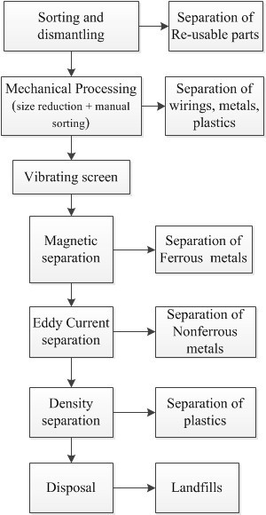

Other recycling routes for non-metallic PCB materials are based on chemical processes that include gasification, pyrolysis, supercritical fluid de-polymerization and hydrogenolytic degradation for producing chemical substances and fuels. For example, the non-metallic fractions can be used in pyrometallurgical processes as fuels and reducing agent. Overall, the identified techniques for recycling of non-metallic materials from wasted PCBs are promising and can be used for the sustainable management of plastics resources from e-waste [15].
The metallic fraction of e-waste can be further processed to separate or extract minor metals/elements using various metallurgical processes. The following sections will explain in more detail the metallurgical processes to extract metals from e-waste.

  - Metallurgical Processes for the Extraction of Metals from E-Waste

The metal fractions separated from e-waste during preprocessing can be further processed using hydrometallurgical, pyrometallurgical, electrometallurgical, biometallurgical processes, and their

combinations. The hydrometallurgical and pyrometallurgical processes are the major routes for processing of e-waste. These routes may be followed by electrometallurgical/electrochemical processes (for example electrorefining or electrowinning) for selected metal separation and recovery. Currently, there are only limited laboratory studies for e-waste processing through biometallurgical routes, e.g., bioleaching of metals from e-waste. Nevertheless, this route has a potential for further development. This paper will focus on the hydrometallurgical and pyrometallurgical processing of e-waste.
The preprocessing of e-waste is not always required for pyrometallurgical routes. For example, complex electronic equipment such as mobile phones and MP3 players can be treated directly during smelting processes [36]. However for hydrometallurgical routes, preprocessing is required to separate metal fractions from other fractions. This will enhance the efficiency of each step associated with hydrometallurgical routes. Each route has advantages and disadvantages that should be considered for the selection of an appropriate recycling process.

    - Hydrometallurgical Processes

Various investigators studied the extraction of PMs, copper, lead and zinc from e-waste using hydrometallurgical routes [11,37–41]. These routes are based on traditional hydrometallurgical technology of metals extractions from their primary ores. Similar steps of acid or caustic leaching are employed for selective dissolution of PMs from e-waste. The pregnant solution is separated and purified for the enrichment of metal content thereby impurities are removed as gangue materials. The isolation of metal of interest is conducted through solvent extraction, adsorption and ion exchange enrichment processes. Finally, metals are recovered from solution through electrorefining (electrometallurgy) or chemical reduction processes [42–46]. Cui and Zhang [47] reviewed the processes for recovering metals from e-waste. Hydro- and pyrometallurgical processes were evaluated and discussed. It has been reported that hydrometallurgical processes have additional benefits compared to pyrometallurgical processes because they are more exact, predictable, and easily controllable [48].
Solvents especially halides, cyanides, thiourea and thiosulfates are used for the leaching of PMs from their primary ores. Process factors including pH, temperature and stirring control the dissolution of metals from their primary ores. The recovery of PMs from the leached solution is carried out by cementation, solvent extraction, adsorption on activated carbon, and ion exchange methods. Similar techniques could be employed for extracting metals from e-waste, however, its complex nature makes the process complicated compare to natural ores.
Park and Fray [41] proposed a hydrometallurgical method for recovering PMs from e-waste. Aqua regia was used as leachant and a fixed ratio of 1/20 between metals and leachant was exercised. Silver and palladium were extracted during the first stage with 98% and 93% recovery, respectively. For gold, a liquid-liquid extraction method was adopted with toluene and a recovery of 97% was reported. The flow sheet diagram for recovering PMs from PCBs proposed by Park and Fray is shown in Figure 2.
Other investigators have been carrying out studies on the recovery of PMs from e-waste at laboratory scale. A brief explanation of the processes is given in Table 7. It is noted that HNO₃, H₂SO₄, and HCl-based solutions are commonly employed for dissolving PMs from e-waste. From the leachants, PMs are recovered employing methods similar to those used in the mineral industry.

Figure 2. Example of hydrometallurgical recycling of PCBs for the recovery of PMs [41]. Reproduced with permission from [41], 2009.
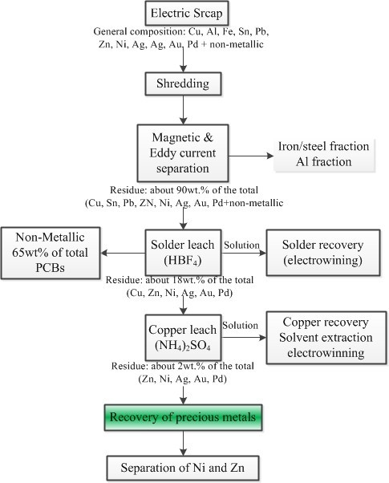

Table 7. Summary of hydrometallurgical recovery of PMs from e-waste.

Investigators | Leaching agent | Process conditions | Recovered metals
Park and Fray [41] | Aqua regia | Ratio of metals to leachant = 1:20 g/mL | Au, Ag and Pd
Sheng and Estell [49] | HNO₃ (1st stage), epoxy resin (2nd stage), and aqua regia (3rd stage) | Extraction was carried out in the three stages (self agitation) | Au
Quinet et al. [50] | H₂SO₄, chloride, thiourea and cyanide leaching | Leaching & metals recovery by cementation, precipitation, ion exchange and carbon adsorption | Au, Ag, Pd and Cu
Chielewski et al. [51] | HNO₃ and aqua regia | Roasting of e-waste in the presence of carbon; leaching with HNO₃ and aqua regia;  and solvent extraction with diethyle malonate | Au
Zhou et al. [52] | HCl, H₂SO₄ and NaClO₃ | Combustion of e-waste at 400–500 °C followed by leaching | Ag, Au and Pd
Kogan [53] | HCl, MgCl₂, H₂SO₄  and H₂O₂ | Dissolution of e-waste in different solvents and leaching conditions; and recovery of metals in stages | Al, Sn, Pb and Zn (1st stage), Cu and Ni (2nd stage), Au, Ag, Pd  and Pt (last stage)
Veit et al. [11] | Aqua regia and H₂SO₄ | Mechanical processing and then dissolution of e-waste in different  solvents | Cu
Mecucci and Scott [54] | HNO₃ | Electrochemical deposition of Cu at cathode from solution | Pb and Cu

Limitations of Hydrometallurgy Route

Hydrometallurgical routes have been successfully used to recover PMs from e-waste. However, these processes are associated with certain disadvantages that limit their application on the industrial scale. Some common limitations of hydrometallurgical methods for recovering PMs from e-waste are listed here [47,55,56]:
- Overall, hydrometallurgical routes are slow and time consuming and impact recycling economy. There are concerns regarding the economy of hydrometallurgical routes compared to pyrometallurgical processes for the extraction of PMs from e-waste.
- Mechanical processing of e-waste takes longer to reduce size for efficient dissolution. It is reported that 20% PM is lost by mechanical force during the liberation process that contributes to a significant loss in the overall revenue.
- Cyanide is a dangerous leachant and should therefore be used with high safety standards. It can cause contamination of rivers and seawater, especially near gold mines, which poses serious health risks to the inhabitants.
- Halide leaching is difficult to implement due to strong corrosive acids and oxidizing conditions. Specialized equipment made of stainless steel and rubbers is required for leaching of gold using halide agents from e-waste.
- The use of thiourea leachants is limited in gold extraction due to its high cost and consumption. Moreover, further developments are required to improve the current technology of thiourea-based gold leaching.
- The consumption of thiosulfate is comparatively higher and the overall process is slower, which limits its application for gold extraction from ores as well as from e-waste.
- There are risks of PM loss during dissolution and subsequent steps, therefore the overall recovery of metals will be affected.
    - Pyrometallurgical Processes

Pyrometallurgical processes for recovering metals from various waste materials have been used during the last two decades. Smelting in furnaces, incineration, combustion and pyrolysis are typical e-waste recycling processes. State-of-the-art smelters and refineries can extract valuable metals and isolate hazardous substances efficiently. Such recycling facilities can close the loop of valuable metals and reduce environmental impact arising from large quantities of e-waste. Currently, e-waste recycling is dominated by pyrometallurgical routes [57], whereas the steel industry embraces the ferrous fractions for the recovery of iron, and the secondary aluminum industry takes the aluminum fractions. Pyrometallurgical processes work with the steps of liberation, separation/upgrading and purification that are fundamentally similar to those of mechanical or hydrometallurgical routes. However, the liberation of valuable metals is not achieved by leaching, crushing or grinding but by smelting in furnaces at high temperatures. In these processes, metals are sorted by exploiting their chemical and metallurgical properties, e.g., PMs are segregated into a solvent metal phase (copper or lead).
The metal fractions separated during the preprocessing of e-waste are composed of Fe, Al, Cu, Pb and PMs. After Fe and Al, Cu and Pb are the main constituents of a typical e-waste. Therefore, it is

logical to send e-waste to smelters that accept copper/lead scrap. Currently, copper and lead smelters work as e-waste recyclers for the recovery of Pb, Cu and PMs. In these pyrometallurgical processes, e-waste/copper/lead scrap is fed into a furnace, whereby metals are collected in a molten bath and oxides form a slag phase. More details about the lead and copper smelting routes are explained in the next sections.

      - Lead Smelting Route

Primary lead is produced from sulfide ores containing iron, zinc, copper, PMs, and other trace elements. The concentrated ore and e-waste is treated for the extraction of lead and PMs. The process consists of sintering (ores), reduction and refining stages. Sintering is carried out to reduce the sulfur contents of feed material that is composed of pyrite, lime rock, silica and high concentrated lead. The reduction process is conducted in blast furnaces with the help of coke where molten lead with about 85% purity is tapped from the bottom of the furnace. The plastics fraction of e-waste can partially replace coke as a reducing agent during the reduction stage, and the metals fraction ends up in the metal phase. In the refining stage, copper dross is skimmed off from the lead dross and is treated in a reverberatory furnace. The lead dross is processed by adding wood chips, fine coke and sulfur. The sulfur dross produced is separated and transferred to the reverberatory furnace. The heating of lead dross in the reverberatory furnace separates the lead bullion (rich in lead), matte (copper and other metals sulfides) and speiss (high in arsenic and antimony contents). Matte and speiss are treated in copper smelters for the extraction of copper and other associated metals [58].
In the last stage of e-waste processing via the lead smelting route, PMs and other elements are separated from the lead bullion. PMs are separated by the Parkes process, in which zinc forms an insoluble intermetallic compound with gold and silver. Other impurities including antimony, tin, arsenic, bismuth, and trance elements are also separated during the refining stage. Final products of refining stage include metallurgical grade lead (99.99%), PMs and other elements [58].

      - Copper Smelting Route

Primary and secondary copper smelting routes are adopted to recycle and extract PMs from e-waste. It is reported that copper smelting routes are more environmentally friendly compared to lead smelters that generate toxic fumes [36]. Copper smelting facilities near populations will minimize the cost of e-waste transportation and therefore the recycling economy will be improved. These advantages allow copper smelters to be installed near cities where e-waste is generated. In these processes, PMs are recovered via a conventional electrorefining process where they are segregated in slimes [59]. Commonly, copper smelting routes including matte and black copper are used for e-waste recycling. In the sulfur-based route (primary copper smelting), copper matte (40%) and blister copper (98.5%) are produced. Finally, blister copper is refined by fire refining to produce pure copper. In the black copper route (secondary copper smelting), crude copper is produced during a reduction process and is refined by oxidation in a converter. The black copper is an attractive route because it can receive high levels of impurities including Fe, Zn, Pb and Sn. These impurities are removed by oxidation as shown in Figure 3. The black copper smelting process consists of reduction and oxidation cycles. Impurities are mostly segregated into the vapor phase and are discharged in the off gas [36].

Figure 3. Simplified flow sheet of black copper smelter process (secondary copper smelting) [59]. Reprinted with permission from [59], 2013.
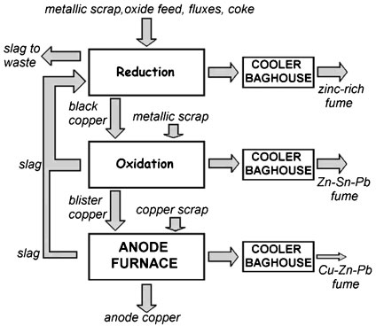

      - Limitations of Pyrometallurgical Processes

Pyrometallurgical routes are generally more economical, eco-efficient and maximize the recovery of PMs, however, they have certain limitations that are summarized here [20,47]:
        - Recovery of plastics is not possible because plastics replace coke as a source of energy;
        - Iron and aluminum recovery is not easy as they end up in the slag phase as oxides;
        - Hazardous emissions such as dioxins are generated during smelting of feed materials containing halogenated flame retardants. Therefore special installations are required to minimize environmental pollution;
        - A large investment is required for installing integrated e-waste recycling plants that maximize the recovery of valuable metals and also protect the environment by controlling hazardous gas emissions;
        - Instant burning of fine dust of organic materials (e.g., non-metallic fractions of e-waste) can occur before reaching the metal bath. In such cases, agglomeration may be required to effectively harness the energy content and also to minimize the health risk posed by fine dust particles;
        - Ceramic components in feed material can increase the volume of slag generated in the blast
furnaces, which thereby increases the risk of losing PMs from BMs;
        - Partial recovery and purity of PMs are achieved by pyrometallurgical routes. Therefore, subsequent hydrometallurgical and electrochemical techniques are necessary to extract pure metals from BMs;
        - Handling the process of smelting and refining is challenging due to complex feed materials. The expertise in process handling and the thermodynamics of possible reactions will be difficult.

Industrial Processes for the Recovery of Metals from E-Waste

Industrial processes for recovering metals from e-waste are based on combined pyrometallurgical, hydrometallurgical and electrometallurgical routes. In pyrometallurgical processes, e-waste is blended

with other materials and incorporated into primary/secondary smelting processes (e.g., into copper or lead smelters). Copper smelting is the dominating route for e-waste recycling where PMs are collected in copper matte or black copper. In the final stage of copper production, i.e., the electrorefining process, pure copper metal is produced and the PMs are separated into slimes where they are recovered using hydrometallurgical routes. Currently, various industrial processes are used globally for extracting metals from e-waste, including the Umicore integrate smelting and refining facility, the Noranda process in Quebec, Rönnskär smelters in Sweden, Kosaka’s recycling plant in Japan, the Kayser recycling system in Austria and the Metallo-Chimique N.V plants operated in Belgium and Spain. The following sections describe the details of selected industrial routes for e-waste recycling.

  - Umicore Integrated Metals Smelters and Refinery

At Umicore, PMs are extracted from e-waste using the secondary copper route. Umicore has heavily investigated building the world’s largest waste recycling facility at Hoboken, Belgium. It is a specialty material group that focuses on recovering gold and silver, PGMs (palladium, platinum, rhodium, iridium and ruthenium), special metals (selenium, tellurium and indium), secondary metals (antimony, tin, arsenic and bismuth), and the BMs (copper, lead and nickel) from various residues including e-waste. Other by-products of the Umicore plant are sulfuric acid (from off gas purification), and slag (consisting of silicon, aluminum and iron oxides) that are used as construction material. The feed material for the Umicore smelting and refining process is composed of wastes from the non-ferrous industry, PM residues, and PCBs. On average 250,000 tons of feed material are treated annually for the recovery of metals. It is the world’s largest recycling facility for the extraction of PMs and has an annual production of over 50 tons of PGMs, 100 tons of gold and 2400 tons of silver [20,60–62]. The Umicore process flow sheet is composed of several pyrometallurgical, hydrometallurgical, and electrochemical processes for recovering PMs that are shown schematically in Figure 4.

Figure 4. A flow sheet for Umicore’s integrated metals smelter and refinery [61]. Reprinted with permission from Acta Metallurgica Slovaca (AMS), 2006.
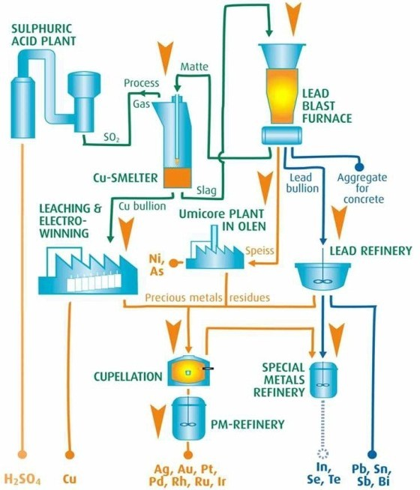

The Precious Metals Operation (PMO) focuses on the recovery of PMs from copper matte smelting, leaching and electrowinning. The feed from e-waste and other industries is smelted in an IsaSmelt furnace. The plastic and organic constituents partially replace coke as a reducing agent and a source of energy during smelting. PMs are segregated mainly in the copper bullion and the rest in the lead slag. Copper is leached out from the copper bullion and recovered by an electrowinning process. The residue of the copper electrowinning process is further treated at a PMs refinery for the recovery of PMs.
The second recycling process at Umicore is called the Base Metals Operation (BMO) that treats by-products from PMO. Figure 5 shows the affinity of PMs with BMs, and simplified Umicore process organization. The main processing units in BMO are a lead blast furnace, lead refinery and special metals plant. The oxidized lead slag and third party residues high in lead are treated in the lead blast furnace that produces impure lead bullion, nickel speiss, copper matte and depleted slag. The Harris process (lead refinery) is used to refine lead bullion that contains fewer PMs. Pure lead, sodium antimonite and special metals (indium, selenium and tellurium) are produced during the Harris process. Bismuth and tin are sold to dedicated companies to produce pure metals. At Umicore’s Olen plant, nickel is leached out from nickel speiss as sulfate. The remaining residue is treated at a PMs refinery for further recovery of metals [60,61].

Figure 5. Principle input-output streams for Umicore’s integrated metals smelter and refinery where Cu/Pb/Ni is used to segregate precious and special metals [61]. Reprinted with permission from AMS, 2006.
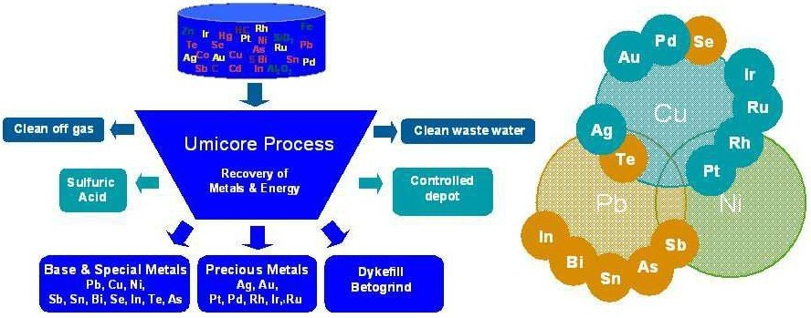

The Umicore’s integrated metals recovery process is coupled with an efficient emission controlled system that meets European and Flemish environmental control requirements. The flue gases controlling and monitoring system is schematically shown in Figure 6. The process exhaust gases are cooled for the recovery of energy and are cleaned using special techniques including bag house filters, electrofilters and scrubbers. Sulfuric acid is produced from SO₂ that is generated from sulfur in the feed material. Toxic gases including NO_{x} and SO₂ are continuously monitored from both stacks over the period of smelting process to avoid environmental pollution. Intensive water sprinkling is used to control diffused emission from stockyards and roads. Further pollution-controlled measures are dust-free drum/bag shipping and handling, sampling procedures, storage of critical materials, and emptying of containers. Consequently, the emissions of dust, metals, gases and dioxins are well below the European and Flemish legal environmental requirements [60,61].

Figure 6. Off gas emission control installation at the IsaSmelt furnace at Umicore e-waste recycling facility [60]. Reprinted with the permission from AMS, 2006.
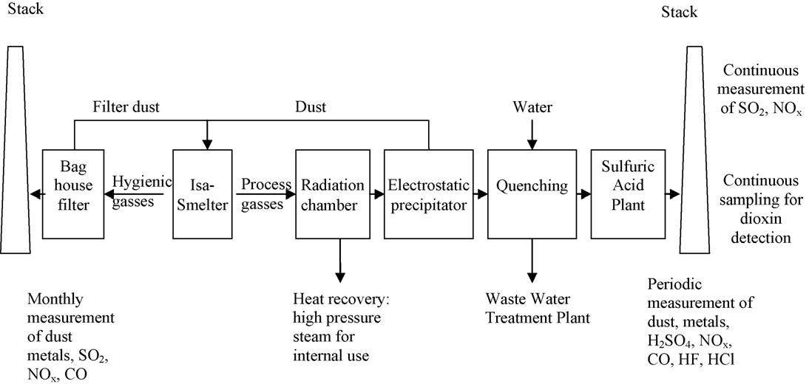

  - Metals Recovery from E-Waste at Rönnskär Smelters

The Rönnskär Smelters (Boliden Ltd., Skelleftehamn, Sweden) are used for the recovery of metals from e-waste. Figure 7 shows the flow sheet diagram of the process at Rönnskär Smelters. A variety of scrap from the non-ferrous and electronic industry is introduced into the process at different stages depending on the purity and requirement of the final product. For instance, high copper containing scrap is fed into the converting process directly, but low-grade e-waste is fed into the Kaldo furnace. The annual recycling of wastes (including e-waste) is more than 100,000 tons. The feed material of the Kaldo converter consists of blended lead concentrates and e-waste that are combusted with the supply of oxygen and oil. The main steps in the Rönnskär Smelters are drying, roasting, smelting, converting and refining, as schematically shown in Figure 7.

Figure 7. Flow sheet diagram of the Rönnskär smelters [63]. Reprinted with permission from Association of Plastics Manufecturers in Europe (APME), 2000.
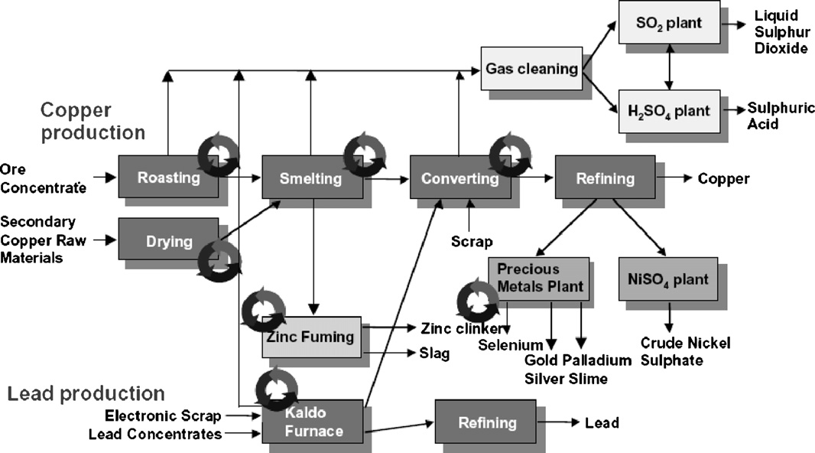

The Kaldo furnace produces a mixed copper alloy that is treated in a copper converter for the recovery of metals including Cu, Ag, Au, Pt, Pd, Ni, Se and Zn. The volatile metals such as Pb, Sb, In and Cd are segregated into the vapor phase that is recovered by a separate process. The off gases emission is treated for producing sulfuric acid and SO₂ gas.
  - Noranda Process

The Noranda process is another commercial pyrometallurgical process for the recovery of metals from e-waste. The feed material for this process is composed of e-waste and mined copper concentrates. At this recycling facility, about 100,000 tons of e-waste is processed for metal recovery. The schematic of the process flow sheet is shown in Figure 8. A blend of e-waste and copper concentrate is fed into the molten bath at 1250 °C and the process temperature is maintained by injecting supercharged oxygen. The energy cost is partially reduced by combusting the plastics and other combustible materials from e-waste. During the oxidation process, impurities including iron, lead and zinc are converted into oxides and segregated into a silica-based slag. The slag is cooled and processed for the recovery of metals before disposal. PMs are segregated in liquid copper that is processed into a copper converter for higher purity. The blister copper is refined in the anode furnace and casted into anodes with 99.1% purity. The remaining residue (0.9%) contains PMs including gold, silver, platinum and palladium, and some other recoverable metals such as nickel, selenium and tellurium. Finally, PMs are recovered by electrorefining of anodes.

Figure 8. Schematic diagram of the Noranda smelting process [64]. Reprinted with permission from [64], 1994.
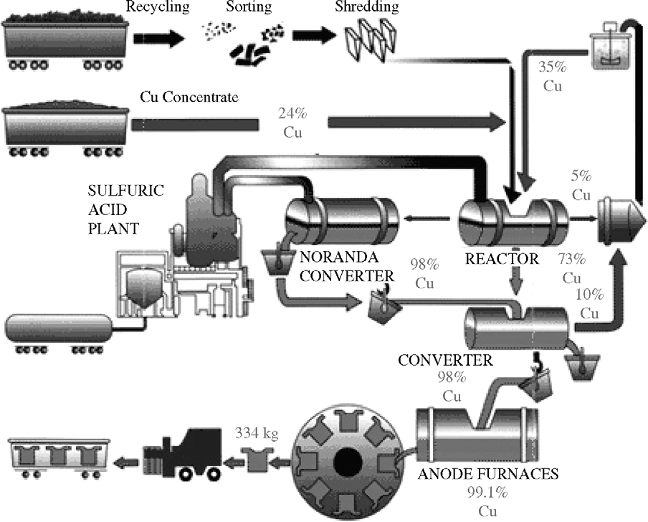

Overall, PMs are recovered with the help of both pyrometallurgical and hydrometallurgical routes. It is worth noting that during mechanical separation of iron, aluminum and plastics from e-waste, there is a risk of inevitably losing the PMs. They are closely tied up with non-ferrous metals and plastics in the PCBs. The acceptance of Fe, Al and plastics in the copper fraction can enhance the

overall recovery of PMs. In a case study at TU-Delft University, Huisman and Stevels [65] reported that the direct smelting route for mobile phones is a more eco-efficient solution compared to the indirect smelting of disintegrated mobile phone components. However, batteries should be separated before smelting in the furnace [60]. Mostly, the integrated e-waste recycling plants directly use PCBs in the smelting furnaces, which have many advantages such as:
- It maximizes the overall segregation of PMs in the copper fraction, and, therefore, the final recovery will be higher;
- It partially replaces coke with plastics as a source of energy during the smelting process;
- It provides a source for recycling of e-waste;
- Moreover, it is efficient in terms of resource management by closing the loop of metals.
Pyrometallurgical routes are beneficial to segregate and upgrade valuable metals in the BMs from e-waste that are further treated by hydrometallurgical routes to recover metals. Industrially, IsaSmelt, Kaldo, rotary and plasma arc furnaces are used for collecting valuable metals in the BMs. A short of summary of selected industrial process is given in Table 8.

Table 8. Summary of selected pyrometallurgical methods for recovery of metals from e-waste. TSL: top submerged lanced; PGMs: platinum group metals; and BM: base metal.
Industrial processes | Metals recovered | Main process features
Umicore’s process [20,60,61] | Au, Ag, Pd, Pt, Se, Ir, Ru, Rh,  Cu, Ni, Pb, In, Bi, Sn, As, Sb | Isasmelt smelting, copper leaching & electrowinning  and PMs refinery
Outotec TSL [66] | Zn, Cu, Au, Ag, In, Pb,  Cd, Ge | Ausmelt TSL furnace (trials in Melbourne, Australia),  smelting of e-waste in copper/lead/zinc processes
Rönnskär smelters [63,67] | Cu, Ag, Au, Pd, Ni, Se, Zn, Pb | Smelting in Kaldo reactor, upgrading in copper and  followed by refining, high PMs recovery
Noranda process [64] | Cu, Au, Ag, Pt, Pd, Se, Te, Ni | Smelting of e-waste and Cu concentrate. Upgrading in converter and anode furnaces. Electrorefining for  metal recovery
Rönnskär smelters tests [63,68] | Cu and PMs | PC scrap feeding to Zn fuming process, Plastics is used as reducing agent, PMs are segregated in Cu  and are recovered at later stage
Umicore’s trials [69] | Au, Ag, Pd, Pt, Se, Ir, Ru, Rh,  Cu, Ni, Pb, In, Bi, Sn, As, Sb | Plastics from e-waste is tested at energy and reducing  agent during smelting
Dowa mining Kosaka Japan [70] | Cu, Au, Ag | E-waste TSL smelting in secondary copper process
LS-Nikko’s recycling  facility, Korea [71] | Au, Ag & PGMs metals | Recycling in TSL smelting followed by  electrolytic refining
Day’s patent [72] | PMs, Pt and Pd | Smelting in plasma arc furnace at 1400 °C. PMs collected in BM. Ceramic residue went in the slag  phase. Ag and Cu used to collect metals during process
Aleksandrovich patent [73] | PGMs and gold | Scrap combustion in a BM using carbon as reducing agent, Solidification and separation of solidified  product are carried out by formed phase boundaries
Aurubis recycling Germany [74] | Cu, Pb, Zn, Sn and PMs | Smelting of Cu and e-waste in TSL reactor, black  copper processing and finally electrorefining

Design for Resource (DfR) Efficiency

One of the key factors in the e-waste management and recycling is the DfR efficiency. It refers to the product designs that strive for minimum loss of resources at the end of product life. Similarly, a DfR efficiency for electrical and electronics equipment ensures effective recovery of metals during processing. The recycling of e-waste initiates with collection, dismantling and sorting and is followed by preprocessing and final processing for the recovery of metals. The role of DfR is important in e-waste recycling at all stages such as dismantling, sorting, preprocessing and final processing. For example, aluminum is used as a heat dissipater in electronic equipment that could be designed for easy manual extraction. This could prevent the loss of aluminum in recycling of e-waste in the integrated smelting facility to recover copper and PMs. Moreover, PCBs that are rich in silver, gold and other PMs are mostly treated in copper smelters. Therefore, product designers should try to avoid the use of PMs with plastics or other materials that are separated from the copper fraction during preprocessing [62]. Hagelüken [20] reported a 20% loss of PMs during mechanical processing of PCBs. Such a loss is not only restricted to PMs but also includes copper, aluminum and iron, and corresponds to a decrease in the net intrinsic value of 43% to 93%. Considering that, electronic product designers should consult with recyclers to modify the design of PCBs that can facilitate higher separation of PMs during preprocessing of e-waste.
The recovery of metals during e-waste smelting could also be improved by designing products for recycling. The recycling efficiency will be dictated by the mineralogy of the input materials. Metals with similar thermodynamic properties should be kept together to maximize their recovery and resource efficiency. For example, product designers should use silver and gold with copper rather than nickel or lead that can be treated in the copper smelters.
The DfR efficiency comes under the policy framework that could be implemented by the producers. Over the years, many countries have adopted extended producer responsibilities (EPR) regulations that require the EEE producers to take back and recycle their products that have reached the end of their life [75]. Moreover, public policy can influence manufacturers to design products for recycling that will also encourage material innovation without impeding the functionality of the components [62]. Overall, the role of DfR efficiency in the electrical and electronic industry is important for the recycling of e-waste and extraction of metals, and this approach could be expanded around the world.

E-Waste Recycling in Australia

Australia is a significant producer of e-waste in the world. In 2007–2008, 106,000 tons of e-waste was generated, which are composed of discarded televisions, computers and their products and mobile phones. The estimated production of e-waste in Australia by 2027–2028 will exceed 181,000 tons. Currently, recycling of e-waste in Australia is limited. It is reported that about 10% of e-waste was recycled and 80% was disposed in landfills during 2007–2008 [76]. According to the Australian Bureau of Statistics more than half of the e-waste generated in 2010 was landfilled, stored or incinerated [77]. Australia also exports e-waste to Singapore, India and China for processing as depicted in Figure 9. Being a signatory of the Basel convention, it is illegal to export e-waste overseas until the importing country processes it in an environmentally friendly way. Australia is complying with the

Basel Convention by controlling the trans-boundary movements of hazardous wastes and their disposal. Keeping in view the strict global legislations, acquiring a permit to export e-waste in Australia is a difficult process. In 2009–2010, the Department of the Environment, Water, Heritage and Arts processed 14 permits to export hazardous wastes and 20 permits to import hazardous wastes. 16 of the permits were granted and four applications were refused that were unable to meet the strict criteria [76]. Currently, the export of e-waste to underdeveloped countries is not a viable option. A robust recycling management is required in Australia to deal with the large quantities of e-waste that will be generated in the future.

Figure 9. Asian e-waste traffic—who gets the trash [78]? Reprinted with permission from GRID-Arendal, Norway.
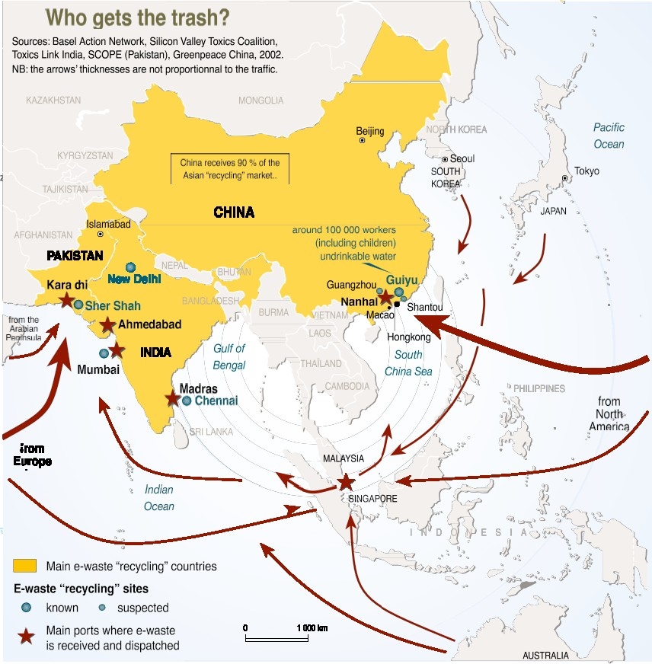

The Australian government has taken an initiative to encourage the recycling of e-waste. In a recent circular 23.4 on 30 May 2012, updates on e-waste collection, transport, recycling and disposal have been provided. According to the Australian National Television and Computer Recycling scheme (NTCRS), e-waste needs to be recycled according to the environmental guidelines [79]. For the success of NTCRS, collection services are provided across Australia since mid-2012, whereby existing facilities are used for recycling. Currently, more than 40 drop off points is working across Australia to collect obsolete televisions and computers [80]. Other schemes in Australia are Mobilemuster—mobile phone recycling, Cartridges for Planet Ark—printer cartridge recycling and Australian battery recycling initiatives.
Companies including Sims metal management (SIMSMM) and Outotec are processing e-waste for the recovery of metals. SIMSMM is the leading e-waste recycler that has facilities all across Australia

and is located in New South Wales, Victoria, Queensland and Western Australia. E-waste from various collection centers is processed at the SIMS Victoria facility, using manual sorting, dismantling and shredding. The annual capacity of the Victoria based facility is 2500 tons [81]. The functional parts are resent to the market and the wasted ones are processed to recover the metal fraction. The copper enriched metals are processed in a copper smelting facility overseas. Other metal fractions containing valuable metals are exported to other facilities that are specialized in refining [82]. PCBs are fed into TSL lead and copper smelting furnaces. During the smelting process, PMs are segregated in the copper matte, plastic is used as a source of energy and reducing agent, and the ceramic fractions end up in the slag.

Challenges for the Recycling of E-Waste in Australia

Only 10% of the total waste generated in Australia is recycled, the rest is exported to other countries or disposed in landfills. A significant wealth is disposed in waste that could be exploited by developing or improving current e-waste recycling technologies. In the United Nations Environment Programme (UNEP) report on the Metal Recycling, Opportunities, Limits and Infrastructure, Reuter [62], described the limiting factors in the recycling of e-waste. Although the reported factors are in the global context, some of them are even more critical in Australia. Important limiting factors are briefly discussed here from the perspective of Australian e-waste recycling.

  - Lack of Facilities for E-Waste Collection

Collection of e-waste is a critical step for the recycling of e-waste and the efficient management of resources. The main collecting options for post-consumer goods are municipal, retailers, producers and individuals. The policies and economics of countries dictate the balance between various collection routes. In Australia, 40 collecting centers are working, which is much less than actually needed [76]. Councils in the Australian states should take initiatives to facilitate e-waste collection. The trend of e-waste recycling in Australia is on the rise. It is still far behind that of Europe and the USA. It is noted that well-organized collections and preprocessing systems are lacking in Australia, which limits the availability of metals and alloys to the appropriate recycling facility. The collection process can be improved by public awareness and investment in well-organized collection facilities.

  - Transportation (Cost and Distance)

E-waste contains limited amounts of valuable metals; therefore, it is uneconomical to transport it over long distances. In Australia, transportation is a significant barrier due to the scattered population and e-waste collection facilities. The enabler for this barrier is the development of city-based preprocessing facilities. Such facilities can perform sorting, dismantling, and shredding to liberate metal fractions from other waste material. Therefore, shipment of metal fractions alone can minimize transportation charges that may improve the economy of e-waste recycling in Australia.

  - Lack of Facilities for Separating Metals from Complex E-Waste Materials

One of the barriers in the extraction of PMs from e-waste is their liberation/separation during mechanical processing. Initial processing and liberation of metals are crucial for e-waste recycling.

The preprocessing steps including sorting, dismantling, crushing and liberation will isolate metals, alloys and other valuables from complex e-waste material. A part of the technical difficulties during the smelting and refining processes can be minimized during the stage of liberation. The isolation of PMs from e-waste is challenging because of their interlinkage with other metals in the PCBs. For example, in the computer boards, PMs are in contact with other metals, connectors, solders, and hard disc drives. In ceramics they coexist in multilayer capacitors, integrated circuits (ICs), and with plastics in PCBs tracks, interboard layers and ICs. Although preprocessing using mechanical techniques separates the major metal fractions, approximately 20% is retained by plastics and other composite materials. This results in the loss of about 7% to 42% of copper and 43% to 93% of PMs. Assuming a 20% loss of PMs from PC boards and cell phones, this represents an overall loss of $1300/ton [20].
Currently in Australia, few companies are recycling e-waste. There is an opportunity to improve and optimize the current mechanical processing technology to minimize metal loss, especially PMs. Moreover, an optimized preprocessing will recover the aluminum and iron fractions that are lost during the direct smelting in integrated plants.

  - Technical Barriers—Knowledge of Process Thermodynamics

One of the barriers affecting the potential of e-waste recycling is the underpinning knowledge of smelting and refining process. It is decisive to have the knowledge of feed material composition, its possible reactions and final product [62]. The recovery of PMs from e-waste using technology similar to their natural ores is challenging. When processing natural ores, the relationship between PMs and other accessory metals is well understood and investigated. However, for e-waste recycling using conventional metallurgical routes, the knowledge on the behavior of complex input materials is not well understood. To extract small quantities of PMs from e-waste, thermodynamic knowledge of more than one BMs including copper, lead, nickel and zinc is required. Australia is a world leader in the mineral and mining industry and possesses the capability of copper, lead, zinc and PM processing. There is an opportunity to optimize the existing non-ferrous extraction processes to recycle e-waste and recover PMs.

  - Lack of Integrated Smelting and Refining Facility

Globally, integrated smelting and refining facilities are successfully operating for e-waste recycling. In these plants, e-waste is blended with a feed material composed of Cu concentrates or waste (scrap and dust, etc.) from metallurgical processes. Smelting technologies based on copper and lead are commonly employed in these integrated plants. Therefore, the recovery of PMs is high with minimal generation of wastes. Such integrated smelting and refining facilities can be installed in Australia similar to the Umicore, Rönnskär and Noranda processes overseas.
Australian technical expertise in the primary BM production and mineral processing is an opportunity for e-waste recycling. However, primary BM smelters have closed or are closing (Mount Isa Mines Copper Smelter, Brisbane) in Australia. The main contributing factors for the closing of copper smelting and refining operations are higher operating cost and over-capacity in the global market. This is a significant barrier for e-waste recycling in Australia. Currently, it is cheaper to

export e-waste or metal concentrates due to the economic factors and lack of localized integrated processing facilities.

  - Economic Barriers

The recycling of e-waste in optimized conventional processes is possible if the production of BM operation is uninterrupted. Globally, PMs are recovered as a by-product of copper, nickel, zinc and lead processes that are the core of the integrated smelting and refining facility. The recycling in such facilities needs optimization and an efficient emission control system. The toxic emission should be treated to minimize environmental impact. Moreover, separate plants are required for the processing of each BM including copper, nickel, zinc and lead. These installations require huge investments for smelting, refining and emission control systems. For example, at Umicore, more than €200 million were invested to recycle wastes for the recovery of metals [60].
The installation of an integrated smelting and refining facility could be an opportunity to treat metal rich ores and e-waste as a supplement material. Compared to Europe, the import of e-waste to Australia from other countries will be costly. However, the availability of rich metal ores is an opportunity to justify large investments for installing an integrated e-waste recycling facility.

  - Direct Recycled Metal Manufacturing

Direct recycled metal manufacturing could be an opportunity as a part of integrated smelting and refining facility. This could reduce the burden on the refining process by preparing alloys with a broad range of compositions. For instance, aluminum and iron fractions could be re-melted with other scraps to adjust the required composition. This approach will reduce the energy consumption by directly treating molten metals for the manufacturing of components. Moreover, the plastic fraction could be mixed with other epoxies and resins for the manufacturing of plastic components. It should be noted that direct manufacturing facilities will further increase the capital investment of an integrated smelting and refining facility. This business model could be an opportunity for the recycling of e-waste. However, further assessment is required to validate the concept of direct recycled metal manufacturing as a part of e-waste recycling.

Conclusions

The recycling of e-waste is important for resource and waste management. Traditional methods of managing e-waste including disposing in landfills, burning in incinerators or exporting to underdeveloped countries, all of which are not permitted anymore. The presence of PMs in e-waste makes recycling an attractive and viable option both in terms of environment and economics. Industrially, pyrometallurgical, hydrometallurgical or a combination of both routes is used for recovering PMs from e-waste. Fundamentally, hydrometallurgical routes are similar to those used in the mineral industry, which include leaching and metal extractions from leachates. Pyrometallurgical routes are economical and eco-efficient for the recovery of PMs. However, hazardous emissions should be controlled to minimize environmental pollution. Both processes have advantages and disadvantages, which therefore should be considered for a specific feed materials and final product. It must be noted

that the recycling of e-waste in Australia is limited due to the challenges including insufficient collection facilities, higher transportation cost, lack of integrated and automatic smelting and refining facilities.

Acknowledgments

This work is funded by the Commonwealth Scientific and Industrial Research Organization (CSIRO) Cluster Wealth from Waste, a research cluster of University Technology Sydney, Swinburne University of Technology, University of Queensland, Monash University and Yale University.
The authors would like to thank Troy Demunck from SIMSMM Victoria for sharing his experience, and barriers for e-waste recycling in Australia.

Conflicts of Interest

The authors declare no conflict of interest.

References

- Robinson, B.H. E-waste: An assessment of global production and environmental impacts. Sci. Total Environ. 2009, 408, 183–191.
- European Parliament. Directive 2002/96/EC of the European Parliament and of the Council of 27 January 2003 on waste electrical and electronic equipment (WEEE). Off. J. Eur. Union 2003, L37, 24–38.
- European Parliament. Directive 2012/19/EU of the European Parliament and of the Council of 4 July 2012 on waste electrical and electronic equipment (WEEE). Off. J. Eur. Union 2012, L197, 38–71.
- Puckett, J.; Byster, L.; Westervelt, S.; Gutierrez, R.; Davis, S.; Hussain, A.; Dutta, M. Exporting Harm—The High-Tech Trashing of Asia; The Basel Action Network (BAN) Silicon Valley Toxics Coalition (SVTC): Seattle, WA, USA, 2002.
- Association of Plastics Manufacturers in Europe (APME). Plastics—A Material of Choice for the Electrical and Electronic Industry-Plastics Consumption and Recovery in Western Europe 1995; APME: Brussels, Belgium, 2004; p. 1.
- Ogunniyi, I.O.; Vermaak, M.K.G.; Groot, D.R. Chemical composition and liberation characterization of printed circuit board comminution fines for beneficiation investigations. Waste Manag. 2009, 29, 2140–2146.
- Luda, M.P. Recycling of printed circuit boards. Integr. Waste Manag. 2010, 2, 285–299.
- Moltó, J.; Font, R.; Gálvez, A.; Conesa, J.A. Pyrolysis and combustion of electronic wastes. J. Anal. Appl. Pyrolysis 2009, 84, 68–78.
- Wienold, J.; Recknagel, S.; Scharf, H.; Hoppe, M.; Michaelis, M. Elemental analysis of printed circuit boards considering the ROHS regulations. Waste Manag. 2011, 31, 530–535.
- Jie, G.; Ying-Shun, L.; Mai-Xi, L. Product characterization of waste printed circuit board by pyrolysis.
J. Anal. Appl. Pyrolysis 2008, 83, 185–189.
- Veit, H.M.; Bernardes, A.M.; Ferreira, J.Z.; Tenório, J.A.; de Fraga Malfatti, C. Recovery of copper from printed circuit boards scraps by mechanical processing and electrometallurgy. J. Hazard. Mater. 2006, 137, 1704–1709.

- Li, J.; Xu, Z.; Zhou, Y. Application of corona discharge and electrostatic force to separate metals and nonmetals from crushed particles of waste printed circuit boards. J. Electrost. 2007, 65, 233–238.
- Lu, H.; Li, J.; Guo, J.; Xu, Z. Movement behavior in electrostatic separation: Recycling of metal materials from waste printed circuit board. J. Mater. Process. Technol. 2008, 197, 101–108.
- Yamane, L.H.; de Moraes, V.T.; Espinosa, D.C.; Tenório, J.A. Recycling of WEEE: Characterization of spent printed circuit boards from mobile phones and computers. Waste Manag. 2011, 31, 2553–2558.
- Guo, J.; Xu, Z. Recycling of non-metallic fractions from waste printed circuit boards: A review.
J. Hazard. Mater. 2009, 168, 567–590.
- Shuey, S.A.; Taylor, P. A Review of Pyrometallurgical Treatment of Electronic Scrap. In Proceedings of the SME Annual Meeting, Denver, CO, USA, 23–25 February 2004.
- Kim, B.S.; Lee, J.C.; Seo, S.P.; Park, Y.K.; Sohn, H.Y. A process for extracting precious metals from spent printed circuit boards and automobile catalysts. JOM 2004, 56, 55–58.
- Iji, M.; Yokoyama, S. Recycling of printed wiring boards with mounted electronic components.
Circuit World 1997, 23, 10–15.
- The Composition of Valuable Substances in E-Waste. Available online: http://ewasteguide.info (accessed on 19 November 2013).
- Hagelüken, C. Improving Metal Returns and Eco-Efficiency in Electronics Recycling—A Holistic Approach for Interface Optimisation between Pre-Processing and Integrated Metals Smelting and Refining. In Proceedings of the IEEE International Symposium on Electronics and the Environment, Scottsdale, AZ, USA, 8–11 May 2006.
- Cui, J.; Forssberg, E. Mechanical recycling of waste electric and electronic equipment: A review.
J. Hazard. Mater. 2003, 99, 243–263.
- Office of Solid Waste. Electronic Waste Management in the United States—Approach 1;
U.S Environmental Protection Agency: Washington, DC, USA, 2008; p. 56.
- Widmer, R.; Oswald-Krapf, H.; Sinha-Khetriwal, D.; Schnellmann, M.; Böni, H. Global perspectives on e-waste. Environ. Impact Assess. Rev. 2005, 25, 436–458.
- Kang, H.-Y.; Schoenung, J.M. Electronic waste recycling: A review of U.S. infrastructure and technology options. Resour. Conserv. Recycl. 2005, 45, 368–400.
- Kahhat, R.; Kim, J.; Xu, M.; Allenby, B.; Williams, E.; Zhang, P. Exploring e-waste management systems in the United States. Resour. Conserv. Recycl. 2008, 52, 955–964.
- Lee, J.-C.; Song, H.T.; Yoo, J.-M. Present status of the recycling of waste electrical and electronic equipment in Korea. Resour. Conserv. Recycl. 2007, 50, 380–397.
- Huang, K.; Guo, J.; Xu, Z. Recycling of waste printed circuit boards: A review of current technologies and treatment status in China. J. Hazard. Mater. 2009, 164, 399–408.
- Hischier, R.; Wäger, P.; Gauglhofer, J. Does WEEE recycling make sense from an environmental perspective?: The environmental impacts of the Swiss take-back and recycling systems for waste electrical and electronic equipment (WEEE). Environ. Impact Assess. Rev. 2005, 25, 525–539.
- Dalrymple, I.; Wright, N.; Kellner, R.; Bains, N.; Geraghty, K.; Goosey, M.; Lightfoot, L. An integrated approach to electronic waste (WEEE) recycling. Circuit World 2007, 33, 52–58.
- Institute of Scrap Recycling Industries (ISRI). Scrap Recycling: Where Tomorrow Begins; ISRI: Washington, DC, USA, 2003; pp. 16–24.

- Rankin, J. Minerals, Metals and Sustainability—Meeting Future Materials Needs; Commonwealth Scientific and Industrial Research Organization (CSIRO): Melbourne, Australia, 2011.
- Meskers, C.E.M.; Hagelüken, C.; Salhofer, S.; Spitzbart, M. Impact of Pre-Processing Routes on Precious Metal Recovery from PCs. In Proceedings of the European Metallurgical Conference (EMC), Innsbruck, Austria, 28 June–1 July 2009.
- Guo, J.; Cao, B.; Guo, J.; Xu, Z. A plate produced by nonmetallic materials of pulverized waste printed circuit boards. Environ. Sci. Technol. 2008, 42, 5267–5271.
- Yin, J.; Li, G.; He, W.Z. Preparation of a Composite plate Using Nonmetallic Materials Powder from the Waste Printed Circuit Boards. In Proceedings of the 4th International Conference on Bioinformatics and Biomedical Engineering (iCBBE), Chengdu, China, 18–20 June 2010.
- Sohaili, J.; Muniyandi, S.K.; Mohamad, S.S. A review on printed circuit boards waste recycling technologies and reuse of recovered nonmetallic materials. Int. J. Sci. Eng. Res. 2012, 3, 138–144.
- Anindya, A. Minor Elements Distribution during the Smelting of WEEE with Copper Scrap. Ph.D Thesis, RMIT University, Melbourne, Australia, 2012.
- Chehade, Y.; Siddique, A.; Alayan, H.; Sadasivam, N.; Nusri, S.; Ibrahim, T. Recovery of Gold, Silver, Palladium, and Copper from Waste Printed Circuit Boards. In Proceedings of the International Conference on Chemical, Civil and Environment Engineering (ICCEE), Dubai, United Arab Emirates, 24–25 March 2012.
- Dhawan, N.; Kumar, M.; Kumar, V.; Wadhwa, M. Recovery of Metals from Electronic Scrap by Hydrometallurgical Route. In Proceedings of the Global Symposium on Recycling, Waste Treatment and Clean Technology (REWAS), Cancun, Mexico, 12–15 October 2008; pp. 693–698.
- Dhawan, N.; Kumar, V.; Kumar, M. Recovery of Metals from Electronic Scrap by Hydrometallurgical Route. In Extraction and Processing Division (EPD) Congress; The Minerals, Metals and Materials Society: Warrendale, PA, USA, 2009; pp. 1107–1109.
- Delfini, M.; Ferrini, M.; Manni, A.; Massacci, P.; Piga, L. Antonio Scoppettuolo Optimization of precious metal recovery from waste electrical and electronic equipment boards. J. Environ. Prot. 2011, 2, 675–682.
- Park, Y.J.; Fray, D.J. Recovery of high purity precious metals from printed circuit boards.
J. Hazard. Mater. 2009, 164, 1152–1158.
- Sadegh Safarzadeh, M.; Bafghi, M.S.; Moradkhani, D.; Ojaghi Ilkhchi, M. A review on hydrometallurgical extraction and recovery of cadmium from various resources. Miner. Eng. 2007, 20, 211–220.
- Ritcey, G.M. Solvent extraction in hydrometallurgy: Present and future. Tsinghua Sci. Technol.
2006, 11, 137–152.
- Yang, B. Ion exchange in organic extractant system. Ion Exch. Adsorpt. 1994, 10, 168–179.
- Shamsuddin, M. Metal recovery from scrap and waste. J. Metals 1986, 38, 24–31.
- Tavlarides, L.L.; Bae, J.H.; Lee, C.K. Solvent extraction, membranes, and ion exchange in hydrometallurgical dilute metals separation. Sep. Sci. Technol. 1985, 22, 581–617.
- Cui, J.; Zhang, L. Metallurgical recovery of metals from electronic waste: A review. J. Hazard. Mater.
2008, 158, 228–256.

- Paretsky, V.M.; Antipov, N.I.; Tarasov, A.V. Hydrometallurgical Method for Treating Special Alloys, Jewelry, Electronic and Electrotechnical Scrap. In Proceedings of the Minerals, Metals & Materials Society (TMS) Annual Meeting, Charlotte, NC, USA, 14–18 March 2004; pp. 713–721.
- Sheng, P.P.; Etsell, T.H. Recovery of gold from computer circuit board scrap using aqua regia.
Waste Manag. Res. 2007, 25, 380–383.
- Quinet, P.; Proost, J.; van Lierde, A. Recovery of precious metals from electronic scrap by hydrometallurgical processing routes. Miner. Metall. Process. 2005, 22, 17–22.
- Chmielewski, A.G.; Urbański, T.S.; Migdał, W. Separation technologies for metals recovery from industrial wastes. Hydrometallurgy 1997, 45, 333–344.
- Zhou, P.; Zheng, Z.; Tie, J. Technological Process for Extracting Gold, Silver and Palladium from Electronic Industry Waste. Chin. Patent 1603432, 6 April 2005.
- Kogan, V. Process for the Recovery of Precious Metals from Electronic Scrap by Hydrometallurgical Technique. Int. Patent WO/2006/013568, 9 February 2006.
- Mecucci, A.; Scott, K. Leaching and electrochemical recovery of copper, lead and tin from scrap printed circuit boards. J. Chem. Technol. Biotechnol. 2002, 77, 449–457.
- Hilson, G.; Monhemius, A.J. Alternatives to cyanide in the gold mining industry: What prospects for the future? J. Clean. Prod. 2006, 14, 1158–1167.
- La Brooy, S.R.; Linge, H.G.; Walker, G.S. Review of gold extraction from ores. Miner. Eng.
1994, 7, 1213–1241.
- Antrekowitsch, H.; Potesser, M.; Spruzina, W.; Prior, F. Metallurgical Recycling of Electronic Scrap. In Proceedings of the EPD Congress, San Antonio, TX, USA, 12–16 March 2006; pp. 12–16.
- US Environmental Protection Agency (EPA). Lead Smelting Process. Available online: http://www.epa.gov/ttn/chief/ap42/ch12/final/c12s06.pdf (accessed on 2 December 2013).
- Anindya, A.; Swinbourne, D.R.; Reuter, M.A.; Matusewicz, R.W. Distribution of elements between copper and FeO_{x}-CaO-SiO₂ slags during pyrometallurgical processing of WEEE. Miner. Process. Extr. Metall. 2013, 122, 165–173.
- Hagelüken, C. Recycling of electronic scrap at Umicore’s integrated metals smelter and refinery.
Proc. EMC 2005, 59, 152–161.
- Hagelüken, C. Recycling of electronic scrap at Umicore precious metals refining. Acta Metall. Slov.
2006, 12, 111–120.
- Reuter, M.A. Metal Recycling—Opportunities, Limits and Infrastructure; United Nations Environment Programme (UNEP): Nairobi, Kenya, 2013.
- Mark, F.E.; Lehner, T. Plastics Recovery from Waste Electrical and Electronic Equipment in Non-Ferrous Metal Processes; Association of Plastics Manufacturers in Europe: Brussels, Belgium, 2000.
- Veldbuizen, H.; Sippel, B. Mining discarded electronics. Ind. Environ. 1994, 17, 7–11.
- Huisman, J.; Stevels, L.N. Eco-efficiency of take-back and recycling, a comprehensive approach.
IEEE Trans. Electron. Packag. Manuf. 2006, 29, 83–90.
- Hoang, J.; Reuter, M.A.; Matusewicz, R.; Hughes, S.; Piret, N. Top submerged lance direct zinc smelting. Miner. Eng. 2009, 22, 742–751.

- Lehner, T.; Vikdahl, A. Integrated Recycling of Non-Ferrous Metals at Boliden Ltd. Ronnskar Smelter. In Proceedings of the IEEE International Symposium on Electronics and the Environment (ISEE), Oak Brook, IL, USA, 4–6 May 1998; pp. 42–47.
- Lehner, T.; Wiklund, J. Sustainable Production: The business of Non-Ferrous Smelting in Sweden. In Proceedings of the International Congress on Mineral Processing and Extractive Metallurgy, Melbourne, Australia, 11–13 September 2000.
- Meskers, C.E.M.; Hagelüken, C.; van Damme, G. Green Recycling of EEE: Special and Precious Metal Recovery from EEE. In Extraction and Processing Division (EPD) Congress; The Minerals, Metals and Materials Society: Warrendale, PA, USA, 2009.
- Maeda, Y.; Inoue, H.; Kawamura, S.; Ohike, H. Metal Recycling at Kosaka Smelter. In Proceedings of the 4th International Symposium on Recycling of Metals and Engineered Materials, Pittsburgh, PA, USA, 22–25 October 2000.
- Nikko, L. Pride in Value Smelter—Smelt Passion, Refine Future; LS-Nikko Copper Inc.: Seoul, Korea, 2013.
- Day, J. Recovery of Platinum Group Metals, Gold and Silver from Scrap. U.S. Patents 4,427,442, 24 January 1984.
- Aleksandrovich, S.; Nicolaevich, E.; Ivanovich, E. Method of Processing of Products Based on Ahalcogenides of Base Metals Containing Metals of Platinum Group and Gold. Russ. Patent 2112064, 11 February 1998.
- Recycling Technology—Aurubis’ Multi-Metal Recycling. Available online: http://www.aurubis. com/en/our-business/raw-materials/recycling/technology/ (accessed on 24 November 2013).
- Tanskanen, P. Management and recycling of electronic waste. Acta Mater. 2013, 61, 1001–1011.
- Westcott, M. E-Waste; Queensland Parliamentary: Queensland, Australia, 2012.
- Pink, R. Australia’s Environment: Issues and Trends; Australian Bureau of Statistics: Canberra, Australia, 2010.
- Baker, E.; Bournay, E.; Harayama, A.; Rekacewicz, P. Vital Waste Graphics; GRID-Arendal: Arendal, Norway, 2005.
- Local Government Association of South Australia. Regulatory Requirements for the Collection, Handling, Transporting and Recycling of E-Waste.—Circular 23.4. Available online: https://www.lga.sa.gov.au/page.aspx?c=28933 (accessed on 18 November 2013).
- Australian Bureau of Statistics. Electronic and Electrical Waste, 2013. Available online: http://www.abs.gov.au/ausstats/abs@.nsf/Products/4602.0.55.005~2013~Main+Features~Electron ic+and+Electrical+Waste?OpenDocument (accessed on 18 November 2013).
- Sims Recycling Solutions. Sims Metal Management. Available online: http://us.simsrecycling.com/About-Us/Sims-Metal-Management (accessed on 22 November 2013).
- Demunck, T. E-waste Recycling in Australia. In Proceedings of the Personal Communication with Sims Metal Management, Melbourne, Australia, 7 November 2013.

© 2014 by the authors; licensee MDPI, Basel, Switzerland. This article is an open access article distributed under the terms and conditions of the Creative Commons Attribution license (http://creativecommons.org/licenses/by/3.0/).

View publication stats

