**MET CODE 2792 - Special chapters of Extractive Metallurgy in English**

**Methodical instruction for implementation to practice**

**Practice 1. Introduction to extractive metallurgy practice unit**

**Phase diagram – Useful information**

**Important information, useful in materials development and selection, obtainable from a phase diagram:**

* **It shows phases present at different compositions and temperatures under slow cooling (equilibrium) conditions.**
* **It indicates equilibrium solid solubility of one element/compound in another.**
* **It suggests temperature at which an alloy starts to solidify and the range of solidification.**
* **It signals the temperature at which different phases start to melt.**
* **Amount of each phase in a two-phase mixture can be obtained.**

**Practice 2.** **Construction of phase equilibrium diagrams of various systems, Purbe diagrams (analysis and calculations) according   
to the HSC Outocumpu program**



A Pourbaix diagram is **a kind of phase diagram that shows the stability boundaries for a metal- aqueous interaction system**. The phase boundaries are shown as a function of pH (acidity) and Eh (standard hydrogen electronic potential). An aqueous solution phase is always present in such a system.

A Pourbaix diagram is **a plot of the equilibrium potential of electrochemical reactions against pH**. It shows how corrosion mechanisms can be examined as a function of factors such as pH, temperature and the concentrations of reacting species.

The lines in the Pourbaix diagram show the **equilibrium conditions**, that is, where the activities are equal, for the species on each side of that line. On either side of the line, one form of the species will instead be said to be predominant.

Pourbaix Diagrams plot **electrochemical stability for different redox states of an element as a function of pH**. As noted above, these diagrams are essentially phase diagrams that map the conditions of potential and pH (most typically in aqueous solutions) where different redox species are stable.

Pourbaix diagrams are useful in **predicting the spontaneous direction of electrochemical reactions**, identifying the corrosion products and predicting the changes in environment in terms of potential and pH that result in high or low corrosive attack

How is Pourbaix diagram calculated?

1. A Pourbaix diagram plots the equilibrium potential (Ee) between a metal and its various oxidised species as a function of pH.
2. M = Mz+ + ze-
3. depend on various factors, including the potential, E, pH and the concentration of the oxidised species, Mz+. ...
4. To plot a Pourbaix diagram the relevant Nernst equations are used.

Characteristics of Pourbaix diagram: **Horizontal lines represent electron transfer reactions**. They are pH-independent, but potential-dependent. Vertical lines are potential-independent but pH-dependent and not accompanied by any electron transfer.

Eh represents the **oxidation-reduction potential** based on the standard hydrogen potential (SHE), while pH represents the activity of the hydrogen ion (H+, also known as a proton).

What is PE and pH?

The **pE provides a nondimensional scale (like pH) that expresses the activity of electrons in factors of 10**. Eh (called the redox potential) is measured in volts. F is the Faraday which is the electric charge of one mole of electrons (96,500 coulombs). The ratio 2.3 RT.

How are pH and PE related?

The pE scale is intended to represent **the concentration of the standard reducing agent** (the e-) analogously to the pH scale representing the concentration of standard acid (H+). PE values are obtained from reduction potentials by dividing Eoby 0.059.

Eh–pH diagram, any of a **class of diagrams** that illustrate the fields of stability of mineral or chemical species in terms of the activity of hydrogen ions (pH) and the activity of electrons (Eh).

One far end is not more than 1M of hydrogen ions, which results in a pH value of not more than 0. While on the other end is not more than 1M of hydroxide ions which results in a pH value of not more than 14. ... The pH value goes out of the 0-14 range **when the concentration of the solution exceeds 1M**.

How does pH affect E cell?

pH doesn't affect the Nernst equation. But the Nernst equation predicts the cell potential of reactions that depend on pH. **If H⁺ is involved in the cell reaction**, then the value of E will depend on the pH.

**Practice 3. Modeling of the liquid extraction process according to the SOLVAY EXTRACTION program**

**Consider the process according this scheme**



Annotated McCabe-Thiele diagram for a 3-stage, counter-current solvent extraction. Extraction stage numbers are indicated in bold

The effects of decreasing % extraction at fixed A/O = 1 (increasing raffinate [Cu+2]) are shown in (d)-(f). Increasing % extraction is good with respect to recovery from the leach solution, but it lowers the loaded organic [Cu+2] and lowers the barren organic [Cu+2]. The latter effect has significant implications for stripping. Low barren organic concentrations are difficult to achieve. In parts (a), (d) and (f) one stage is also being used very inefficiently; the change in concentrations is relatively small compared to the other stage.

These diagrams are based on equilibrium conditions. In a real SX circuit, steady state conditions may prevail, but the chemical reactions might not necessarily come to equilibrium, particularly when the extraction reactions are not fast.

The same kinds of considerations as described above apply to stripping, although the aqueous phase is now being enriched and the organic depleted. A plot of aqueous strip solution concentration versus organic concentration may be plotted (instead of organic versus aqueous). A McCabe-Thiele diagram for stripping can be similarly drawn. However, the operating line now has a slope of O/A, not A/O.

The loading and stripping operations must be considered together in practice, since the organic is cycled between these two operations. It can be seen that changing the A/O ratio has implications for the inventory of organic reagent required, the number of stages of both loading and stripping and the extent of loading and stripping. In the end an economic minimization must be performed to determine the right balance of tradeoffs between technical possibilities and economics.

**Practice 4. Calculation of material flows of the leaching process**

**1 академический час**

Calculation of material flows of the leaching process

Calculation of material flows of the leaching process

**Solute +solvent = solution**

**Leaching:** is the separation of a solute from solid mixture by dissolving it in a liquid phase.

**Leaching occurs in two steps:**

1. Contacting solvent and solid to effect a transfer of a solute (leaching).

2. The separation of the solution from the remaining solid (washing).

**Factors influencing the rate of extraction:**

There are four important factors to be considered:

1. Particle size.

2. Solvent.

3. Temperature.

4. Agitation of the fluid.



**Batch Leaching**

Mass transfer rates within the porous residue are difficult to assess because it is impossible to define the shape of the channels through which transfer must take place. It is possible, however, to obtain an approximate indication of the rate of transfer from the particles to the bulk of the liquid. Using the concept of a thin film as providing the resistance to transfer, the equation for mass transfer may be written as:

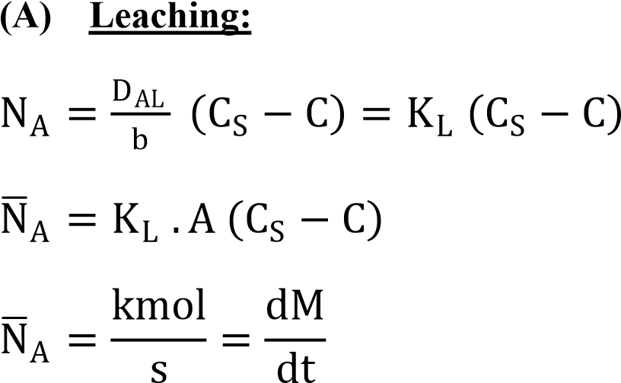

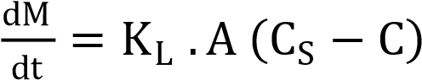



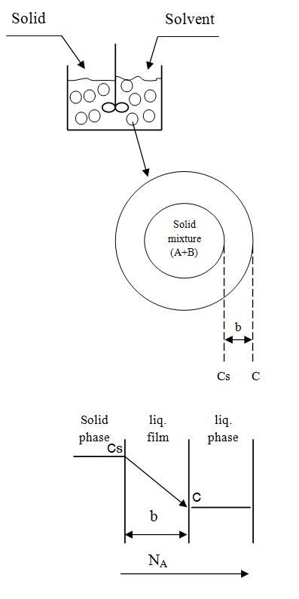d (Constant volume)

ln

C

S

−

C

C

S

=

−

K

L

.

A

V

t

C

S

−

C

C

S

=

e

−

K

L

.

A

V

t

C

=

C

S

1

−

e

−

K

L

.

A

V

t

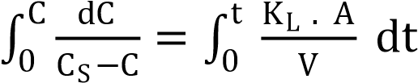

**(B) Number of Washing:**

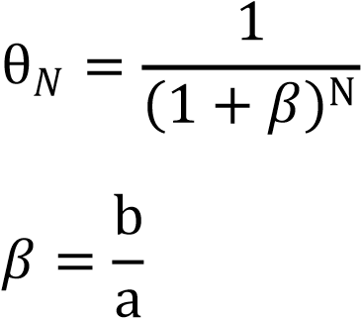

Where:

*:* is the fraction of solute remain with the residue from the original.

: Solvent decanted per solvent remaining in the insoluble solid.

a : is the solvent remaining.

b : is the solvent decanted.

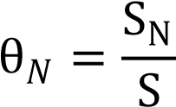 **equals/ divided by/**

SN : is the weight of solute remaining in the solid after washing.

S : is the original weight of the solute which was in the solid before washing.

**Example (1):**

500 kg of the inert solid containing 28 percent by mass of the water-soluble component (A), is agitated with 100 m3 of water for 600 sec.

After each decanting 25% of the solution produced remain in the residue. Water is saturated with the solute at a concentration of 2.5 kg/m3.

**Find the concentration of the solute (A)** in the solution after the leaching and **number of washing** such that the concentration of A in the solid residue is 0.01% by mass.

In a pilot scale test using a vessel 1m3 in volume, a solute was leached from an inert solid and the water was 75 percent saturated in 10 s. **Assuming conditions are equivalent to those in the pilot scale vessel.**

**Solution:**

For the pilot scale vessel:

V = 1 m3, t = 10 sec, Cs = 2.5 kg/m3 and C = 0.75 Cs

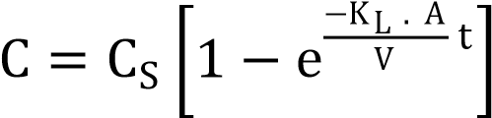 0.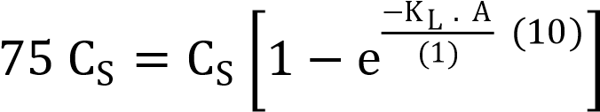



For the full-scale vessel:

V = 100 m3, t = ?,

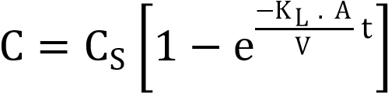 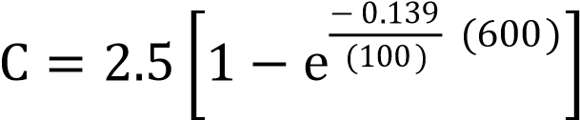

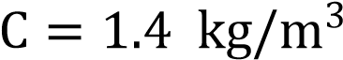

The initial amount of the solute in the solid = (500) (0.28) =140 kg



That’s mean that the leaching process is efficient.

**Number of washing:**

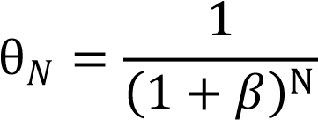

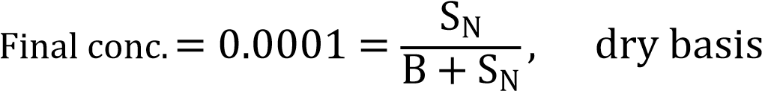

B = (500) (1- 0.28) = 360 kg 0.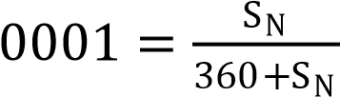

SN = 0.036 kg

S = (0.25) (100) (1.4) = 35 kg

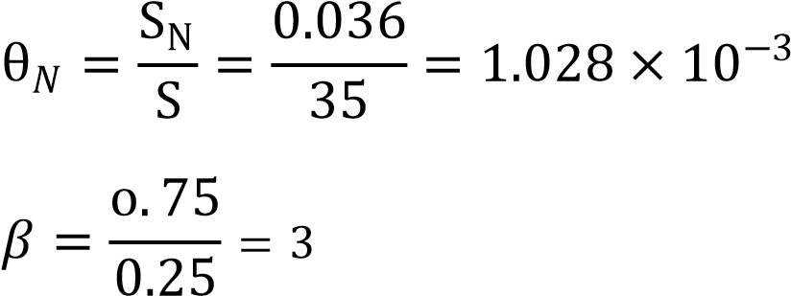

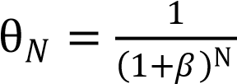

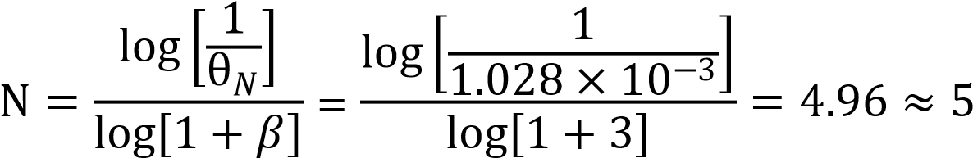

**Example (2):** Repeat the previous example (1) but the time of leaching is 300 sec. Find the concentration of solute in the solid (dry basis)? after five washes where the decanting ratio is the same.

**Solution:**

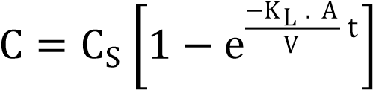 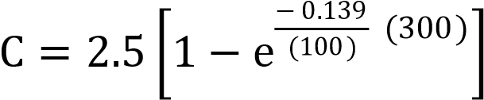

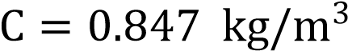

The amount of solute unleached = (500) (0.28) – (0.847) (100) = 140 – 84.7 = 55.3 kg

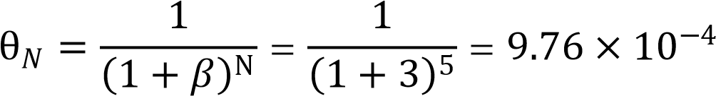

S = (0.847) (100) (0.25) = 21.175 kg

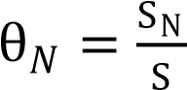 9.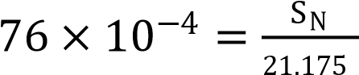

SN = (21.175) ( kg

B = (500) (1- 0.28) = 360 kg

Total solute = unleached + remaining in the solid after washing

= 55.3 + 2.kg

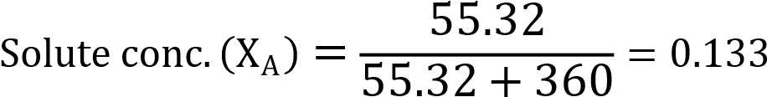

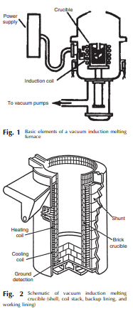**Practice 5. Vacuum melting of refractory materials**

Consider the vacuum melting of refractory materials and equipment according with nest consequence:

* Process design
* Equipment
* Main aim of the process
* Mechanism
* Chemical reaction
* Conclusion

**Practice 6. Calculation of the extraction process**

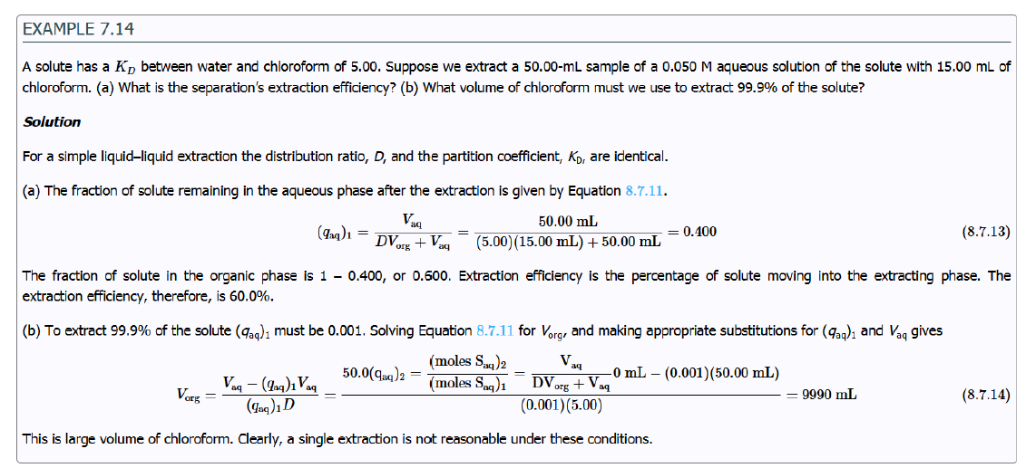

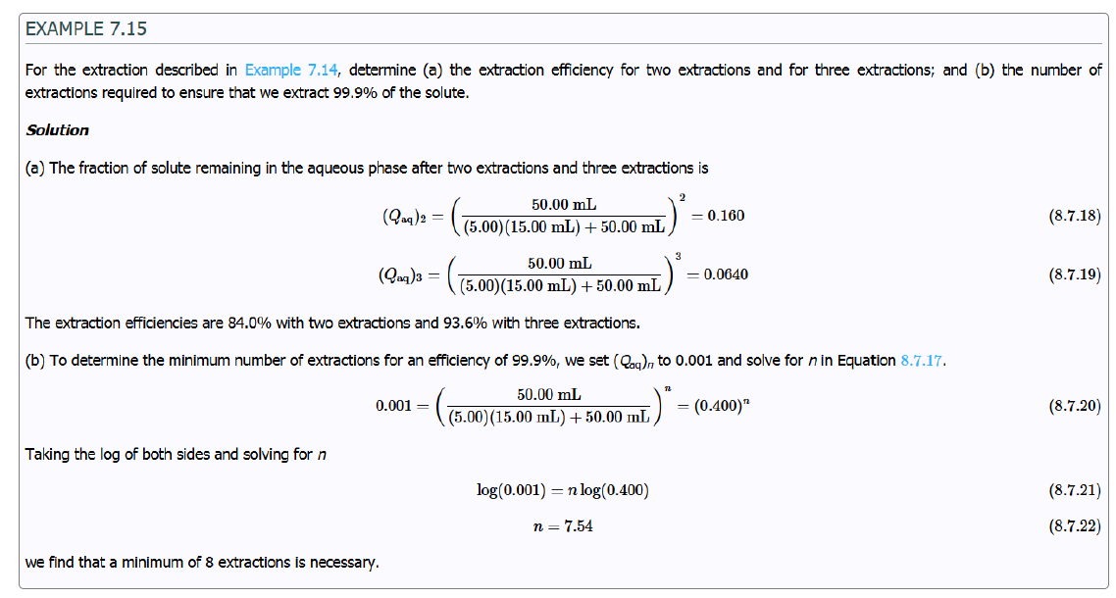

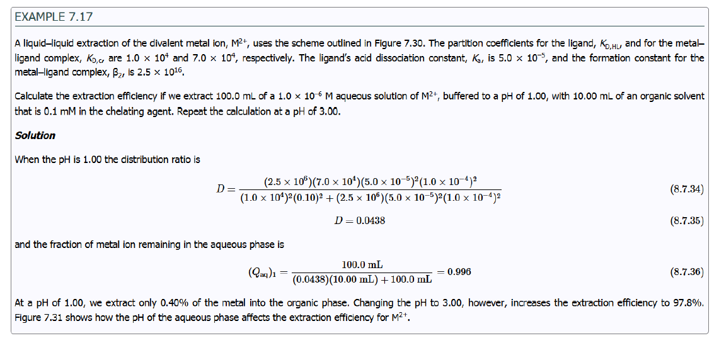

**Practice 7. Calculation of the sorption process**

If we are interested in recovering two ions, I1 and I2 of similar charge present in the solution, advantage is taken of the separation factor. The separation factor (*α*) of the resin is defined as the ratio of two distribution coefficients, *K*I1 and *K*I2 :



Use this following formula for sorption process calculation.

Ion exchange is carried out in two steps namely **“sorption” and “elution”.**

In the first step, the solution containing ions of interest

is allowed to pass through a column filled with grains of a resin in an appropriate

form.

During the downward movement in the column, the ions of the same charge as

those on the resin are taken up (sorbed) by the resin and the depleted solution flows out of the column. In the second step, the ions retained by the resin are recovered by percolating a suitable solvent (water, appropriate acidic or alkaline solution) through the bed.

The liquid eluted from the column contains the desired ions.

Therefore, elution is just the reverse of sorption. A resin can be employed for thousands of cycles. Often the

resin bed is regenerated during elution. When the bed becomes impervious due to pick

up of dust and insoluble matter, a “back-wash” with water is carried out to “loosen”

the bed and to remove mechanically entrapped matter.

**Practice 9. Thermal analysis of sulfide raw materials**

### **Abstract**

Thermal analysis is a critical, analytical, and characterization tool in the field of materials sciences. Specific thermal properties of synthetic polymers and biomaterials with different phases and morphology can be determined through this technique. Traditional thermal analysis techniques include differential scanning calorimetry (DSC), thermogravimetric analysis, thermomechanical analysis, and dynamic mechanic analysis. Among these techniques, DSC is the core thermal analysis technique. It was further developed into modulated-temperature DSC, quasi-isothermal DSC as well as fast DSC. The various DSC techniques and methods characterize the temperatures and heats and/or specific heat capacity changes at the thermodynamic and kinetic transitions of different materials such as low-molecular-mass substances, amorphous and semicrystalline synthetic polymers, and also biopolymers. Moreover, DSC can also help monitor the structural changes of polymers during the heating, cooling, and isothermal measurements. In addition, the calculation of the reversing and nonreversing heat flow can help separate the various transitions.

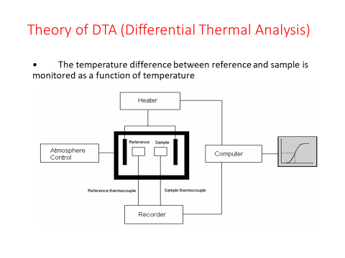

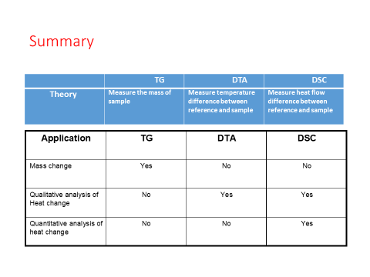

Make the analysis of thermal analysis application:

* Materials
* Technology
* Process

**Practice 10. Analysis of thermograms using the Proteus program, radiographs, diffractograms and the results of electron microscopic analysis of JEOL firing products**

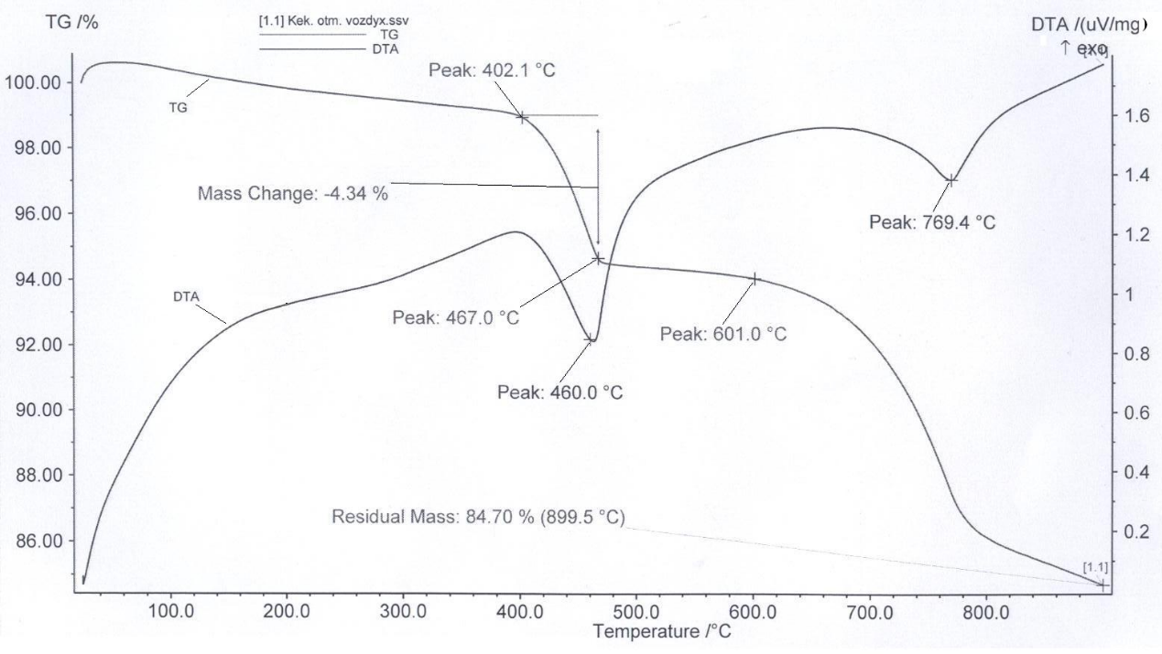

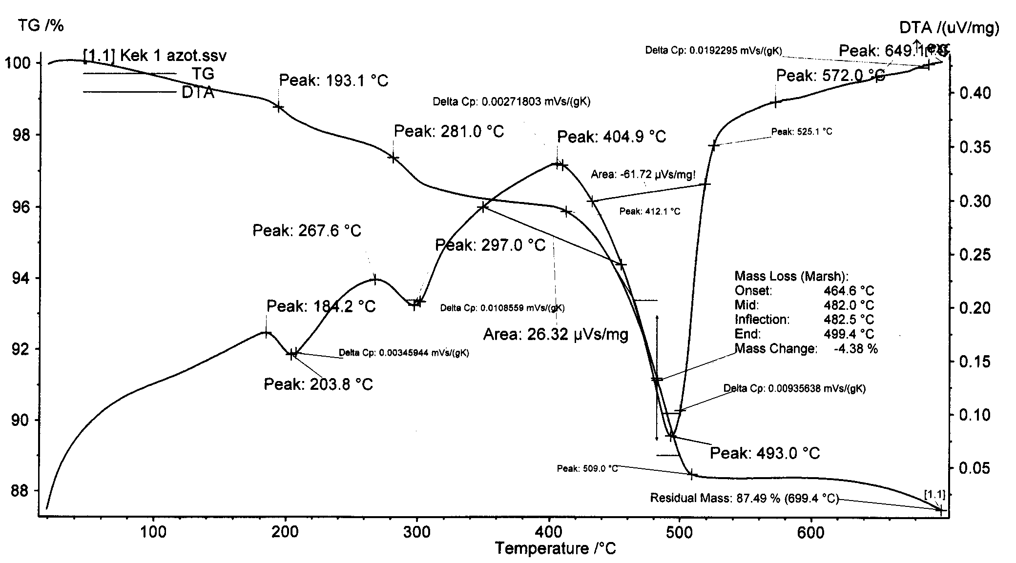

Make the analysis of thermogramms

* Peaks temperature
* Mass change
* Endo or exo peaks
* Analysis of the process – dehydration, oxidation, decomposition