Утверждено на заседании кафедры №4 от 22 октября 2021 г
Дисциплина IDO19907 Metallurgical engineering

Семестр весенний, учебный год 2022-2023

ЭКЗАМЕНАЦИОННЫЙ ЛИСТ
ВАРИАНТ 0
IDO19907 Metallurgical engineering
Проверка базовых знаний. Максимально 15 балла (сложность вопросов минимальная), время подготовки 48 минут
- Problem #1 (15 points)
A current of 0.2 amp was passed through molten potassium chloride for 1 h. What mass of potassium was liberated at the cathode?
If the same amount of current was passed through molten aluminium oxide for the same time, what mass of aluminium would be liberated at the cathode?
(i) m= 0.2 × 60 × 60 = 720 /96 500 = 7.5 × 10–3 mol electrons
Number of mol K discharged = 7.5 × 10^{–3} mol, or
m=7.5 × 10^{–3} × 39 =0.2925=0.3 g
(ii) (Al₂O₃) 0.2 × 60 × 60 = 720 /96 500 = 7.5 × 10–3 mol electrons
Number of mol Al discharged = 7.5 × 10^{–3} mol, or m=7.5 × 10^{–3} × 27/3 =0.0675=0.07 g
Answer
m(K) = 0.3 g; m(Al)=0.07 g
- Problem #2 (15 points)
Максимально 15 баллов (сложность вопросов средняя), время подготовки 24 минуты
Can carbon be used to reduce zinc oxide to zinc at a) 1000 K b) 1500 K?
Use the Ellingem diagram (Appendix 1)
Solution
The reaction we require is:
2C+2ZnO⟶2CO+2Zn
The graph shows that at 1000 K we have the following approximate ΔG values:
1. 2C+O₂⟶2CO ;ΔG=−400 kJ mol⁻¹
2. 2Zn+O₂⟶2ZnO; ΔG=−550 kJ mol⁻¹
So reversing reaction 2:
3. 2ZnO⟶2Zn+O₂; ΔG=+550 kJ mol⁻¹
Adding 1. and 3. we get:
4. 2C+O₂+2ZnO⟶2CO+2ZnO+O₂
ΔG=−400+550=+150 kJ mol⁻¹
So at 1000 K the reaction is not feasible. At 1500 K we have the following ΔG values:
5. 2C+O₂+2ZnO⟶2CO+2ZnO+O₂
6. 2Zn+O₂⟶2ZnO ;ΔG=−250 kJ mol⁻¹
So:
2ZnO⟶2Zn+O₂ ;ΔG=+250 kJ mol⁻¹
Adding 4. and 6. and cancelling the oxygens as above we get
2ZnO+2C⟶2CO+2Zn ;ΔG=−250 kJ mol⁻¹
Проверка глубоких знаний, навыки анализа.
Максимально 10 баллов (сложность вопросов высокая), время подготовки 50 минут.
- Task#3 (10 points)
Write the processes (chemical reactions) to be carried out to obtain metals using method/device given below
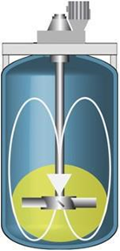

Aswer
In the figure shown the apparatus in which agitation leaching is carried out.
Basic types of leaching are:
  - Underground leaching (in-situ leaching)
  - Heap leaching
  - Percolation leaching
  - Agitation leaching
  - High-pressure leaching (autoclave leaching)
  - Biological leaching.
Agitation leaching is significantly influenced by the proportion of liquid and solid phases. To ensure maximum leaching efficiency, this ratio has to be the lowest possible. Other factors influencing the leaching process are material lumpiness, temperature, pressure and intensity of contact of ore particles with the leaching solution. Agitation leaching can be performed either continuously, or discontinuously.
During continuous leaching, a mash flows through a line of agitation units connected one by one. This method is usually supplemented with continuous vanning, thickening and filtering.
During discontinuous leaching, a mash is pumped into simultaneously operating agitation units and then pumped out into a catch basin after leaching. This process is constantly repeated.
Leaching tanks with agitators are divided into these groups:
- mechanical:
  - mash collecting tanks (reservoirs of mash kept in a suspended state),
  - tanks with propeller agitators,
  - tanks with suction agitators,
- pneumatic
- combined

Критерии оценивания
Оформление ответов – 5 %
Точность решения задачи – 40 %
Полнота решения задачи – 40 %
Креативность и оригинальность в решении задачи (для определенного вида задач) – 15 %

Экзаменатор К.К. Мамырбаева

Appendix 1
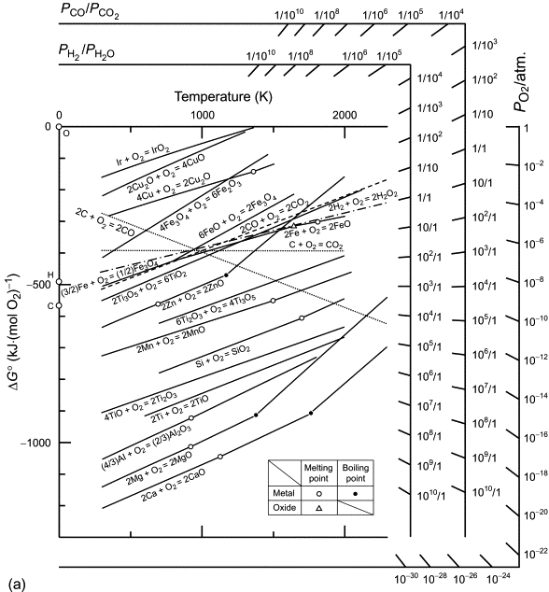
Temperature

