**2. Unit properties of metals**

**Metals. Classification of Metals. METALS.** Elements are broadly divided into two groups—metals and nonmetals.

The properties of element: are largely governed by factors such as size, polarizability, and the charge carried by the ions that they form.

These factors are functions of the atomic structures; the latter provide a fundimental basis for the classification of elements, i.e., the periodic table of elements (given in Table 1).

Although the periodic table shows a classification of elements based on certain universally accepted criteria, the division of elements into, metals and nonmetals is rather imprecise. There are several borderline cases where the element is neither distinctly metallic nor distinctly nonmetallic. This table, however, explains the gradual transition from the metallic to the nonmetallic properties of the elements, and vice versa, as the atomic number increases.

Although it is difficult to define a metal precisely, material scientists classify as metals these elements whose electrical resistivities increase with temperature. However, in common parlance an element may be considered a metal if it exhibits a lustre (commonly called ‘metallic lustre and possesses a good electronic conductivity and good mechanical properties such as ductilir malleability, strength, hardness, impact strength, and fatigue strength. The metallic behaviour of an element depends also on its basic nature, i.e., its tendency to react with an acid. There are however, many exceptions to the aforestated criteria. For example, brittle metals such as arsenic and bismuth hardly.possess any ductility, whereas nonmetals such as iodine and graphite (a foni of carbon) exhibit a metallic lustre. (Graphite also possesses a remarkable electrical conductivity Diamond (another form of carbon and a nonmetal) is one of the hardest substances known.

Further, the mechanical properties of metals change with heat treatment and with the concentra­tion of impurities.

Despite such exceptions, we can make some general predictions on the properties of metals, knowing their positions in the periodic table.

In the periodic table, the properties of the elements show that the metallic nature of the elements increases along a vertical column (known as a group) as we proceed from the top to the bottom and along a horizontal row (known as a period) as we proceed from the right to the left.

The extranuclear electronic structures of elements, within each particular group, are similar to each other. However, in the periods, the elements towards the right have an increasing number of electrons in their outermost shell, which indicates that the metallic behaviour of elements increases as the atomic number in the groups increases. It follows that the elements are decidedly nonmetallic at the extreme right of the periods. For instance, iodine, although it forms a few salts such as iodine sulphate, is a nonmetal.

REACTIVITIES OF METALS

The electronic structure of elements serves as a basis for determining their reactivities. Such a procedure would, however, be too fundamental when dealing with metals alone. Extractive metallurgists have employed many criteria simpler than the electronic structure to estimate the reactivities of metals. These criteria are based on the properties of the metals or their compounds that are now listed:

1. The reversible electrode potential in aqueous solutions and fused salts.
2. The free energy of formation of compounds such as oxides and sulphides.
3. Electronegativity.

*REVERSIBLE ELECTRODE POTENTIALS*

*Numerous reactions in metallurgical extraction processes are electrochemical in nature and depend on the transition of a metal from an ionic state to the elemental form or vice versa. The chemical equilibria of the reactions during such a transition are determined, among other factors, by the value of the electrode potential of a system constituted by a metal and its ion under the given conditions of temperature and activities. (This has already been discussed in Section 2.21.) Since reactions in extraction processes generally take place in media such as aqueous solutions and molten salts, we shall now discuss electrode potentials in these media.*

*ELECTRODE POTENTIALS IN AQUEOUS SOLUTIONS*

*As already discussed in Section 2.21, the electrode potential* E *directly indicates the tendency of a metal to form an ion, i.e., its reactivity in the aqueous medium. As is obvious, the higher the electrode potential, the greater is the negative free energy change and, therefore, the greater the reactivity. Table 3.2 lists the standard electrode potentials of some elements based on the hydrogen scale. It should be noted that the metals placed in higher positions in the electrode potential series form ions more readily than those in lower positions.*

*ELECTRODE POTENTIAL IN FUSED SALTS*

*The difficulty faced in finding a reference electrode for expressing electrode potentials in fused salt systems has already been discussed in Section 2.21. While the hydrogen electrode serves as a universally accepted reference for aqueous systems, no such electrode exists for fused salt systems. However, for a quantitative comparison of the electrode potential of one element with*

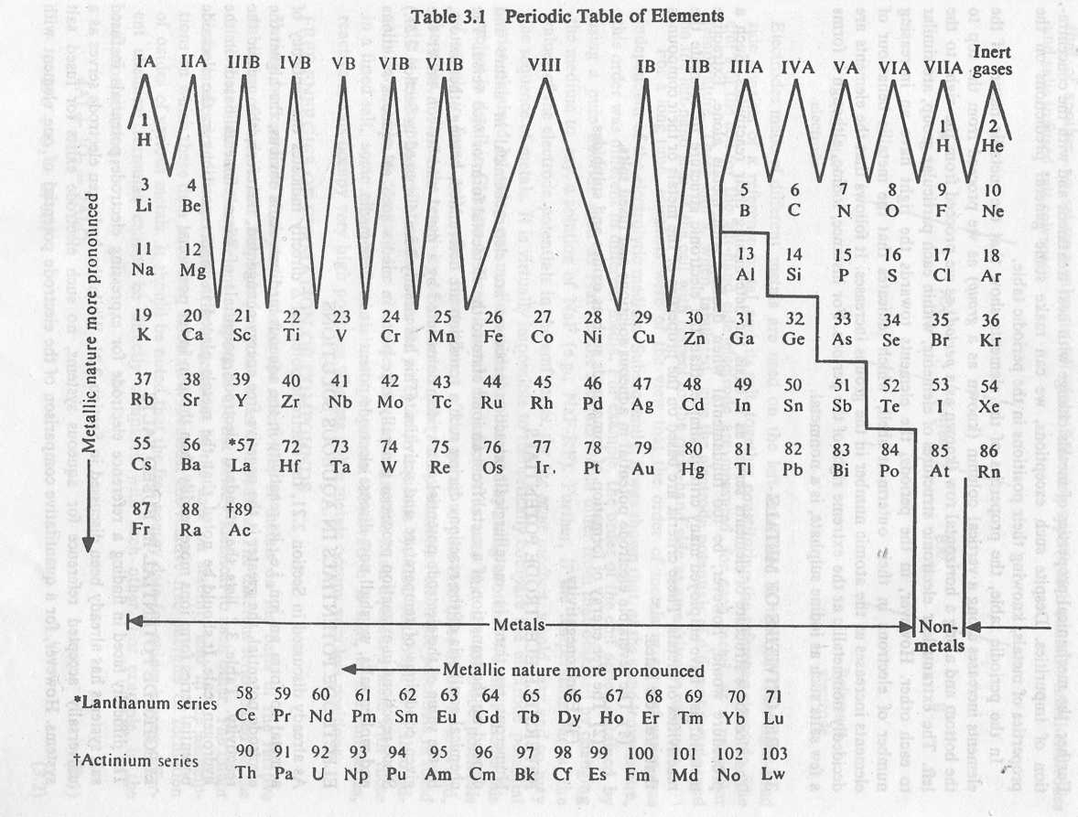

The chemical properties of Metals and Nonmetals are described below. Let us start with the chemical properties of metals.

* The density of metals is usually high.
* [Metals](https://www.toppr.com/guides/chemistry/metals-and-nonmetals/physical-properties-of-metals-and-non-metals/) are malleable and ductile.
* Metals form an alloy with other metals or non – metals.
* Some metals react with air and [corrode](https://www.toppr.com/guides/science/physical-chemical-changes/rusting-iron/). For e.g. Iron.
* Metals are good conductors of heat and electricity. [Lead](https://www.toppr.com/guides/chemistry/the-p-block-elements/group-14-elements-carbon-family/) is an exception.
* Generally, metals are in a solid state at room temperature. Except for Mercury. Mercury is in a liquid state.
* Many metals produce metal oxide by burning in the oxygen of the air. [Highly reactive metals](https://www.toppr.com/bytes/reactivity-series-of-metals/) react violently when they’re burnt in oxygen.
* Metals like sodium and potassium are stored in oil as they react with air in seconds. They’re highly reactive metals.
* Less reactive metals like gold, silver, platinum, etc do not tarnish easily. They stay shiny and lustrous.
* Metals produce metal oxide and [hydrogen](https://www.toppr.com/guides/chemistry/hydrogen/position-of-hydrogen-in-the-periodic-table/) gas while reacting with water.
* Soluble metal oxides dissolve in water and create metal hydroxide.
* Not all metals react with water. However, highly reactive metals like sodium and potassium react with water violently and an [exothermic reaction](https://www.toppr.com/guides/chemistry/chemical-reactions-and-equations/types-of-reactions/) takes places where the hydrogen immediately catches fire.
* Salt and hydrogen are produced when a metal reacts with an acid.
* Generally, a metal displaces a less reactive metal in a metal salt solution.

Did you know? Sodium is the most reactive metal.

## Chemical Properties of Nonmetals

In the chemical properties of metals and nonmetals, we will now see the chemical properties of nonmetals

* Nonmetals are poor conductors of heat and electricity. Graphite and Gas carbon are exceptions.
* Unlike metals, nonmetals aren’t malleable and ductile.
* Nonmetals react more with metals than with nonmetals.
* Usually, nonmetals react with other nonmetals in high temperature.
* Most nonmetals do not react with air in room temperature.
* White phosphorus is the only nonmetal that reacts with air to form its oxide by burning.
* Usually, nonmetals do not react with water. Except for Chlorine, chlorine dissolves in water to form an acidic solution.
* Nonmetals have a low density.
* They do not form alloys. However, nonmetals like carbon, silicon and phosphorous.
* Nonmetals exist in all states of matter at room temperature.
* Different nonmetals have different reactions.
* Chlorine is the most reactive metal in the [halogen family](https://www.toppr.com/guides/chemistry/the-p-block-elements/group-17-elements/) i.e. Chlorine (Cl), Bromine (Br), Iodine (I), and Fluorine (F). The reactivity order of the halogen family is Cl > Br > I.
* Therefore, Chlorine (Cl) can displace Bromine (Br) and Iodine (I) from solutions of bromides (NaBr) and Iodides (NaI).
* Ionic solids are formed when nonmetals with high electronegativity react with alkali and alkaline earth metals.

**Classification of Metals**

A common classification of metals is given below. Note that iron is the only element that is both abundant and has useful metallic properties. Some other elements are important primarily because they alloy with iron to form various steels. The non-ferrous metals are in high demand in their own right. Precious metals are important because of their value, fissionable metals because of their radioactive properties. Minor metals are produced in small quantity but all have important, specialist uses.

Subdivision of metals used by the metals industries. –

|  |  |
| --- | --- |
| Group | Typical metals |
| Iron and ferroalloy  (ferrous) metals | iron, manganese, nickel, chromium, molybdenum, tungsten, vanadium, cobalt |
| non-ferrous metals | copper, lead*, zinc*, tin, aluminium |
| precious metals | gold, silver, platinum group |
| fissionable metals | uranium, thorium |
| minor metals | antimony, arsenic, beryllium, bismuth, cadmium, mercury, niobium, selenium, tantalum, tellurium, titanium, zirconium |

  * Also known as base metals