Lesson 7 Smelting
Smelting is a type of pyrometallurgical processing of raw materials, during which a metal- containing batch is heated above its melting temperature in order to separate metal content and waste within the smelt. During the process, two liquid phases are generated – metal concentrates in the heavier one and waste concentrates in the lighter one as slag. Sometimes, generation of three and more liquid phases is favorable, since metal concentrates in the heaviest one, its compounds in the lighter one, while slag is the lightest one. Raw materials for smelting, such as ores, ore concentrates, semi- products, wastes, rests, scrapings etc., contain among main metals also accompanying elements – admixtures and impurities. During smelting, reduction proceeds to produce a raw metal, which is subsequently refined to the required degree of purity. The metal can be subsequently concentrated to produce metal compounds, such as matte and speiss, or it can get separated into other smelting products – slag, air-borne dust, light ash, gasses and more. Smelting can be divided into two basic types:

Smelting to produce compounds
  - concentration smelting
  - coagulative smelting
  - dissociative smelting

Smelting to produce metals
  - thermal reduction processes
  - reaction smelting
  - reduction processes of smelting and reducing
  - displacement smelting
  - oxidizing smelting – convertor processing
  - refining smelting and remelting
  - electrolytical smelting etc.

Pyrometallurgical processing of ores and concentrates includes two main stages:
- metal reduction
- waste separation
During smelting, various batch components dissolve or react with each other to generate final smelting products – metal, matte and slag, having different properties (melting temperature, density, chemical affinity, viscosity etc.).

- SMELTING TO PRODUCE COMPOUNDS

Concentration smelting
Concentration smelting consists in conversion of a metal compound into an individual semi- product, which can be separated from the waste due to their different physical properties, and from which the metal can easily be separated by further technological processing. It therefore consists in increasing in the content of an element in the semi-product – its concentration in the melt. Most of the heavy NFMs have a quite high affinity to sulphur. Therefore they concentrate to produce an individual sulphidic semi-product called matte – a compound of metal sulphides, in which the generated NMF is concentrated. A collective component for all the mattes is ferrous sulphide FeS. Among sulphides, mattes also contain a certain amount of oxygen, which is mostly bound to ferrous oxides.
NFMs with high affinities to antimonite and arsenic concentrate in an individual semi-product containing arsenides and antimonites called speiss. The density of a speiss is higher than the density of

a matte. Therefore, it is located between the matte and metal during smelting. The main components of speiss are arsenides and antimonites of nickel, cobalt, iron and copper (Ni3As2, Ni5As2, Ni5Sb2 etc.). The occurrence of speiss is usually unfavorable, since noble and precious metals divide between matte and speiss and do not concentrate in only one of these semi-products. Moreover, processing of a speiss is rather difficult. The basic reactions to produce a matte are:
MeO + MS = MeS + MO Cu2O + FeS = Cu2S + FeO
MO oxides, generated by these reactions, concentrate in a slag, where they bound slag- producing oxides, such as SiO2, CaO, Al2O3...
Among copper, especially precious metals, tin, lead and non-volatile portions of antimonite, arsenic and bismuth and a bigger portion of nickel separate into a matte. Approximately half of the overall cobalt and zinc content and a significant part of iron separate into a slag.

Coagulative smelting
During this type of smelting, addition of a reagent results in separation of a certain component from the smelt on the basis of its different properties. For example, an addition of calcium into a liquid alloy of lead and bismuth leads to coagulation of Bi3Ca dissoluble compound, which then floats on the surface (Betterton-Kroll method). Similarly, silver and gold are separated from lead using zinc – Parkes process. This type of coagulation smelting is based on a formation of intermetallic compounds of silver and gold with zinc – Ag2Zn3, Ag2Zn5, AuZn, Au3Zn5, which have higher melting temperatures than lead. During cooling of a lead bath, these compounds float towards the surface of a smelt and form foams (Parkes skimmings), which are collected at temperatures between 340 and 380°C. These skimmings, which represent wastes from lead refining and in which precious metals concentrate, are after separation of Zn used as raw materials for productions of precious metals by cupellation.

Dissociative smelting
It is a pyrometallurgical process, during which flux agents are added to ensure changes of phases and chemical compositions of the processed ores and concentrates. Ores for hydrometallurgical processes are usually prepared by dissociative smelting, since the change in chemical composition lies in conversion of dissoluble metal minerals to soluble and extractible compounds.
According to the character of the flux agent and therefore the whole process, smelting can be either acidic, or alkalic. The important acid flux agents are normal and acid alkali metals sulphates (Na2SO4, K2SO4, NaHSO4, KHSO4). The most important alkalic flux agents are NaOH, KOH, Na2CO3, K2CO3. The effect of alkalic dissociation can be increased by oxidation using oxidizing agents, such as NaNO3, KClO3, Na2O2, or by reduction using NaCN, elemental sulphur, coke and other agents. Dissociation smelting is used usually to process ores of precious metals.

Example ⇒ smelting of tungsten with NaOH to generate soluble sodium tungstate: (Fe-Mn)WO4 + NaOH → Na2WO4 + Fe2O3 + Mn3O4

SMELTING TO PRODUCE METALS

Thermal reduction processes – reduction smelting
Reduction smelting is usually used to produce metals from raw oxide materials – e.g. production of Fe, Sn, W, Ta, Nb, Mn, Cr and other metals. To produce metals from raw sulphidic materials, e.g. production of Pb from galena, Zn from zinc blende, Mo from molybdenite, etc., the sulphidic raw material has to firstly be roasted by oxidizing to produce oxides, which are subsequently reduced to metals. Halides and many other metal compounds can be reduced as well.

As reducing agents, H2, CO, CH4, products of natural gas or coal distillation dissociation, solid carbon, calcium carbide and various metals with higher electronegativities than of the reduced metals are usually used. The basic equations of oxides reductions can generally be expressed as:
MeO + RO(g) → Me + RO2 MeO + R(s) → Me + RO
where RO are reducing agents, i.e. all the agents able to dissociate oxygen from an oxide.

Dissociation of oxides as a reducing process
The easiest reducing reaction is dissociation of oxides:
2 MeO ↔ 2 Me + O2
The equilibrium constant of this reaction can be expressed by:
p a²
K = O2∙ Me =p
p 2 O2
a
MeO
where pO2 is the equilibrium pressure during thermal dissociation of a generated gas, which is in equilibrium with a thermally dissociated compound – dissociation pressure.

If only pure components are involved in the process, activities in solid states are constant values and Kp = pO2.
The temperature, at which the dissociation pressure pO2 of a given compound is equal to the value of atmospheric pressure is the dissociation temperature (Fig. 2.2). Dissociation temperature is the lowest temperature needed for intensive dissociation and a complete conversion to simpler components.
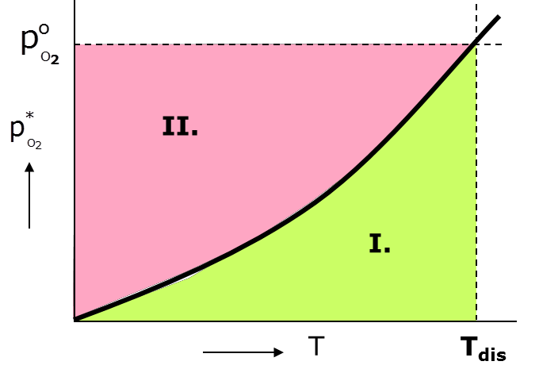
Fig. 2.2 Dependence of dissociation pressure pO2 on temperature: I – dissociation to Me, II – stability of MeO.

Chemical reduction of metals
Reduction of metals is performed using reducing agents, which have higher affinities to oxygen than the reduced metals. Abilities of compounds to bind oxygen can be evaluated using values of Gibbs energies (ΔG) for generation of oxides at various temperatures. Temperature dependences of changes of the Gibbs free energies of reactions to produce oxides of individual elements are depicted in Ellingham–Richardson diagrams (Fig. 2.3). The more negative the value of Gibbs free energy change ΔG is, the more stable is the oxide (CaO, MgO, Al2O3). The lines for individual metals and their components change their directions at temperatures of melting TM, boiling TB and sublimation TS. From the almost parallel character of changes of the Gibbs free energies with temperature for the individual metals during bonding ensues that metals can be reduced by different metals from their compounds of a same kind in a certain order. A metal with a lower (more negative) Gibbs free energy can reduce a metal with a higher Gibbs free energy. If a metal forms several oxides, the lowest oxides

are always the most stable, e.g. (Fe) → FeO → Fe3O4 → Fe2O3. Therefore, higher metal oxides are reduced more easily than lower metal oxides.
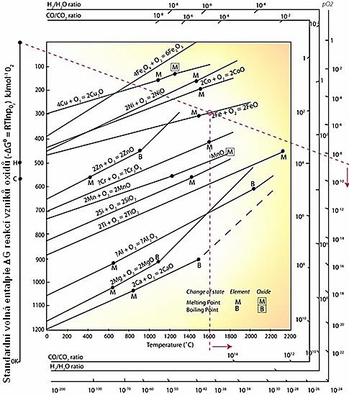
Fig. 2.3 Ellingham-Richardson diagram – temperature dependence of Gibbs free energies ΔG for reactions of metals oxides generation [3].

Reduction of oxides by gaseous reducing agents – H2, CO, CH4 etc.

General form of a reaction of reduction of oxides using gaseous reducing agents: MeO(s) + H2 (CO)(g) ↔ Me(s) + 2 H2O (CO2)(g)
The equilibrium constant of this reaction can be expressed by:
K = pH2O(CO2) =f(T)
p
pH2(CO)
The most effective reducing agents are carbon monoxide at lower temperatures and hydrogen at higher temperatures.
Reduction by a gas involves, from thermo-dynamic point of view, simultaneous processes of dissociation of a metal oxide and mutual action of a reducing gas with oxygen:
2 MeO ↔ 2 Me + O2 + ΔG1
2 H2O ↔ 2 H2 + O2 + ΔG2 or

2 CO2 ⇔ 2 CO + O2

S. R. 2 MeO+ 2 H2 (CO) ⇔ 2 Me + 2 H2O (CO2) + ΔG
The possibilities of the final reducing reaction process can be evaluated using thermodynamic potentials of dissociation reactions (1) and (2):
ΔG = 1/2 (ΔG1 - ΔG₂)
Conditions for reduction of an oxide: Δ G < 0; ΔG2 > ΔG1; po2(g) < po2(MeO) Conditions for oxidation within the system: Δ G > 0; ΔG1 > ΔG2; po2(g) < po2(MeO) Equilibrium conditions within the system: Δ G = 0; ΔG2 = ΔG1; po2(g) = po2(MeO)
Speed of a metal oxide reduction depends on many factors:
- character of the batch materials containing metal oxides to be reduced, i.e. their mineralogical composition and physical properties, such as size of ore pieces – lumpiness, ore porosity, uniformity of distribution of the oxide in the prepared material etc.,
- process temperature,
- reducing gas composition (mixture of gases),
- speed of penetration of a gaseous mixture flowing through the batch and drifting carbon dioxide produced by reduction, other gaseous products and unused reducing gas – carbon monoxide.

Pure carbon monoxide is used to reduce compounds of Ni, Cr and other metals within the carbonyle process. Hydrogen is used to reduce pure metal oxides – reduction of oxides of high-melting metals Mo, W, Re, production of pure metals Fe, Ni, Co, Bi and other. Hydrogen reduces metals oxides already at relatively low temperatures, which is favorable especially for reducing of oxides of high-melting metals. The products of the reaction are metal – usually as powder, and aqueous vapor.

4. Reduction of metal oxides by carbon
The reaction of a solid metal oxide MeO with carbon, denoted as direct reduction, can be summarized by equations:
MeO(s) + C(s) = Me(s) + CO (g) (1)
2 MeO(s) + C(s) = 2 Me(s) + CO2(g) (2)
Partial reaction of equation (1):
MeO + CO = Me + CO2 CO2 + C = 2 CO
MeO is an oxide of Me metal (Cu2O, PbO, NiO, FeO, ZnO). The MeO oxide, as well as the reduction product Me, can also be present as liquids during reduction smelting. Since an increase in volume occurs during reaction due to generation of gaseous products (CO, possibly CO2), a decreased pressure supports the reaction in the direction from left to right. At high temperatures, the second reaction loses its importance, since with increasing temperature the portion of carbon monoxide in the gaseous mixture increases significantly by the Boudouard reaction (CO2 + C = 2 CO) – see Fig. 2.4.
Direct reduction occurs only if particles of a reduced oxide are in a direct contact with a reducing agent. Reduction by carbon monoxide gaseous reducing agent – indirect reduction – is significantly faster than reduction by solid carbon, since a reducing gas surrounds the to be reduced particles and also penetrates to their pores. During this reduction, CO is consumed and CO2 is generated. Subsequently, carbon monoxide regenerates from carbon dioxide by an addition of a solid reducing agent (carbon, coke, charcoal etc.) according to the Boudouard reaction. Kinetics of this reaction is given by speed of the chemical reaction at lower temperatures and by speed of diffusion at higher temperatures.

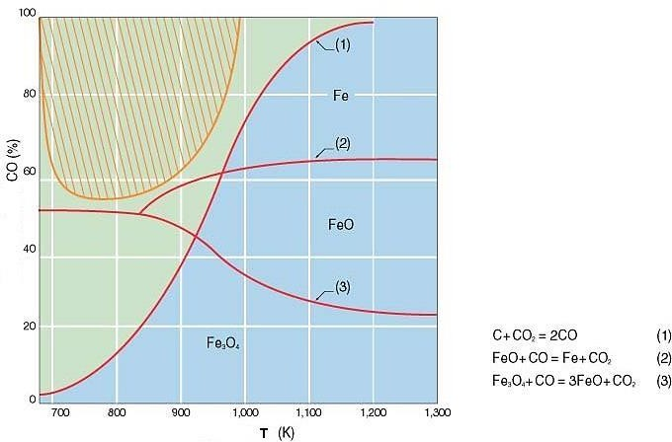
Fig. 2.4 Equilibrium curves of temperature dependences of reductions of metal oxides by carbon during the CO2 + C = 2 CO reaction – the Boudouard reaction [4].

Thermal processes of metal compounds reductions
Among thermal processes belong also reduction processes of production of metals and their compounds, during which solid reducing agents and high temperatures are applied. From the heat intake and consumption point of view, the processes can be denoted as auto-thermal and electro- thermal. According to an applied reducing agent, the processes can be divided into:
- Carbothermic processes – the reducing agent is carbon in the form of coke, coal, graphite or pure soot.
- Metallothermic processes – the reducing agent to reduce metal compounds (oxides, halides, etc.) is a metal or another metallic element:
  - Al ⇒ aluminothermic reduction process
  - Mg ⇒ magnesiothermic reduction process
  - Si ⇒ silicothermic reduction process
  - Ca ⇒ calciothermic reduction process
  - Na ⇒ sodium-thermic reduction process
During thermal processes, melting of metals and slags occur at high reaction temperatures in the reaction area.

Carbothermic reduction processes
These processes are used to reduce hardly reducible metal oxides by carbon reducing agents in pure forms at high temperatures, which are achieved via electric heating in the reaction area of an electric furnace. The necessary temperature and gas partial pressure for reduction of a selected hardly reducible oxide can be found in a relevant Ellingham-Richardson diagram – see chapter 2.3.4. A general carbo-thermal reaction can be described as:
MeO + C ↔ Me + CO
Equilibrium state of the reaction can be influenced by:
  - change of temperature, since ΔG is dependent on temperature

  - change of equilibrium activity via
    - reacting compounds
    - additive compounds (Cl, F etc.)

By a change of equilibrium reducing atmosphere (decrease in CO content), a required carbo- thermic reaction can proceed completely, since the CO partial pressure becomes lower than the equilibrium pressure. Equilibrium can also be broken by production of carbides of the prepared metals.
Carbo-thermic processes are used to produce metal Nb and possibly V and Mo, furthermore Ti and Zr compounds or master alloys with other transition metals, ferroalloys and more, using pure soot as a reducing agent.

Reduction of metal compounds by metals – metallothermic processes
Metallothermic reduction of oxides

The basic reaction of reduction of metal oxides by metal reducing agents (Ca, Mg, Na, Al, Si) can generally be expressed as:
s Me mOn + rR ↔ s.m Me + R r Os
n n
This equation summarizes a metal-thermal reaction, for which the oxide produced from a reducing agent is alkalic, e.g. CaO, MgO, Na2O… If the reducing agent produces an amphoteric oxide, such as Al2O3, or acid SiO2 oxide, then the basic oxide of the reduced metal reacts to produce complex compounds:
MemOn + RrOs ↔ MemOn.RrOs The summarizing reaction of metal-thermal reduction is then:

n + s Me n
m On
- rR ↔ s.m Me + Me n
m On
. R r Os

This reaction is not favorable since the reduced metal also separates into the slag, which lowers the effectivity of the reduction process.

Metallothermic reduction of metal halides
This process is used to produce metals, which cannot be reduced from their oxides, or can be reduced only hardly. The raw materials for reductions are usually metal chlorides or fluorides prepared
e.g. by chlorination or fluorination.
From such halides the metal can be reduced by another metal with a higher affinity to the applied halide element. These metallothermic reactions proceed according to general equations (R – reducing agents – Mg, Na, K, Ca etc.):

y MeCl x x
y MeF

- R ↔ y Me + RCl
x y
- R ↔ y Me + RF

x x x y
when displacement of a Me metal from its MeCl2 chloride by a R metal, the affinity of which to chlorine is higher than the affinity of the produced Me metal, occurs.

Aluminothermic reduction process
The high reaction heat of aluminothermy reactions according to the following equation 3 MeO + 2 Al → 3 Me + Al2O3 + Q
is sufficient to reduce most oxides to the basic metals and enables operation without any additional

heat source. Aluminothermy is used to produce e.g. vanadium and niobium with 0.2% residual oxygen content and up to 15% of residual aluminum, which is subsequently removed by remelting in an electron furnace (final purity 99.9%). It can also be applied to prepare ferroalloys and to deoxidize steels as Si-Al, Fe-Si-Al, Fe-Al-Si-Mn, Fe-Al and more.

Magnesiothermic reduction process
Magnesiothermy is used primarily to reduce halides – fluorides and chlorides, less to reduce oxides. This method is applied to produce e.g. Be, Ti, Zr, Hf, U, Z, Th and others. Contrary to sodium and calcium, magnesium has a relatively low reaction heat, which is sometimes not sufficient and additional heat has to be supplied.

Calciothermic reduction process
Calcium is a strong reducing agent, which reduces all halides and many oxides to the basic metals (e.g. vanadium, uranium, chromium, titanium, thorium and plutonium oxides; uranium, thorium, plutonium and scandium halides etc.). In practice, calciothermy is mostly applied to reduce fluorides, which are contrary to chlorides usually solid and not sensitive to humidity at normal temperatures. Metal fluorides are often the final products after processing of ores or they can be prepared from oxides by application of hydrogen fluoride or ammonium fluoride.

Sodium-thermic reduction process
Sodiothermy is applied to reduce chlorides and fluorides of transition high-melting metals – titanium, tantalum, vanadium, zirconium, hafnium and thorium. Due to their low ΔG value, reduction of oxides by sodiothermy is very difficult.

Silicothermic reduction process
This type of reduction is performed using silicon or ferrosilicon. A disadvantage of silicon as a reducing agent is a formation of non-stable silicates, which cannot be evaporated by dissociation and evaporation of silicon due to their high boiling temperatures. In practice, silicothermy is applied to reduce chromium oxides, to prepare ferrochromium from ores and mixtures of ores with slag-forming additions and to prepare other ferroalloys and master alloys, such as Fe-Zr-Si, Si-Mn, Si-Cr, Fe-Nb, Fe-V etc. with silicon content from 4 to 20 (40)%.

Reaction smelting
Reactions between sulphides and oxides of a same metal or of different metals occurring within ores and concentrates are highly important during production of certain NFMs (Cu, Ni, Pb). During reaction smelting, two metal compounds react together at temperatures higher than melting to produce a metal. A reaction between a sulphide and an oxide of a same metal is the mostly occurring one:
MeS + 2 MeO ↔ 3 Me + SO2
Metal oxides are generated either by oxidation of a portion of sulphides during smelting, or by exchange reactions between Me metal sulphides and M metal oxides.
MeS + MO = MeO + MeS
The direction of a given reaction of conversion of a metal oxide to a metal sulphide can be entirely controlled if affinities of the individual metals to sulphur are known.

Displacement smelting
In some cases, displacements in sulphides (ZnS, PbS, HgS) by iron or other metals occur during their processing according to the reaction:

MeS + M = Me + MS
The basic presupposition for this reaction is a higher stability of MS sulphide than of Me. A disadvantage of this process is production of a matte, in which most of the reduced metal is melted.

Products of smelting
The following products are generated during smelting due to the occurrence of chemical, physical-chemical and physical reactions: metal, slag, matte, speiss, light ash, air-borne dust and gasses. It is necessary to separate all the products (Fig. 2.5). Separation of the present phases is influenced by the following factors:
- their mutual solubility and miscibility
- their different densities
- their different viscosities
- effective forces of surface tensions
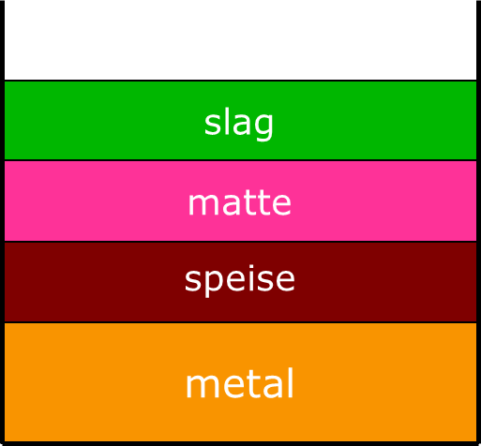

Fig. 2.5 Product of smelting.

Separation of two mutually dissoluble phases is possible only if the difference between their densities is minimally 1 kg.dm-3. The raw metals produced by reduction processes have to be subsequently refined.

Slag
Besides valuable minerals, ores and concentrates also contain admixtures, waste and deads, which have to be separated from the reduced metal into a slag. Selection of an optimum slag composition has the most significant influence on the smelting process. Main functions of a slag are:
- to control heat transfer from a gaseous atmosphere into a melted metal,
- to form a protective layer on a metal bath, making dissolution of gasses from a furnace atmosphere in the melted metal more difficult.
Slag is an alloy of oxides of metal and non-metal elements forming compounds and solutions.
Among this it also contains a small amount of metals, metal sulphides and gasses. The main non- ferrous metallurgy slags components are SiO2, CaO, FeO. The rest consists of Al2O3, Fe3O4, MgO, BaO, PbO, ZnO... The individual components affect each other, mutually react, form compounds (silicates, aluminates, ferrites etc.) and solutions, which can form eutectics with melting temperatures lower than of the original compounds.
Slags can be divided according to their characters to:

  - alkalic (basic) – contain mostly CaO, MgO, FeO
  - acid – contain mostly SiO2, Al2O3 and Fe2O3
  - neutral – equilibrium of basic and acid oxides Slags can be characterized using basicity:
Σ MeO - basic (%, kg)
V = ΣMeO - acid (%, kg)
According to their chemical compositions, slags can be:
- silicate-based – featuring high SiO2 content
- phosphate-based – containing mostly acid P2O5 component
- oxide-based – containing mixtures of various oxides

Contents of metals remaining in slags depend on chemical compositions of the slags and the smelting control process. Metals losses in slags can be:
- chemical – e.g. slags from copper production contain small amounts of Cu in the form of Cu2O, which did not react with FeS to produce Cu2S. These losses are usually low-negligible.
- physical-chemical – metals dissolved in slags in the forms of e.g. sulphides. These losses depend on the composition and temperature of a slag and the composition of a matte. They usually are 0.1
– 0.2% of the metal.
- physical-mechanical – mechanically stripped drops of the matte or metal in the slag due to a higher slag viscosity and small difference in densities. These losses are usually the highest, up to several
% of the metal.

Matte
A matte is a product of concentration smelting and consists of a homogenous alloy of metal sulphides. In the matte concentrate metals with high affinities to sulphur, such as FeS, Cu2S, Ni3S2, PbS, but also precious metals (Au, Ag) and rare and trace elements. The basic component for all the mattes is ferrous sulphide FeS. Among sulphides they also contain a certain amount of oxygen in the form of magnetite Fe3O4 or iron ferrite FeO.Fe2O3. The matte has lower density than a metal smelt, its melting temperature is between 950 and 1100°C.
The matte represents an inter-stage during production of some metals (Cu, Ni, Sn). The condition for its formation is sufficient sulphur content in the batch. Sulphur content in the matte is approximately 20 – 25%. Redundant amount of sulphur in the batch can be removed by roasting. Lack of sulphur can be compensated by an addition of pyrite, another sulphide concentrate etc.
Division of types of mattes according to:

produced metal:
  - copper – basic components Cu2S, FeS
  - nickel – basic components Ni3S2, FeS
  - lead – basic components: PbS, Cu2S, FeS
  - copper-nickel – basic components Cu2S, Ni3S2, FeS
  - tin – basic components: SnS, FeS

content of the basic produced metal:
  - raw mattes (low Me content) – Me/Fe ratio < 1concentrated mattes (rich in Me) – Me/Fe ratio > 1
  - white mattes (almost pure Me metal sulphide) – Me/Fe ratio >> 1

Speise
The main speise components are arsenides and antimonites of nickel, iron and cobalt. This semi-product is produced especially during concentration smelting of nickel-cobalt ores with high contents of arsenic and antimony and during production of lead in shaft furnaces in the forms of Fe3As2, Fe2As, Fe5As, Ni5As, NiAs and others. Speiss melting temperatures are usually between 898 – 1160°C, depending on their chemical compositions. Their densities are usually approximately 5.8 –
8.3 kg.dm-3 and are higher than densities of mattes and lower than densities of metals.
Generation of a speiss is usually unfavorable, since 1. it contains arsenic, 2. precious and platinum metals are divided between the matte and speiss and do not concentrate only in one semi- product, and 3. processing of a speise is a difficult and expensive process.

Gasses and air pollutants
Gasses, metallurgical exhaust gasses, light ashes and air-borne dusts are also produced during metals productions. These gaseous products do not contain only gaseous components, but also liquid and solid particles. Exhaust gasses are systems consisting of a basic medium – gas, in which liquid and solid substances are dispersed:
- gaseous phase – among gaseous exhaust combustion gasses, this phase can also contain gasses produced by heating of fuel and batch and by reactions within the batch. Gasses from NFMs production usually contain especially these gaseous components:
  - combustible gasses generated by fuel combustion: CO2, H2O, low contents of SO2 and N2, SO3
  - vapors of (volatile) metals and their gaseous compounds and exhaust gasses of gaseous halides
- liquid phase – drops of smelt (metal, matte, slag) stripped from a smelt bath by a stream of gas. Their content is usually small.
- solid phase in exhaust gasses – mechanically stripped particles of batch, such as shots and air- borne dusts, furthermore solid particles – light ash, originating from cooling of gasses or possibly from chemical reactions between individual components of an exhaust gas.

