Lesson 9 Hydrometallurgy 1 part

Raw material sources of non-ferrous metals (NFMs)
Raw materials for production of NFMs are:
- Ores – metal-bearing mineral mass, originated from local clustering of one or more elements. They are defined as utility minerals containing metals in amounts, which can be economically extracted using available technologies. Minerals of ores containing metals to be extracted are denoted ore minerals. The other (remaining) minerals in an ore are denoted waste. Ores, in which several metals are present, are denoted polymetallic.
Ores classification:
  - pure metal form: Cu, Ag, Au, Bi, Pt
  - oxygen compounds:
    - oxides (Cu2O, SiO2, Fe2O3, SnO2, TiO2)
    - silicates (Al2O3.2SiO2)
    - carbonates (CaCO3.MgCO3, ZnCO3)
    - sulphates (CaSO4.2H2O, BaSO4)
    - phosphates

  - sulphur, arsenic and antimony compounds (FeS, Cu2S, CuFeS2, PbS, ZnS, NiAsS, NiAs),
  - halogen elements compounds NaCl, CaF2, AgCl, Na3AlF6.

Ores with high metal contents (natural) can be processed directly. Minerals with poor qualities and low metals contents have to be converted using complex technological processes to concentrates (collective, selective) with metals contents high enough for further processing.

- Wastes – energy savings up to 80%, rate of return of metals up to 50%. Wastes classification:
- metallurgical semi-products and rests (slag, matte, speiss, light ash, solution, etc.),
- wastes of metals and alloys from metallurgical plants and factories of consumer industry,
- scrap of non-ferrous metals,
- rests from other industrial branches (ash, alumina solutions from Al2O3 production),
- solutions and liquids – Mg from sea water, Cu from mine waters and pickling baths.

Fig. 1.1 schematically depicts the individual technological steps of production of NFMs from mineral ores and wastes.
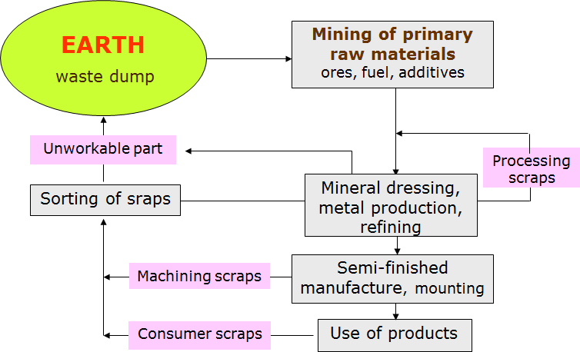

Fig. 1.1 Schematic depictions of processing of ores and production of wastes.

- Leaching methods
The basic factor determining selection of a leaching method is character of the ore and the ability of the to-be-produced component to dissolve in the selected solution Basic types of leaching:
- Underground leaching (in-situ leaching)
- Heap leaching
- Percolation leaching
- Agitation leaching
- High-pressure leaching (autoclave leaching)
- Biological leaching.

  - Underground leaching (in-situ leaching)

Underground leaching was originally used for mining of water dissoluble salts and sulphur. Nowadays, it is used especially to leach low-concentrated deposits of copper, uranium and gold. During this method, solutions of suitable agents are pumped into drill holes in the vicinities of ores deposits, in some cases to the depth of 1,500 m (Fig. 3.2). The solutions penetrate the rock along its cleavage and fracture planes and dissolve the mineral contained in the ore. The leachate is pumped to the surface at a suitable place and subsequently processed. Regenerated leaching agent is returned to the leaching process.
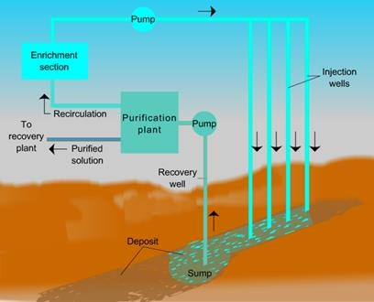

Fig. 1.1 Principle of underground leaching [2].

Heap leaching

A layer of ore in the height of 6 – 9 m is poured on a flat surface covered with asphalt or rubber. Then the ore is sprayed from the top with water or a diluted solution of H2SO4, or a leaching solution is supplied into the layer using perforated pipes. Diameters of ore particles are approximately 25 mm.
Leachates are collected and further processed. The method is applied to leach low-concentrated uranium ores.

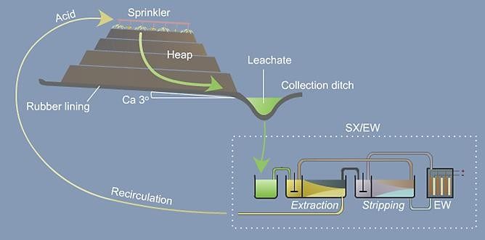

Fig. 1.2 Principle of heap leaching [3].

Percolation leaching – diffusion leaching
Percolation leaching is usually used for ores with bigger lumpiness, pellets or agglomerates, which can easily be leached. This method is used to leach e.g. old dumps and ores stored on platforms or in percolation tanks. It is often used to process copper, uranium and gold ores (Fig. 3.4). The critical factor for application of percolation is the penetration speed, which depends on porosity of the material, content of clay components and height of the layer. Its value should be higher than 2 cm h-1. A leaching agent is either pumped from the bottom, or is poured freely onto the ore. Pumping of a leaching solution from the bottom has many advantages, such as its lower dilution, uniform penetration through the batch and a good penetration also while using non-sorted material containing finer particles.
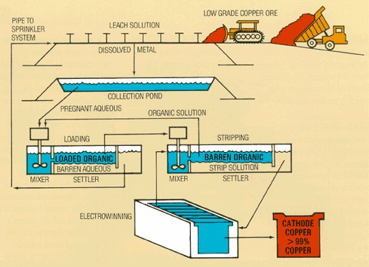

Fig. 1.3 Leaching of low-concentrated Cu-ores by percolation [4].

Agitation leaching
Leaching is significantly influenced by the proportion of liquid and solid phases. To ensure maximum leaching efficiency, this ratio has to be the lowest possible. Other factors influencing the leaching process are material lumpiness, temperature, pressure and intensity of contact of ore particles with the leaching solution. Agitation leaching can be performed either continuously, or discontinuously (Fig. 3.5).
During continuous leaching, a mash flows through a line of agitation units connected one by one. This method is usually supplemented with continuous vanning, thickening and filtering. During discontinuous leaching, a mash is pumped into simultaneously operating agitation units and then pumped out into a catch basin after leaching. This process is constantly repeated. Leaching tanks with agitators are divided into these groups:
- mechanical:
  - mash collecting tanks (reservoirs of mash kept in a suspended state),
  - tanks with propeller agitators,
  - tanks with suction agitators,
- pneumatic
- combined.
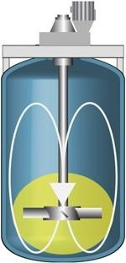

Fig. 1.4 Leaching tanks with agitators [5].

High-pressure leaching (autoclave leaching)
Application of increased pressure and temperature leads to acceleration of chemical reactions. Some reactions also begin to occur at these conditions. For example, ferrites of Zn or Cu are only hardly dissoluble in sulphuric acid under normal conditions. Nevertheless, if the leaching temperature increases to 160°C, they dissolve very easily. Leaching under high pressures is performed in specialized pressure vessels – autoclaves (Fig. 3.6) – which have to be resistant to high pressures (up to 10 MPa), to effects of various agents and to abrasion of transferred mashes. Dissolubilities of gasses multiply at increased pressures, which results in an occurrence of reactions between gasses and minerals, which would not occur (or only rarely) under normal pressure conditions.
Autoclave processes, running with a participation of oxygen, are processes during which:
- Oxidation of metals or lower oxides to dissoluble forms occurs; for acidic leaching under pressure, the necessary sulphuric acid can be replaced by an addition of finely ground pyrite.
- Oxidation of original elements, on which the produced metals are bound, occurs.

- CoAsS + 13 O2 + 6 H2O  4 CoSO4 + 4 H3AsO4
- Oxidation of both the components occurs:
MoS2 + 9 O2 + 6 H2O  2 H2MoO4 + 4 H2SO4
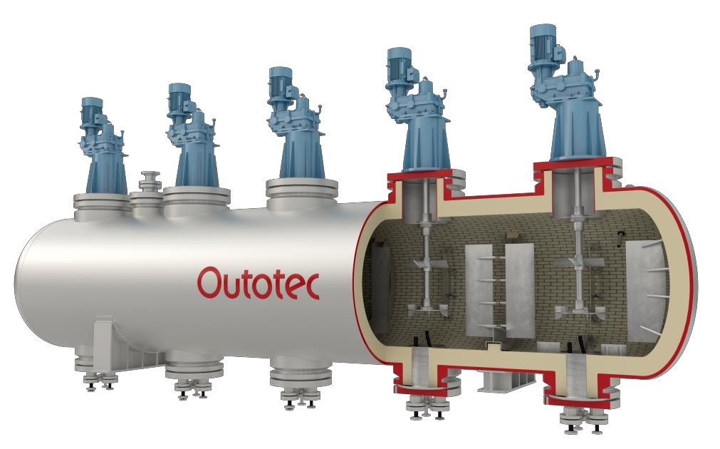
Fig. 1.5 Principle of Outotec's autoclave for gold leaching under high pressure [6].

Biological leaching
Biological (bacterial) leaching includes processes of ores leaching, during which microorganisms are used together with chemical agents to convert metals to solutions. Bacteria are generally wide-spread in soil, water and air. Depending on the materials necessary for their existence they can be denoted as:
- heterotrophic
- autotrophic
Heterotrophic bacteria use final organic compounds (carbohydrates, proteins etc.), while autotrophy bacteria need only inorganic substances for their existence. Bacteria applied during leaching belong to autotrophic bacteria:
- Thio- bacteria, e.g. thiobacillus thiooxidans – have the ability to oxidize sulphur and sulphides to sulphuric acid.
- Ferrobacillus – the source of energy is an oxidation reaction of divalent iron.
- Thiobacillus ferrooxidans – have the properties of both the above mentioned groups.
In hydrometallurgy of sulphides, the highest importance has the thiobacillus ferrooxidans (TF) and thiobacillus thiooxidans (TT) bacteria – Fig. 3.7.

Both types of these bacteria are suitable for hydrometallurgy, since they supplement each other. TF oxidizes pyrite to iron sulphate in a biochemical way and by this enables dissolution of other ores components in a chemical way (Fig. 3.8):
2 FeS2 + 7 O2 + 2 H2O  2 FeSO4 + 2 H2SO4
4 FeSO4 + O2 + 2 H2SO4  2 Fe2(SO4)3 + 2 H2O
Fe2(SO4)3 further chemically reacts:

Cu2S + Fe2(SO4)3  CuSO4 + 2 FeSO4 + CuS
The produced FeSO4 is biochemically re-oxidized and therefore can again contribute to leaching
FeSO4 + 12 O2 + H2SO4  Fe2(SO4)3 + H2O
Elemental sulphur, generated as the final product during leaching of sulphides, accumulates on the ores surfaces and inhibits further diffusion. By this reason, the presence of TT bacteria oxidizing the generated sulphur to the sulphuric acid is necessary.
2 S + 3 O2 + 2 H2O  2 H2SO4
Biological leaching enables processing of old dumps, as well as underground leaching of deposits, which are non-mineable by other methods due to their low metals contents. Its significant advantage is a high yield degree, often up to 96%.
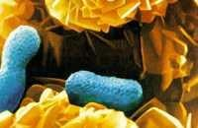
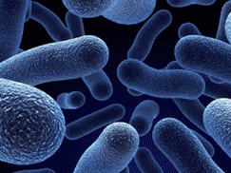
a)
b)
Fig. 3.7 Bacteria thiobacillus ferroxidans (TF) (a) and thiobacillus thiooxidans (TT) (b) [7, 8].
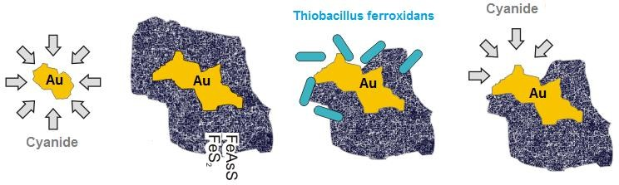
Fig. 1.6 Biological leaching of gold from pyrite and arsenic-pyrite ores [9].

- Leaching agents
Selection of a leaching agent depends on many factors. Among the most important are:
- Chemical and physical character of the leached material.
- Cost of the dissolving agent.
- Corrosion effects of the dissolving agent on the apparatus.
- Selectivity of the dissolving agent regarding the leached material.
- Possibility of regeneration of the leaching agent.

Selectivity of a leaching agent is influenced by:
- leaching agent concentration,
- temperature,
- contact time of the leaching agent with the leached material.

The mostly applied leaching agents are:
- Water – for leaching of calcines after sulphate or chloride roasting, e.g. leaching of Re2O7.
- Aqueous solutions of salts:
  - Fe2(SO4)3: leaching of CuS,
  - NaCN: leaching of Au,
  - Na2S: leaching of Sb2S3,
  - Na2S2O3: leaching of Ag.
- Chlorinated water: leaching of ZnS.
- Acids – mostly H2SO4.
- Alkalic agents:
  - Especially leaching of bauxites and Al,
  - NH4OH: leaching of Cu and Ni.

Summary
- Leaching rate increases with decreasing lumpiness, since small particles have greater specific surface.
- For a leaching process controlled by diffusion, the leaching rate depends on the intensity of agitation. Agitation should be sufficient to keep the solid particles floating.
- Leaching rate increases with increasing temperature.
- Leaching rate increases with increasing leaching agent concentration.
- Leaching rate increases with decreasing content of solid particles in the mash.
- If dissoluble by-products are generated during leaching, then the leaching rate depends on their character. Non-penetrable products decrease leaching rate.

