**ELECTROMETALLURGY**

Electrometallurgy is the field concerned with the processes of metal [electrodeposition](https://en.wikipedia.org/wiki/Electrophoretic_deposition). Electrometallurgy includes all metallurgical processes which utilize electricity and electrical effects.

The electrometallurgical processes can be categorized into four main groups:

1. [***Electrowinning***](https://en.wikipedia.org/wiki/Electrowinning)***,*** the extraction of metal from ores.
2. [***Electrorefining***](https://en.wikipedia.org/wiki/Electrorefining), the purification of metals. [Metal powder production](https://en.wikipedia.org/wiki/Powder_metallurgy) by electrodeposition is included in this category, or sometimes electrowinning, or a separate category depending on application.
3. [***Electroplating***](https://en.wikipedia.org/wiki/Electroplating), the deposition of a layer of one metal on another.
4. [***Electroforming***](https://en.wikipedia.org/wiki/Electroforming)***,*** the manufacture of, usually thin, metal parts through electroplating.

Nowadays some metals are produced exclusively by electrolysis, whereas in the case of some others, a substantial percentage of the total production is by electrowinning. The approximate percentages (by electrolysis) of some important metals are: aluminium 100; sodium 100; lithium 100; magnesium 80; chromium 70; cobalt 50; cadmium 50; zinc 50; copper 10; nickel 10. Electrolysis can be used, among other methods, to obtain other metals, for example, Be, Та, Nb, rare earths, Ga, Ti, TI, In, Zr, Hf, and B.

The schematic representation of electrometallurgical processes is shown in Fig. 1

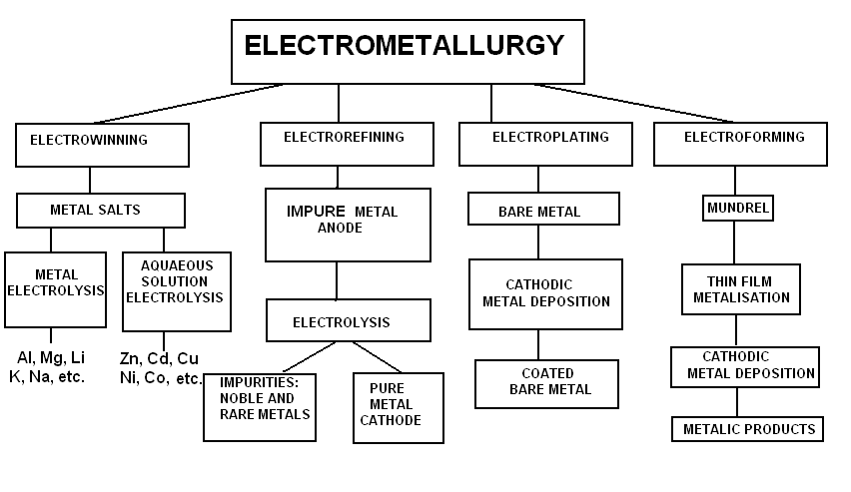

Figure 1. Schematics representation of electrometallurgical processes

***Electrowinning*** is the extraction of metals by electrodepo­sition from aqueous solution or melts of their salts. On a large scale electrodeposition from molten salts is used for extraction of electronegative elements which cannot be electrodeposited from aqueous solutions, such as aluminum and magnesium, as well as very pure copper, zinc and cadmium by electrodepo­sition from an aqueous solutions of the metal salts'.

***Electrorefining*** is the purification of metals by electrolysis. The impure metals is dissolved anodically and pure metal is deposited catodically, while the impurities being left as anode sludge or as ions in the solution. Many metals are electrorefined such as copper because of conducting application and precious metals because of theirs cost. Electrorefining is also a part of processes in recycling of metals.

***Electroplating*** can be defined as a treatment that modifies the surface of a metal or occasionally a nonmetal, without changing its bulk properties, in order to improve the appearance of a surface, to increase the corrosion and abrasion resistivity, etc. Electro­plating can be performed from molten salts and aqueous and non-aquaeous solutions, depending on the nature of electrode­posited metal, but most frequently from aqueous solutions'

***Electroforming*** is the manufacture of articles by electrodepo­sition. If deposit is good from electroplating point of view except adhesion, and can be removed from the cathode as an entity in itself, it has been electroformed. Electroforming is a branch of electroplating technology, but involve some additio­nal steps, as for example the production, preparation and extraction of the master.

In electrolytic operations, the selection of a proper electrolyte is the most important require­ment. The basic conditions that an electrolyte must satisfy are:

1. it must have a sufficiently high ionic conductivity, and conduction must be entirely due ions.
2. it must be chemically inert towards the electrodes, the container material, and the electrolysis products.
3. it must be stable at the temperature of operation.
4. when a solution containing the metal to be extracted is being used, then it must be chemically more stable than the solute.

Common metals such as Cu, Zn, Sn, Au, and Mn can be produced by aqueous electrolysis, whereas reactive metals such as Ti, Zr, Th, Na, K, Mg, and Al cannot. To obtain reactive metals, their fused salts must be electrolyzed at a high temperature.

Words and Word-Combinations to Be Memorized

|  |  |  |  |
| --- | --- | --- | --- |
| include - включает  utilize – использовать  electricity – электричество  metal electrodeposition – электроосаждение металла  electrowinning - электрохимическое извлечение  electrorefining – электрлитическая очистка  electroplating – гальваника, электрлитическое покрытие  electroforming – электрлитическое формование  electrolys – электролиз  substantial percentage - значительная часть/процент  approximate percentages - приблизительные проценты  obtain – получать, добывать, достигать  electrodepo­sition – электроосаждение  оn a large scale - на большом масштабе  purification – очистка, рафинирование  impure metals - нечистые металлы  dissolve – растворить  conducting – проведение  application – приложение | Mundrel – оправка, стержень (тупоконечный инструмент или пруток, используемый для удержания)  [bare](http://rus-eng.com/anglo_russkiy_metallurgicheskiy_slovar/page/bare.2354/) металл – бедный без покрытия металл  electronegative element – электроотрицательный элемент frequently -   |  |  | | --- | --- | |  | [зачастую](http://www.multitran.ru/c/m.exe?t=27399_2_1&s1=frequently); [часто](http://www.multitran.ru/c/m.exe?t=89033_2_1&s1=frequently); [неоднократно](http://www.multitran.ru/c/m.exe?t=4548055_2_1&s1=frequently); [нередко](http://www.multitran.ru/c/m.exe?t=5012503_2_1&s1=frequently); [обычно](http://www.multitran.ru/c/m.exe?t=5045293_2_1&s1=frequently)  abrasion resistivity –устойчивость к истиранию  entity – организация, сущность  a branch of electroplating technology – звено или ветвь гальванической технологии | |

a proper electrolyte – подходящий/ надлежащий электролит  
a sufficiently high ionic conductivity - достаточно высокая ионная проводимость