**Lecture 14. Powder Metallurgy**

**Powder metallurgy** is the process of *blending* fine powdered materials, *compacting* the same into a desired shape or form inside a mould followed by heating of the compacted powder in a controlled atmosphere, referred to as *sintering* to facilitate the formation of bonding of the powder particles to form the final part*.* Thus, the powder metallurgy process generally consists of four basic steps, as indicated in *Figure 13.1*: (1) *powder manufacture,* (2) *blending of powders,* (3) *compacting of powders in a mould or die,* and (4) *sintering. Compacting* is generally performed at room temperature and at high pressure. *Sintering* is usually done at elevated temperature and at atmospheric pressure. Often, *compacting* and *sintering* are combined. Optional secondary processing often follows to obtain special properties or enhanced dimensional precision. *Powder Metallurgy* route is very suitable for parts that are required to be manufactured from a single or multiple materials (in powder form) with very high strength and melting temperature that pose challenge for the application of casting or deformation processes.

## Powder Manufacture

The manufacturing of the material powder is the first step in powder metallurgy processing route that It involves making, characterising, and treating the powder which have a strong influence on the quality of the end product. Different techniques of powder making are: *Atomising Process*

In this process the molten metal is forced through an orifice into a stream of high velocity air, steam or inert gas [*Figure 13.2*]. This causes rapid cooling and disintegration into very fine powder particles and the use of this process is limited to metals with relatively low melting point.

*Gaseous Reduction*

This process consists of grinding the metallic oxides to a fine state and subsequently, reducing it by hydrogen or carbon monoxide. This method is employed for metals such as iron, tungsten, copper, etc.

*Electrolysis Process*

In this process the conditions of electrode position are controlled in such a way that a soft spongy deposit is formed, which is subsequently pulverised to form the metallic powder. The particle size can be varied over a wide range by varying the electrolyte compositions and the electrical parameters.

*Carbonyl Process*

This process is based upon the fact that a number of metals can react with carbon monoxide to form carbonyls such as iron carbonyl can be made by passing carbon monoxide over heated iron at 50 – 200 bar pressure. The resulting carbonyl is then decomposed by heating it to a temperature of 200 – 3000C yielding powder of high purity, however, at higher cost.

*Stamp and Ball mills*

These are mechanical methods which produce a relatively coarse powder. Ball mill is employed for brittle materials whereas stamps are used for ductile material.

*Granulation Process*

This process consists in the formation of an oxide film in individual particles when a bath of metal is stirred in contact with air.

*Mechanical Alloying*

In this method, powders of two or more pure metals are mixed in a ball mill. Under the impact of the hard balls, the powders are repeatedly fractured and welded together by forming alloy under diffusion.

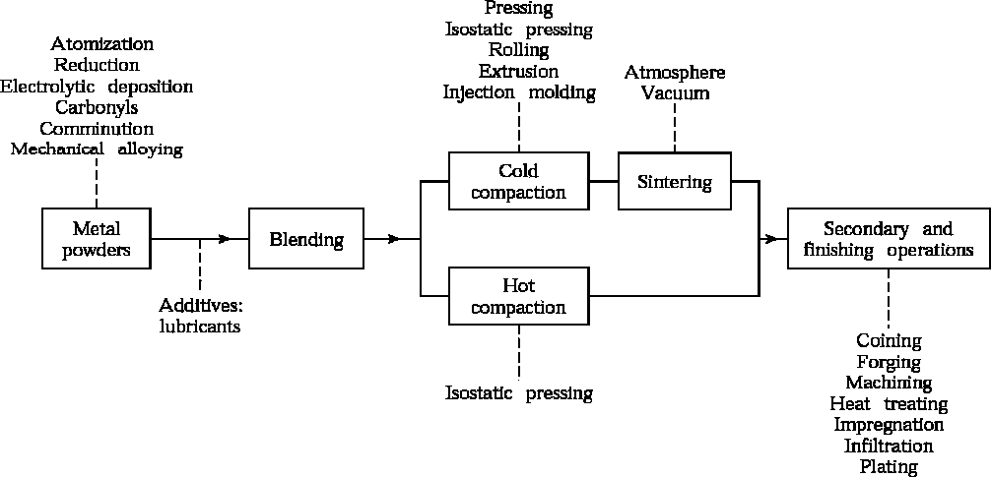

**Figure 13.1** Basic steps in Powder Metallurgy process [3]

*Other methods*

The other less commonly used methods to form metallic powder are by (i) precipitation from a chemical solution, (ii) production of fine metals by machining, and (iii) vapour condensation.

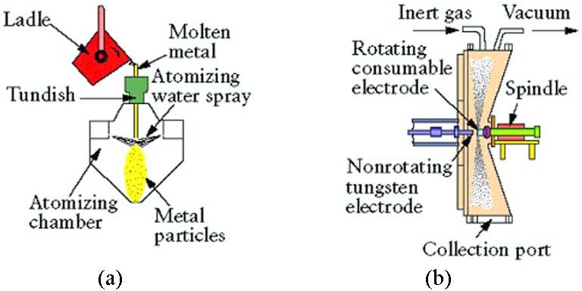

**Figure 3.6.2** Methods of metal-powder production by atomization; (a) melt atomization;

(b) atomization with a rotating consumable electrode. [3]

Powder Blending

A single powder may not fulfil all the requisite properties and hence, powders of different materials with wide range of mechanical properties are blended to form a final part. Blending is carried out for several purposes as follows.

1. *Blending* imparts uniformity in the shapes of the powder particles,
2. *Blending* facilitates mixing of different powder particles to impart wide ranging physical and mechanical properties,
3. *Lubricants* can be added during the *blending process* to improve the flow characteristics of the powder particles reducing friction between particles and dies,
4. *Binders* can be added to the mixture of the powder particles to enhance the green strength during the powder compaction process.

## Powder Compaction

The principle goal of the *compaction process* is to apply pressurize and bond the particles to form a cohesion among the powder particles. This is usually termed as the *green strength*. The *compaction* exercise imparts the following effects.

1. Reduces voids between the power particles and enhance the density of the consolidated powder,
2. Produces adhesion and bonding of the powder particles to improve green strength in the consolidated powder particles,
3. Facilitates plastic deformation of the powder particles to conform to the final desired shape of the part,
4. Enhances the contact area among the powder particles and facilitates the subsequent sintering process.

Compaction is carried out by pouring a measured amount of metallic powder into the die cavity and applying pressure by means of one or more plungers. To improve uniformity of pressure and reduce porosity in the compacted part, compressive forces from both the top and the bottom sides are necessary. The requisite compacting pressure depends on the specific characteristics and initial shape of the particles, the method of blending and the application of the lubricants. Extremely hard powders are slower and more difficult to press. Some organic binder is usually required to hold the hard particles together after pressing until the sintering process is performed. *Figure 13.3* depicts a schematic view of the powder compaction process to manufacture a typical bushing.

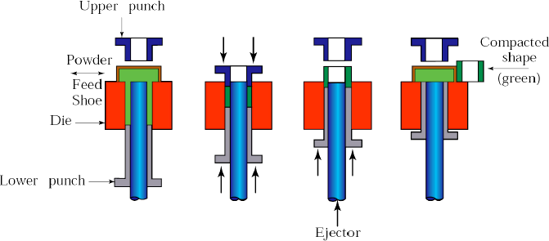

**Figure 13.3** Compaction of metal powder to form a bushing [3]

## Sintering

*Sintering* refers to the heating of the compacted powder perform to a specific temperature (*below the melting temperature of the principle powder particles while well above the temperature that would allow diffusion between the neighbouring particles*). *Sintering* facilitates the bonding action between the individual powder particles and increase in the strength of the final part. The heating process must be carried out in a controlled, inert or reducing atmosphere or in vacuum for very critical parts to prevent oxidation. Prior to the *sintering process*, the compacted powder perform is brittle and confirm to very low *green strength*. The nature and strength of the bond between the particles depends on the mechanism of diffusion and plastic flow of the powder particles, and evaporation of volatile material from the in the compacted preform. Bonding among the powder particles takes places in three ways: (1) *melting of minor constituents in the powder particles*, (2) *diffusion between the powder particles*, and (3) *mechanical bonding*. The *time*, *temperature* and *the furnace atmosphere* are the three critical factors that control the *sintering process*. *Sintering process* enhances the density of the final part by filling up the incipient holes and increasing the area of contact among the powder particles in the compact perform.

*Figures 13.4* and *13.5* schematically show the sintering process by solid-state diffusion process and liquid-phase transport of powder particles.

## Finishing Operation

After sintering, some finishing operations such as *re-pressing* (*to impart dimensional accuracy*) and *machining* are carried out to further improve the quality of the final part. Parts made through the powder metallurgy based processes are also subjected to other finishing operations such as heat treatment, machining and finishing depending on the requirements.

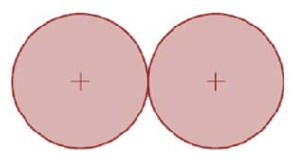 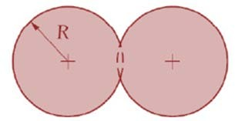 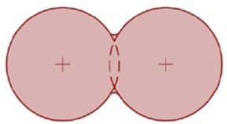

* 1. (b) (c)

Initial powder particles Neck formation by diffusion Reduction in inter-

particle distance

**Figure 13.4** Schematic illustration of sintering of compact preform using solid-state diffusion between powder particles [1]

(a)

(b)

(c)

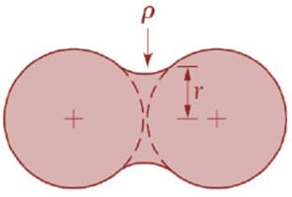

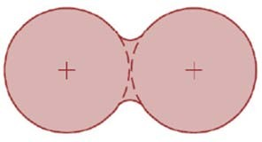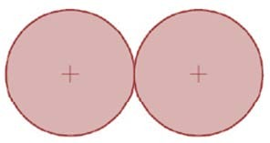

Inter-particle distance

remains same

Neck formation by liquid

-phase transport of particles

Initial powder particles

**Figure 13.5** Schematic illustration of sintering of compact preform using liquid-phase

transport between powder particles [1]