**Lecture 14. Manufacturing Processes**

**Introduction.** Metal forming is a very important manufacturing operation. It enjoys industrial importance among various production operations due to its advantages such as cost effectiveness, enhanced mechanical properties, flexible operations, higher productivity, considerable material saving.

We use in our daily life are man-made, engineered parts, which are obtained from some raw material through some manufacturing process. All these objects are made of a number of small components assembled into finished product. The pen that we use for writing, for example is made of several small parts, assembled together. An automobile is supposed to be an assembly of more than 15000 parts, produced through various manufacturing operations.

***Manufacturing*** of finished parts and components from raw materials is one of the most important steps in production.

Production encompasses all types of manufacturing processes. Manufacturing refers to the conversion of raw materials into finished products employing suitable techniques. There are several methods of manufacturing such as metal casting, metal forming, metal machining, metaljoining and finishing.

Some of the modern methods of manufacturing include micro machining, nano fabrication, ultra precision manufacturing etc.

In order to fulfill the requirements of the ever-increasing demands of various types of industries, the manufacturing engineer has to choose the right type of material and the right type of equipment for manufacture so that the cost of production and the energy consumption are minimum.

The selection of suitable manufacturing process should also include concerns for environmental impacts such as air pollution, waste disposal etc.

Modern concepts such as lean manufacturing, adaptive control, agile manufacturing, group technology etc have considerable influence on cost reduction and quality improvements of products.

Computers and robots play important role in modern manufacturing techniques, today. Modeling and simulation of the process prior to mass production helps the manufacturing engineer fix up the best operating parameters and hence achieve the finished product to the utmost level of quality and cost-effectiveness.

The present lesson is focused on one of the important methods of manufacturing, namely, metal forming.

**Metal forming – definition:**

Materials are converted into finished products though different manufacturing processes. Manufacturing processes are classified into shaping [casting], forming, joining, and coating, dividing, machining and modifying material property.

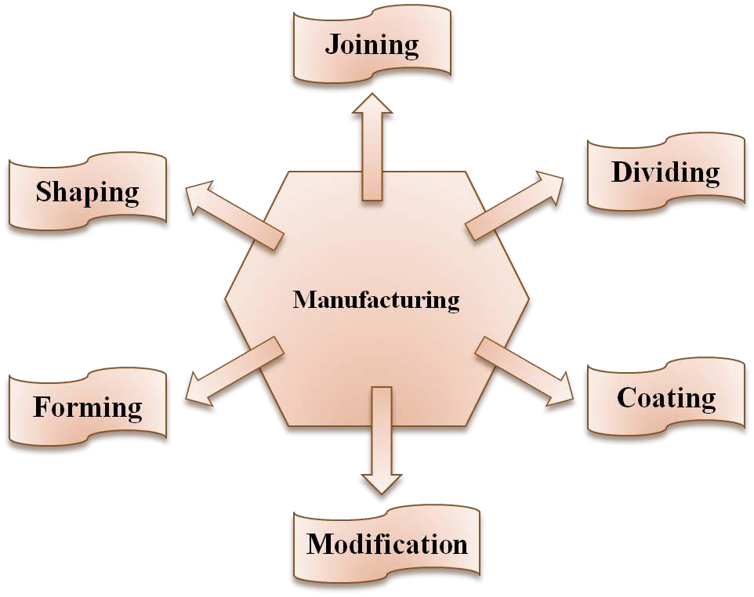

**Fig.1: Various manufacturing operations on materials**

Of these manufacturing processes, forming is a widely used process which finds applications in automotive, aerospace, defense and other industries.

Wrought forms of materials are produced through bulk or sheet forming operations. Cast products are made through shaping – molding and casting.

A typical automobile uses formed parts such as wheel rims, car body, valves, rolled shapes for chassis, stamped oil pan, etc.

In our daily life we use innumerable formed products e.g. cooking vessels, tooth paste containers, bicycle body, chains, tube fitting, fan blades etc.

Forming is the process of obtaining the required shape and size on the raw material by subjecting the material to plastic deformation through the application of tensile force, compressive force, bending or shear force or combinations of these forces.

**Classification of forming:**

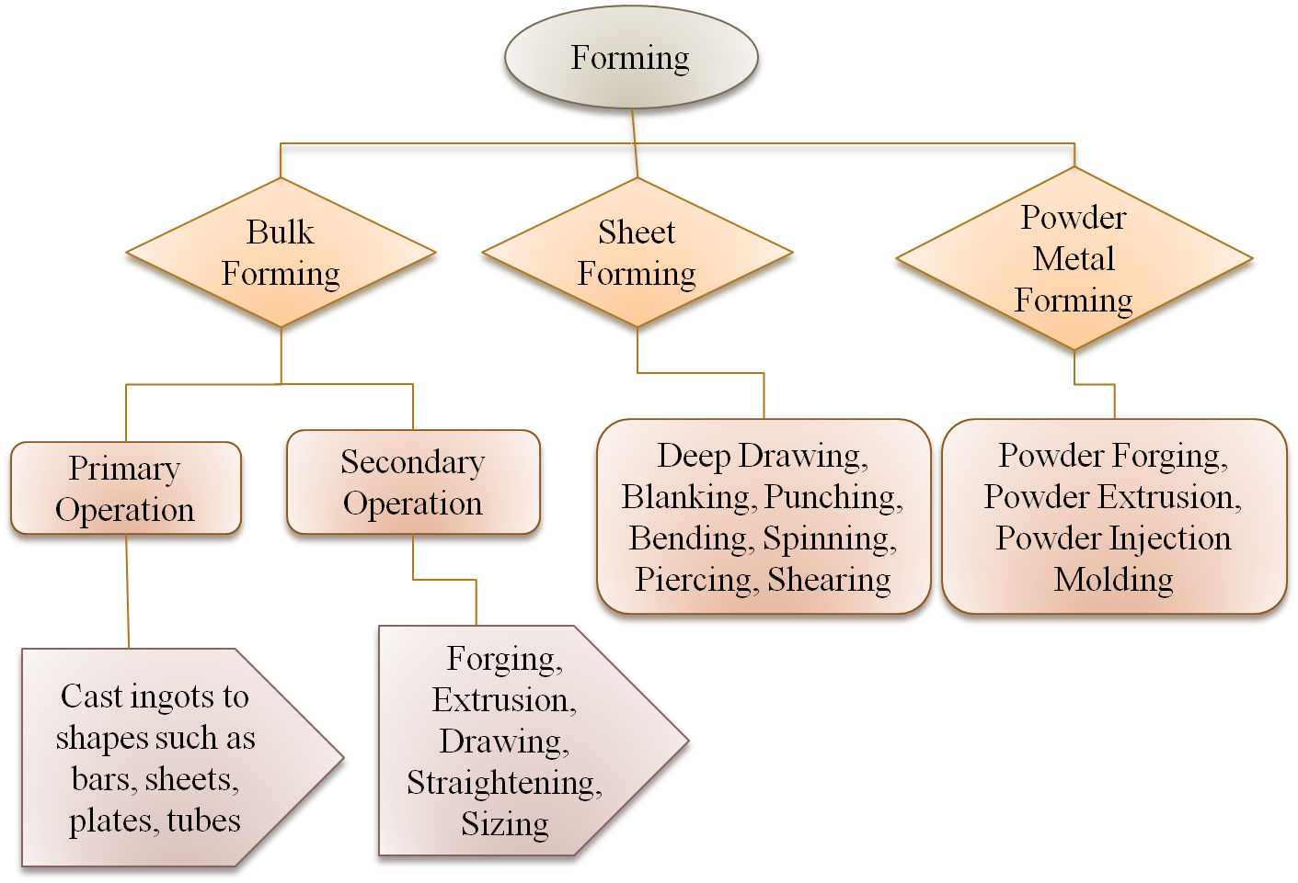

**Fig. 14.1: Classification of metal forming processes**

Typically, metal forming processes can be classified into two broad groups. One is bulk forming and the other is sheet metal forming. Bulk deformation refers to the use of raw materials for forming which have low surface area to volume ratio. Rolling, forging, extrusion and drawing are bulk forming processes. In bulk deformation processing methods, the nature of force applied may be compressive, compressive and tensile, shear or a combination of these forces.

Bulk forming is accomplished in forming presses with the help of a set of tool and die. Examples for products produced by bulk forming are: gears, bushed, valves, engine parts such as valves, connecting rods, hydraulic valves, etc.

Sheet metal forming involves application of tensile or shear forces predominantly. Working upon sheets, plates and strips mainly constitutes sheet forming. Sheet metal operations are mostly carried out in presses – hydraulic or pneumatic. A set of tools called die and punch are used for the sheet working operations. Bending, drawing, shearing, blanking, punching are some of the sheet metal operations.

A new class of forming process called powder forming is gaining importance due to its unique capabilities. One of the important merits of powder forming is its ability to produce parts very near to final dimensions with minimum material wastage. It is called near-net-shape forming. Material compositions can be adjusted to suit the desirable mechanical properties. Formability of sintered metals is greater than conventional wrought materials. However, the challenge in powder forming continues to be the complete elimination or near-complete elimination of porosity. Porosity reduces the strength, ductility and corrosion resistance and enhances the risk of premature failure of components.

Based on the nature of deformation force applied on the material, during forming, metal forming processes are also classified into several types as shown below:

|  |  |  |  |  |  |  |  |
| --- | --- | --- | --- | --- | --- | --- | --- |
| |  |  |  | | --- | --- | --- | | **Forming by**  **compressive stress** |  | **Tensile and compressive stresses** | | |  |  |  | | --- | --- | --- | | **Forming under Tensile stress** |  | **Bending and shearing stresses** | |

|  |  |  |  |  |  |  |  |
| --- | --- | --- | --- | --- | --- | --- | --- |
| |  |  |  | | --- | --- | --- | | * Open Die Forging * Closed Die Forging * Rolling * Coining * Extrusion |  | * Deep drawing * Spinning * Stripping * Wrinkle bulging | | |  |  |  | | --- | --- | --- | | * Stretch forming * Stretching * Expanding |  | * Bending * Shearing * Punching * Blanking | |

Forming is also classified as cold forming, hot forming or warm forming. Hot forming is the deformation carried out at temperatures above recrystallization temperatures. Typically, recrystallization temperatures for materials ranges from 0.5 Tm to 0.8 Tm, where Tm is melting temperature of material.